Empowering Cambodia’s Educators: Closing Workshop Marks Success of the “Developing Teachers to Raise One-Health Awareness at General and Technical High Schools in Cambodia” Project, Phase 2

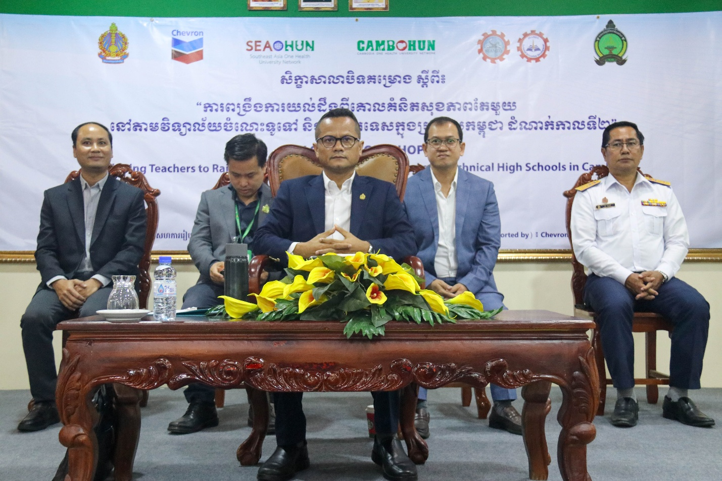
(H.E Kolpheng Vaddhana Presided Over)

Battambang, Cambodia, 17 November 2025 – The Southeast Asian Ministers of Education Organization Regional Center for Technical Education Development (SEAMEO TED) and the Southeast Asia One Health University Network (SEAOHUN) successfully concluded the "Developing Teachers to Raise One Health Awareness at General and Technical High Schools in Cambodia" project phase 2 with a closing workshop at National University of Battambang. This milestone event concluded a seven-month initiative dedicated to equipping teachers with the knowledge and skills to promote One Health awareness in schools and communities.
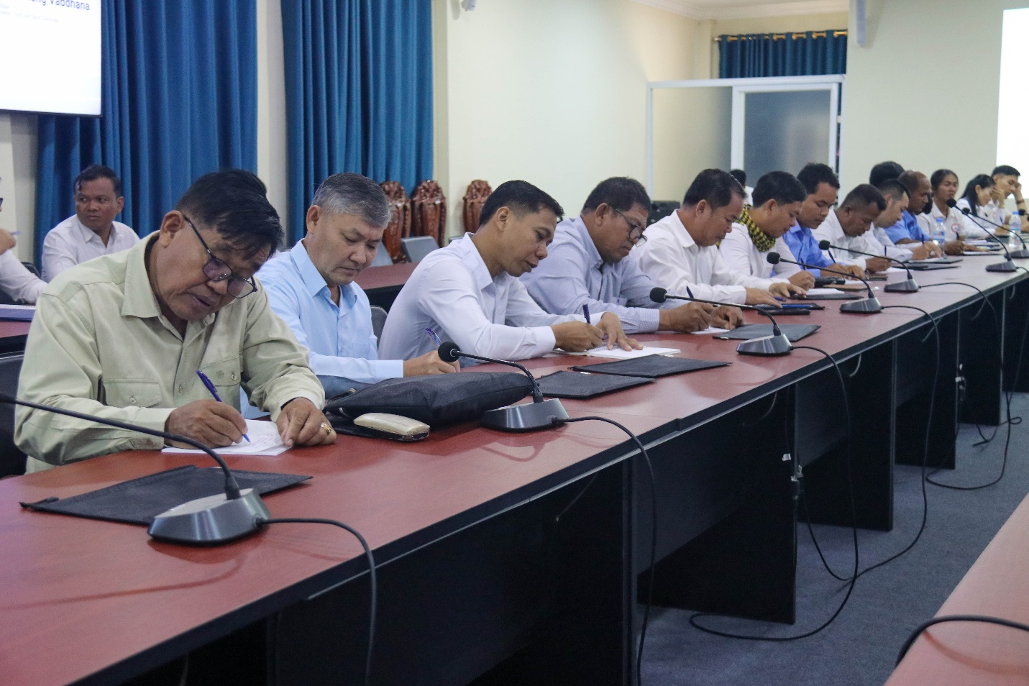
(Participants Taking Note)
At the ceremony, nine national teacher trainers received certificates of completion, recognizing their dedication to advancing One Health education. Additionally, the One Health Champion Awards celebrated outstanding teacher trainees from the three target schools, with Preah Norodom Sihamoni General and Technical High School winning Teacher and Student One Health Champion Award, Hun Sen Peamchikorng High School winning School Campaign Champion Award, and Community Development Institute winning Community One Health Champion Award.
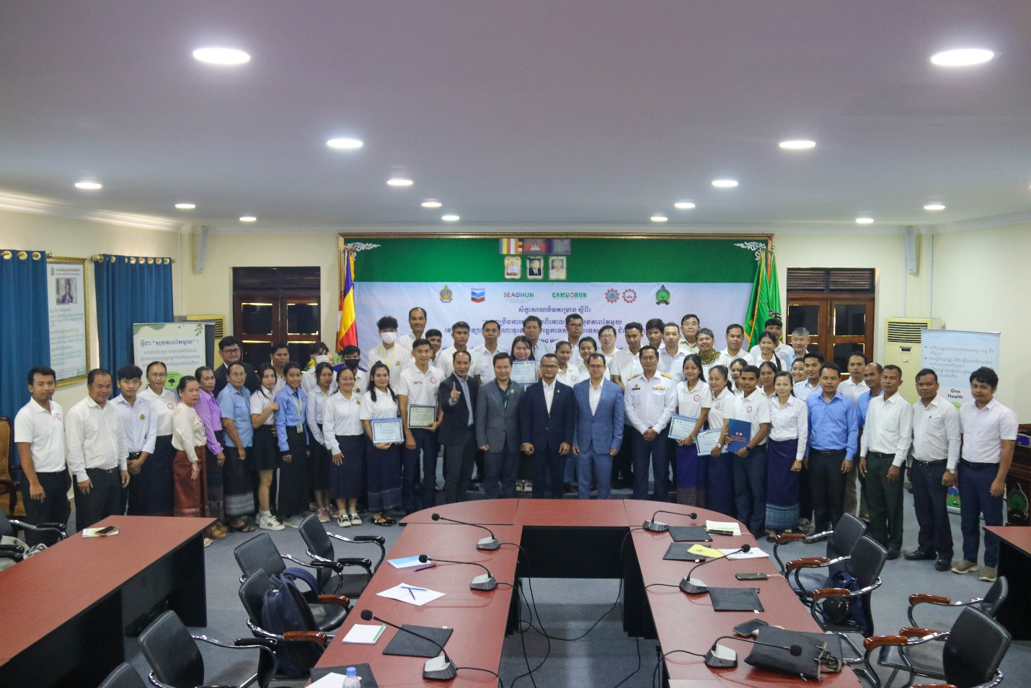
(Group Photo of All Participants)
This initiative, funded by Chevron, aligns with the company’s commitment to empowering communities through education and public health initiatives. The closing workshop was presided over by H.E. DR. KOLPHENG VADDHANA, Under Secretary of State, Ministry of Education, Youth and Sport (MoEYS), and brought together over 60 stakeholders, including representatives from CAMBOHUN, government agencies, and 20 general and technical high schools.
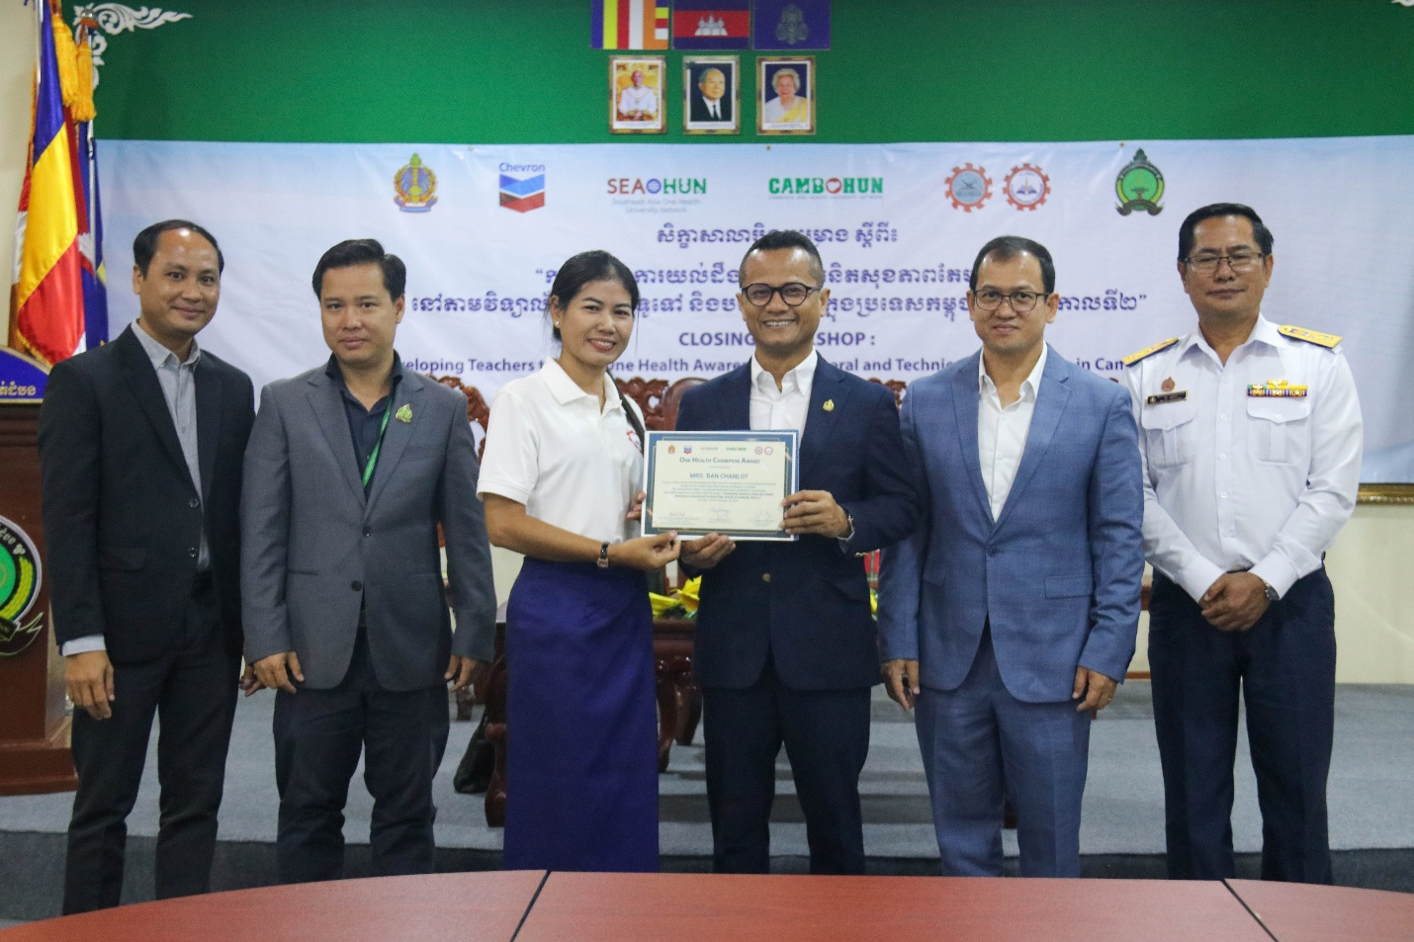
(Appreciation Certificate Conferment)
Scaling Up One Health Education in Cambodia
H.E. DR. KOLPHENG VADDHANA, Under-Secretary of State, Ministry of Education, Youth and Sport (MoEYS), presided over the closing workshop, emphasizing the project’s significance for students, teachers, and communities and advocated for extending One Health awareness programs to other general and technical high schools.
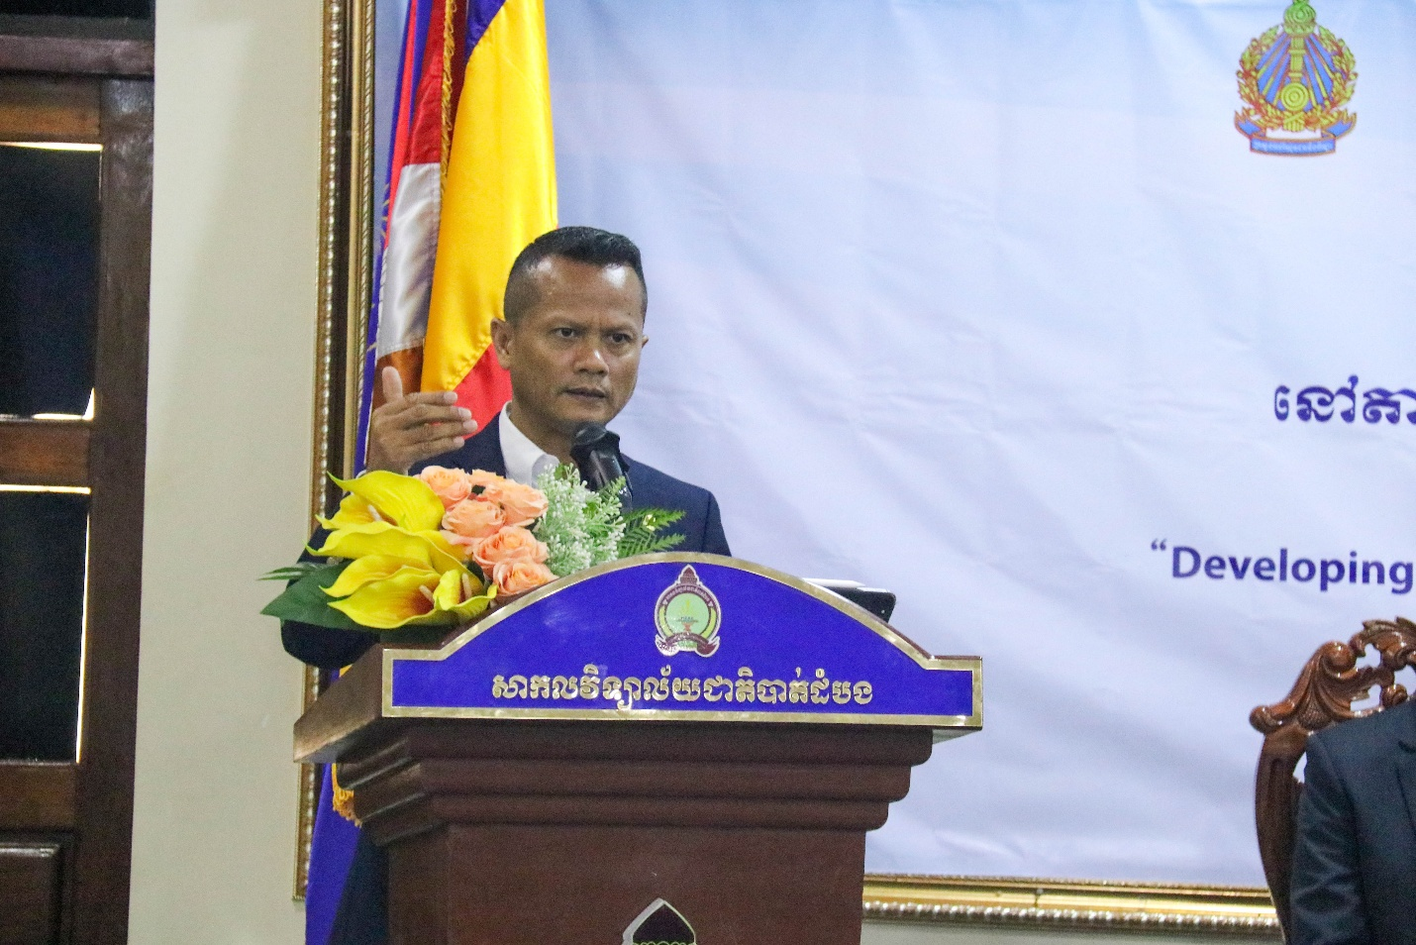
(H.E Kolpheng Vaddhana Delivering his Opening Remarks)
He highlighted that One Health concepts align with Cambodia’s Pentagonal Strategy and MoEYS policies, including student health initiatives through school feeding programs and school food quality regulations. Additionally, he stressed the importance One Health Program for Cambodia. He addressed the sustainability of the project by encouraging the representatives of General and Technical High Schools in attendance to include One Health Concept in the 1-hour-school health session of the existing curriculum. He also emphasized how crucial health was to our lives by quoting the Buddha’s saying, “Health is the best of all Wealth”. To conclude, he thanked the Southeast Asia One Health University Network (SEAOHUN) and Chevron for their support of this project. He called on SEAOHUN and Chevron to continue their support for the One Health project in Cambodia.

Reflections on Achievements and the Path Forward
Dr. Songheang Ai, Center Director of SEAMEO TED and Project Manager, recapped the project's progress and achievements, emphasizing overwhelmingly positive feedback from evaluations. The initiative successfully conducted seven key activities, including a kick-off workshop, three One Health Awareness Raising for teachers and students, and for community. Participants deepened their understanding of One Health concepts, food safety, and zoonotic diseases.
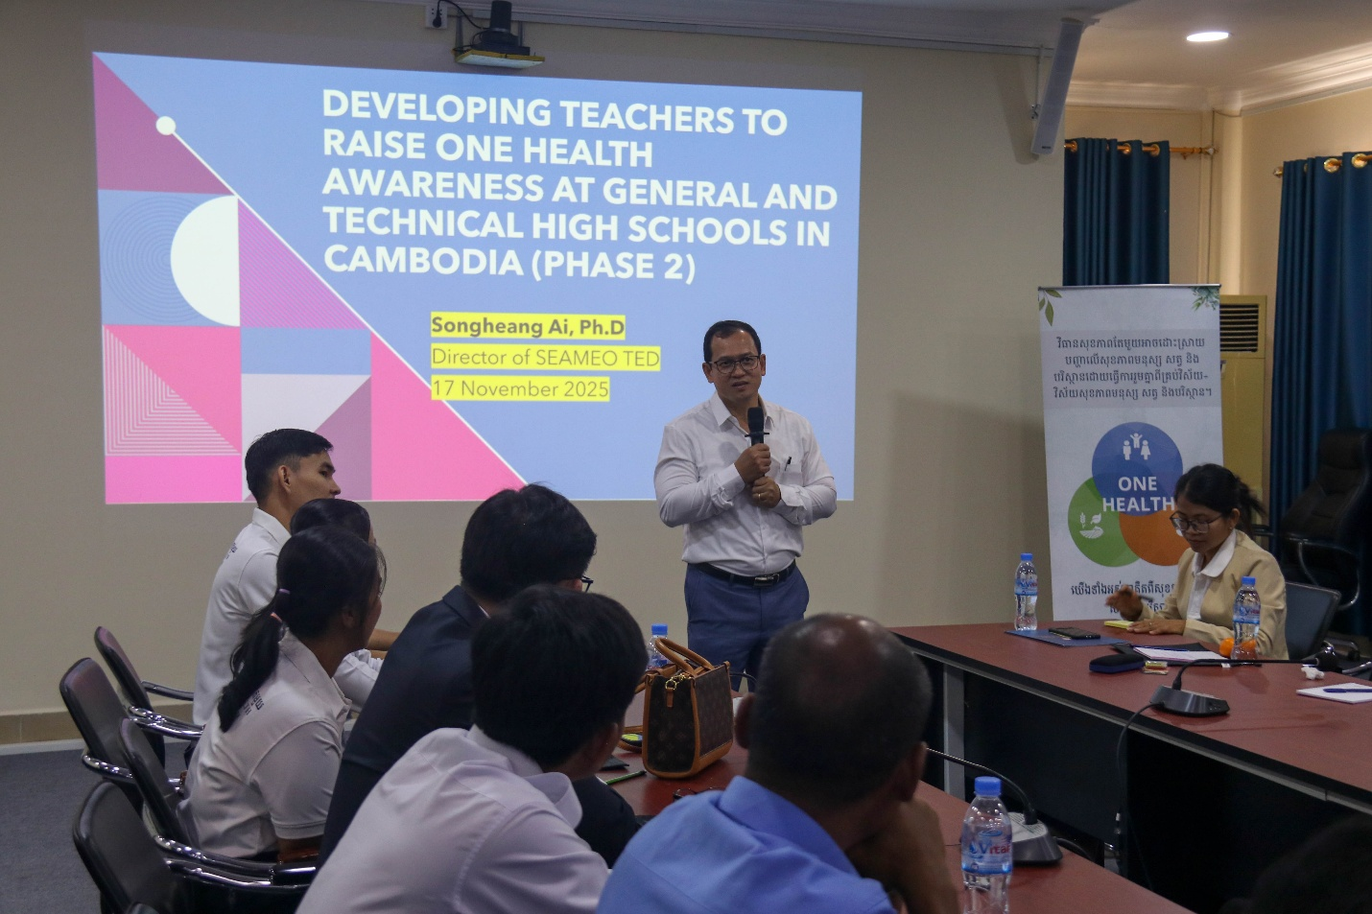
(Dr. Songheang Ai, Director of SEAMEO TED, Presenting the Evaluation Report)
During the feedback and the discussion session he facilitated, there were overwhelming calls for support from Chevron and SEAOHUN to expand the project to other target schools, as well as other communities by the representatives of General and Technical High Schools, CAMBOHUN and MOEYS. Four main emphases were the expansion of One Health Program to both primary and secondary schools, capacity building for teachers, community engagement, and integrating new elements of One Health Concepts such as the effects of drugs on Youth’s physical and mental health.
What is One Health?
One Health is a collaborative approach—working at the local, regional, national, and global levels—with the goal of achieving optimal health outcomes recognizing the interconnection between people, animals, plants, and their shared environment. Schools play a key role in the development of knowledge, positive attitude, and behaviors early in life, incorporating the One Health concept into the school curriculum will help children understand the interdependencies between humans and animals in a shared environment and develop long-lasting preventative behaviors to be less prone to zoonotic diseases. Additionally, children can bring the concept home to their parents and the greater community.
About SEAMEO TED
The Southeast Asian Ministers of Education Organization Regional Centre for Technical Education Development (SEAMEO TED) is one of the 26 SEAMEO centers, based in Phnom Penh, Cambodia. SEAMEO TED assists SEAMEO member countries in identifying technical education problems and finding alternative solutions through capacity-building programs, research and development, and public relations and partnership for supporting administrators, technical teachers, management of technical and vocational high schools and colleges. Currently there are 87 technical and vocational high schools/colleges as the members of Southeast Asian Technical and Vocational High School/College Network from all 11 SEAMEO country members working collectively.
About SEAOHUN
The Southeast Asia One Health University Network (SEAOHUN), established in 2011, is an academic and research network promoting the One Health concept. Comprising over 100 educational institutions from eight ASEAN countries, SEAOHUN builds professional capacity to address complex One Health issues, conducts research for evidence-based decision-making, and assists governments with public health surge capacity. The SEAOHUN Secretariat is in Mueang district, Chiang Mai, Thailand.
About Chevron
Chevron is one of the world’s leading integrated energy companies. We provide affordable, reliable, and ever-cleaner energy to people in the Eurasia Pacific region that is essential to achieving a more prosperous and sustainable world. In Cambodia, Chevron (Cambodia) Limited markets automotive fuels and products under the Caltex® brand at 76 service stations, 40 of which are in Phnom Penh. Of the total number, 17 are company-owned, and 59 are owned by retailers. We operate 24 Star Mart® convenience stores and 72 Coffee Plus® gourmet cafés. In addition, we support the community through health, education, and safety initiatives.
Media Contact
SEAMEO TED
Dr. Songheang Ai
Email: song.heang@yahoo.com | WhatsApp/Telegram: +855-12-527-117
Chevron (Cambodia) Limited
Uzma Nawawi, Corporate Affairs Manager – Southeast Asia
Email: uzma.nawawi@chevron.com | Phone: +603 2289 6688 | Mobile: +6017 521 9294

