Report on
International Youth Talk “How Creative Marketing Can Grab the Attention of Young People”

On the afternoon of October 17, 2025, the 10th “International Youth Talk” online youth exchange meeting successfully concluded. The conference theme, “How Creative Marketing Can Grab the Attention of Young People,” brought together youth representatives from universities in Indonesia and the Philippines to engage in in-depth discussions and idea exchanges on topics such as creative communication, digital culture, and youth agency. This exchange not only allowed the young participants to gain a deeper understanding of the integration of creative marketing and social responsibility from multiple perspectives, but also further inspired them to contribute their creativity, artistic expression, and practical actions in the digital era toward building a more sustainable and inclusive information-driven future.

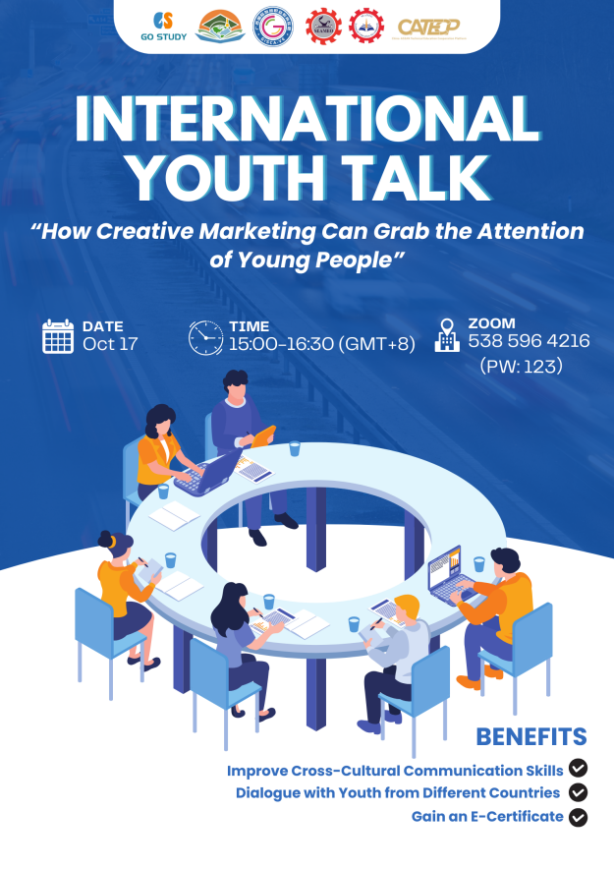
Opening Remarks
The opening remarks of this event were delivered by Ms. Cheng Chantola, Director of Administration, Financial and Planning at SEAMEO TED. She emphasized that in today’s digital age, effectively engaging with future leaders and guiding positive values is crucial. Creative marketing can transcend cultural boundaries, combining youth digital rituals, artistic expression, and social action to shape behavior while fostering social responsibility and global perspectives. As digital natives, youth are both consumers and drivers of change. She hopes this exchange will inspire participants to share ideas and explore the potential of creative marketing in building a sustainable, inclusive digital future.
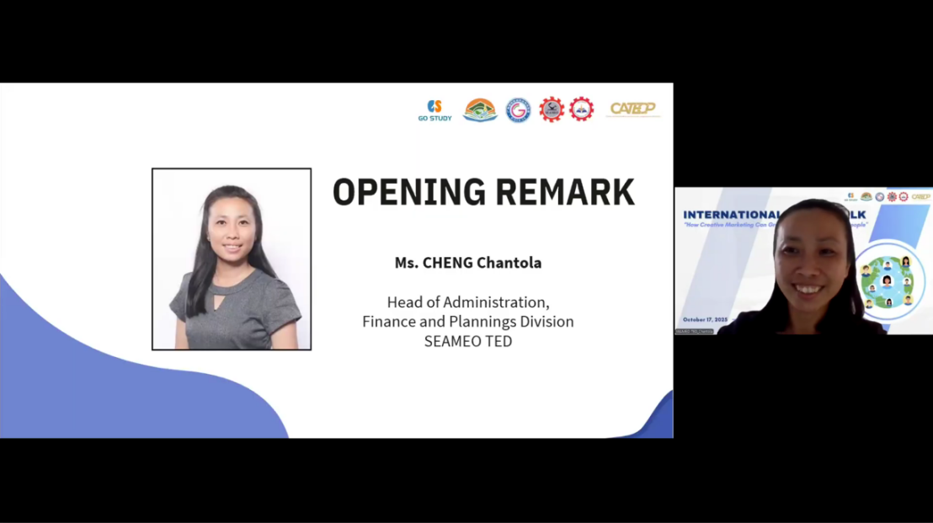

Sharing Session
Youth representatives from the Polytechnic University of the Philippines explored how “Artivism” (art + activism) can create new pathways for creative communication. They highlighted that murals, videos, music, and other art forms can transform political and social issues into emotionally resonant visual languages, turning youth from passive audiences into active participants. Their presentation emphasized “authenticity over slogans” and demonstrated how creativity bridges people and politics. Using examples from digital art, street creations, and online content, they showed how art connects emotion and action, elevating communication from mere persuasion to active engagement. This session underscored the central role of creativity and emotion in public communication and provided practical insights on fostering youth political participation and amplifying meaningful messages.
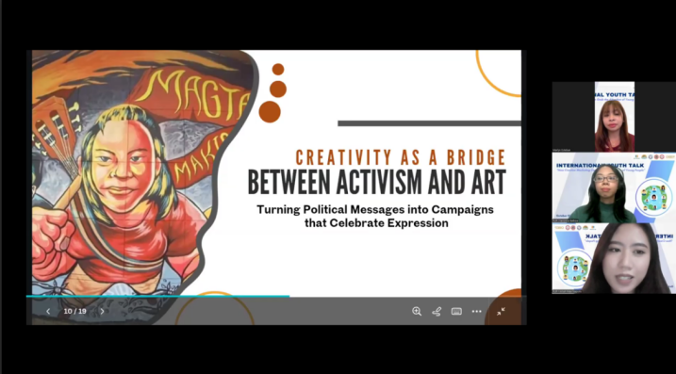

Youth representatives from Universitas PGRI Adi Buana Surabaya, Indonesia, provided an in-depth analysis of digital rituals among young people and proposed a shift in marketing approach from “Fear of Missing Out” (FOMO) to “Joy of Missing Out” (JOMO). They noted that FOMO-based marketing, such as limited-time stories and yearly recaps, can drive immediate engagement but may also cause anxiety and erode brand trust. In contrast, JOMO promotes intentional digital living, encouraging brands to focus on building long-term trust—for example, by promoting mindfulness apps or slow fashion—helping youth form healthier and more autonomous consumption habits. This session offered a conceptual framework and practical guidance for brands to move beyond short-term traffic-driven strategies and cultivate sustainable, positive relationships with young audiences.
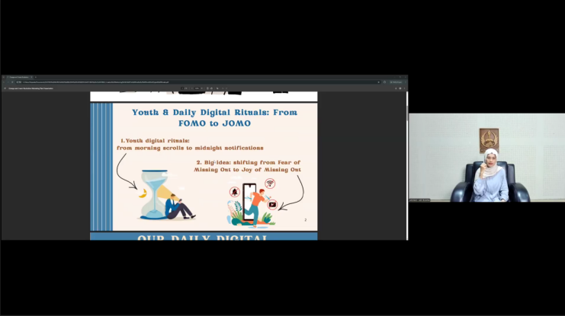

Youth representatives from Universitas Sebelas April, Indonesia, used the local environmental group Pandawara as a case study to illustrate how young people can transform platform trends into social action. Through 30–60 second “clean-up comparison” videos, ironic storytelling, and documentation of real actions, the group turned environmental advocacy into a large-scale movement—cleaning over 200 rivers and beaches, mobilizing thousands of volunteers, and removing hundreds of tons of waste. The case demonstrated that creative marketing characterized by short videos, compelling narratives, and clear calls to action can not only attract attention but also drive offline participation and behavioral change. Their sharing went beyond traditional marketing examples, showing that creative marketing can empower youth to become problem-solvers in society, adding a socially responsible dimension to influence-driven campaigns.
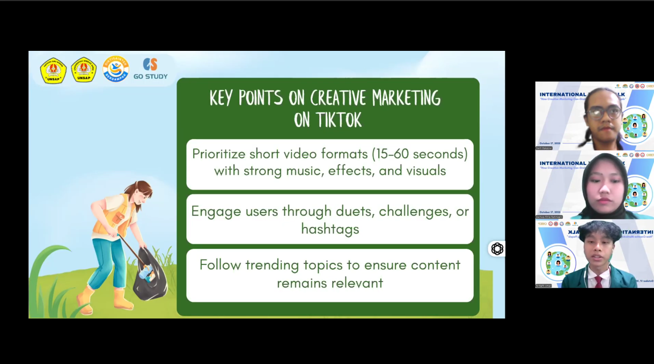

Youth representatives from Rizal Technological University, Philippines, focused on the core of creative marketing—innovation, emotion, and authenticity. They highlighted that, given the eight-second attention span of young audiences, brands need to leverage short videos, authentic influencers, and culturally resonant content for effective engagement—for example, using trending expressions and local humor on platforms like TikTok instead of polished traditional ads. They emphasized that impactful creative marketing transforms a brand into a cultural movement that resonates and builds genuine connections. This insight addresses current marketing challenges, showing that in the digital environment, authentic cultural resonance has far greater impact on young audiences than refined advertising, providing key guidelines for effectively reaching youth.
