Inaugural China–ASEAN Belt and Road Mechanical and Electrical Industry–Education Alliance Conference
Theme: Advancing High-Quality Collaboration among Government, Education Institutions, and Industry
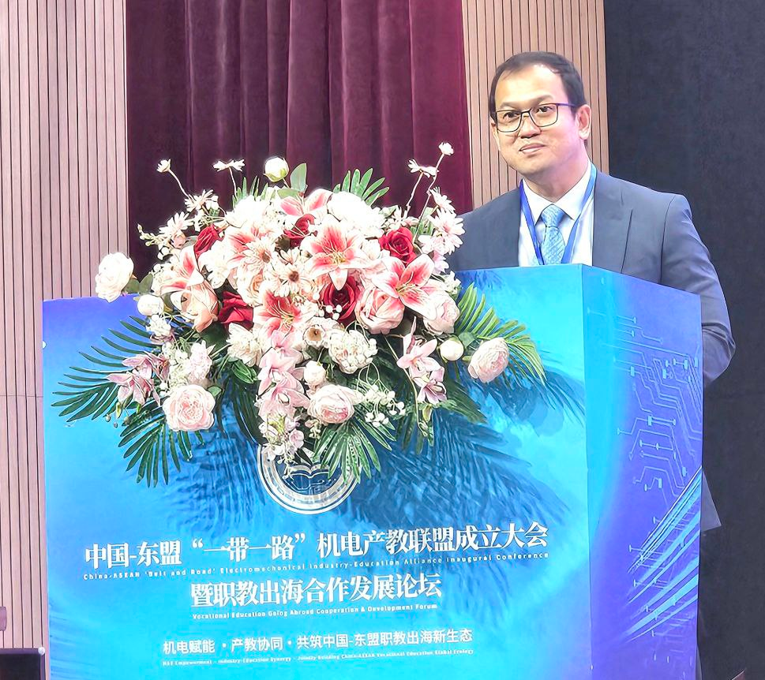
(Dr. Ai Delivering His Remarks)
Dr. Songheang Ai, Director of SEAMEO TED, attended the Inaugural Conference of the China–ASEAN Belt and Road Mechanical and Electrical Industry–Education Alliance and the Forum on International Cooperation in Vocational Education and Industry–Education Integration, held on 15 December in Guangzhou, China. The event brought together representatives from vocational institutions, industry organizations, and enterprises from China and ASEAN Member States to engage in in-depth discussions on the internationalization of vocational education, industry–education integration, and support for regional industrial development.
Dr. Ai was accompanied by Ms. Chantola Cheng, Head of Administration, Planning and Finance Division of SEAMEO TED; Ms. Heng Naline, Deputy Director of the Department of Education, Youth and Sports of Tboung Khmum Province, Cambodia; and Dr. Harth Bunhe, President of Kampong Speu Institute of Technology, Cambodia.
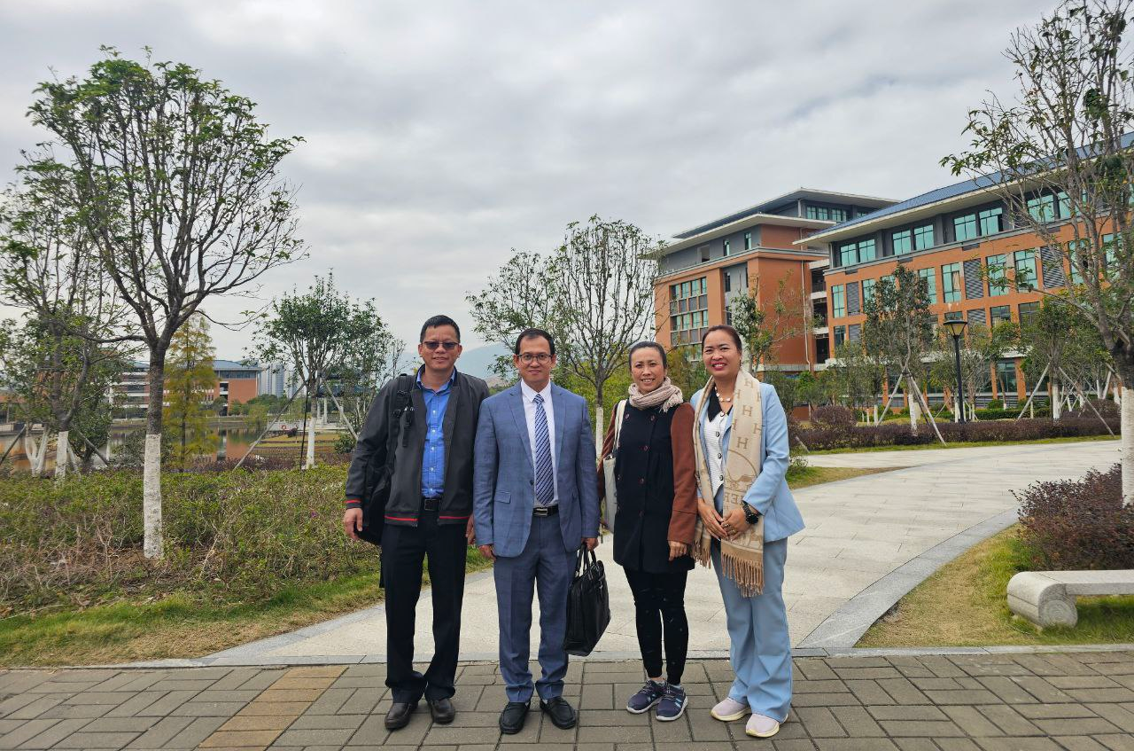
(Cambodian Delegation)
In his address, Dr. Ai emphasized that SEAMEO TED consistently promotes school–enterprise collaboration guided by the real needs of industry and works through multi-stakeholder coordination to establish stable and sustainable cooperation mechanisms. He highlighted that the mechanical and electrical sector occupies an important position in China–ASEAN industrial cooperation and represents a key field for advancing international collaboration in technical and vocational education.
During his remarks, Dr. Ai introduced the China–ASEAN Technical Education Cooperation Platform (CATECP), which SEAMEO TED has been continuously promoting, as well as the newly launched China–ASEAN Industry–Education Integration “Core” Initiative. CATECP aims to provide a platform for resource sharing and collaborative engagement among vocational institutions, enterprises, and relevant organizations in China and ASEAN, facilitating cooperation in curriculum and standards co-development, faculty and student exchanges, and internship and employment programs. He noted that SEAMEO TED positions itself as both a practitioner and enabler of regional vocational education cooperation by connecting governments, educational institutions, and industry partners, thereby fostering more effective school–enterprise collaborative talent development and cultivating technical and vocational professionals with international perspectives and strong practical skills to support regional socio-economic development.
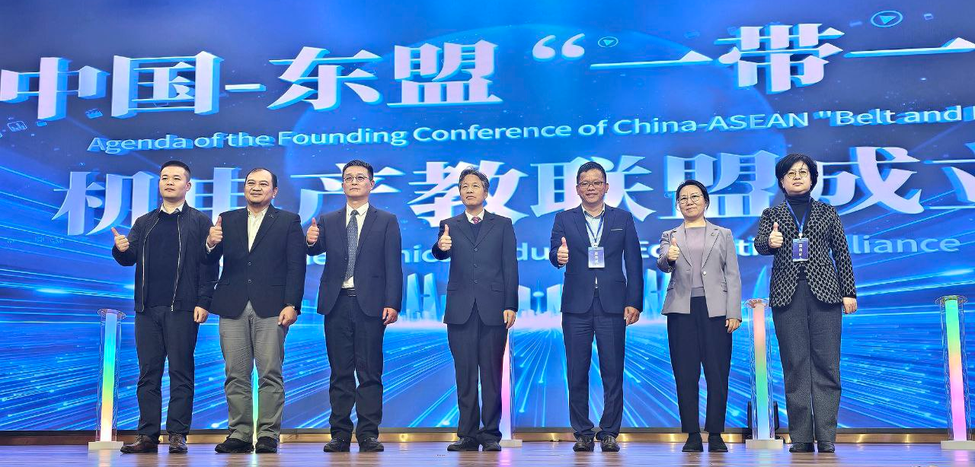

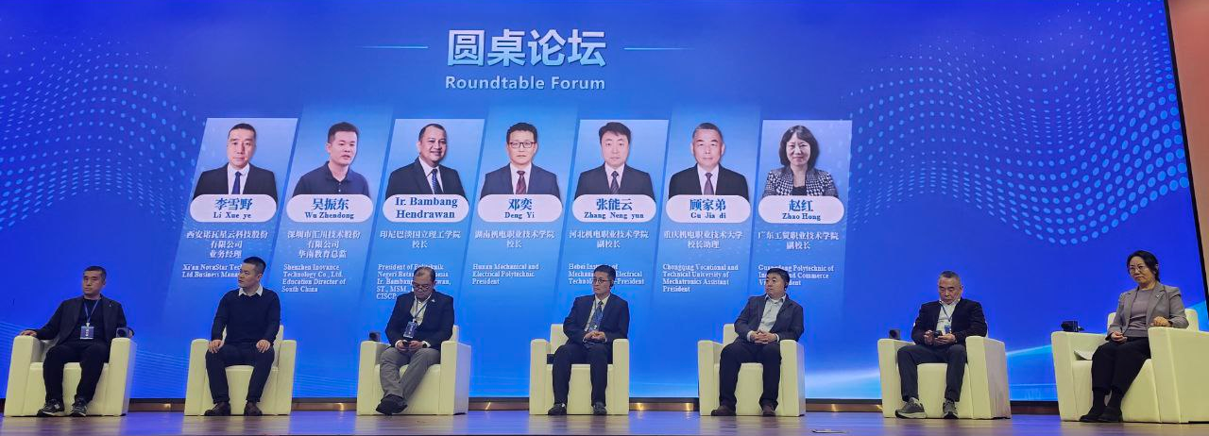
(Roundtable Forum)
During the conference, Dr. Ai also gave an interview to Yangcheng Evening News. He noted that China and ASEAN have a solid foundation for cooperation in vocational education, and that with the continued expansion of Chinese enterprises in ASEAN countries, demand for localized technical and skilled talent has been steadily increasing. Vocational education plays a vital role in linking industrial development with talent cultivation, and further efforts should be made to encourage deeper enterprise participation in collaborative talent development through practical cooperation, promoting positive interaction between workforce development and regional industrial growth.

