International Expert Sharing Forum on
Sustainable Architecture and Green Design
December 12, 2025

On the afternoon of December 12, 2025, the 12th session of the “International Experts Sharing Meeting,” jointly organized by the Southeast Asian Ministers of Education Organization Regional Centre for Technical Education Development (SEAMEO TED), the China-ASEAN Technical Education Cooperation Platform (CATECP), among other partner organizations, was successfully concluded online.

Themed “Sustainable Architecture and Green Design”, the meeting brought together experts and scholars from Malaysia, China, Cambodia, and Brunei Darussalam. Discussions covered digital intelligence, sustainable development and approaches, smart-city concepts, the role of architecture and design, environmental sustainability, and the social–economic impacts of vertical greening in advancing green residential building, explored through keynote speeches, case studies, and interactive exchanges.
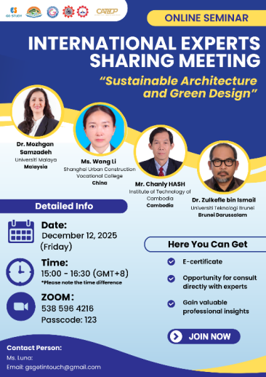

【Opening Remarks】
The opening remarks were delivered by Mr. Mara Pho, Head of Technical Education and Training Division of SEAMEO TED. Mr. Mara Pho opened the event by welcoming all participants and emphasizing the growing importance of sustainable architecture and green design as environmental pressures intensify. He noted that how we plan and build our cities is now a shared responsibility, requiring thoughtful material use, reduced environmental impact, and designs that support healthier communities. He highlighted the value of collaboration between ASEAN countries and China in advancing education, research, and innovation in sustainability. Mr. Mara Pho encouraged participants to share their insights and explore new approaches together, and he thanked all speakers and participants with the hope that the event would inspire meaningful ideas for a greener future.

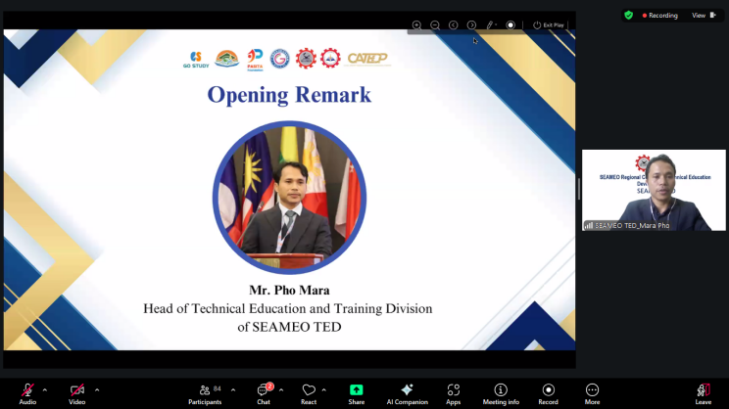

【Sharing Session】
Speaker: Dr. Mozhgan Samzadeh
Lecturer, Department of Building Surveying, Faculty of Built Environment, Universiti Malaya, Malaysia
Topic: Next-Generation Blue Façades: Leveraging Predictive Modeling for Sustainable VRWH in High-Rise Architecture
Dr. Mozhgan explained that Malaysia’s water crisis, intensified by climate change and rising urban demand, requires new strategies beyond conventional rooftop rainwater harvesting, especially for high-rise buildings. She highlighted building façades as a major untapped catchment area, since wind-driven rain frequently hits vertical surfaces. Her work produced the first full-year in-situ dataset of WDR in a tropical climate, capturing 93 rain events and identifying clear seasonal patterns. Dr. Mozhgan stated that ISO and ASHRAE are predictive models to improve accuracy across different façade heights and seasons, activating more reliable estimates of harvestable rainwater. Dr. Mozhgan concluded that vertical rainwater harvesting systems can cut potable water consumption, reduce urban runoff, and support long-term water sustainability in tall buildings, offering a scalable solution for other tropical cities that face the same challenge.
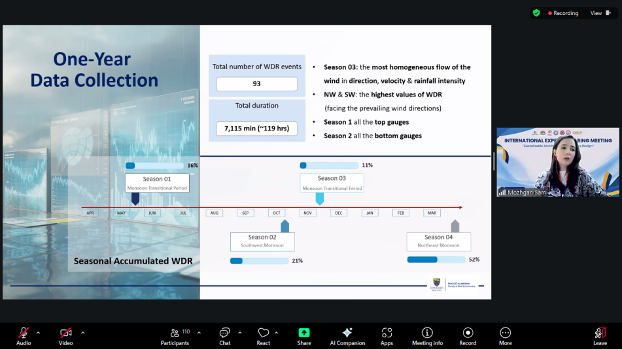

Speaker: Ms. Wang Li
Faculty Member, Shanghai Urban Construction Vocational College, China
Topic: The Ecological Value and Technological Innovation of Vertical Greening
Ms. Wang Li explained that vertical greening helps cities reclaim lost green space by improving air quality, lowering temperatures, and enhancing urban biodiversity. She also described four system types, which are modular, pocket, pot-based, and climbing. She mentioned that each offers different flexibility for buildings and public spaces. Plant selection must consider root depth, drought tolerance, wall orientation, and seasonal variation. Ms. Wang Li added that key technologies include load calculations, structural reinforcement, efficient irrigation systems, and proper substrate and drainage. Maintenance focuses on pruning, pest control, and replacing unhealthy plants. Lastly, she concluded that vertical greening would advance through ecological design, multifunctional integration with rooftop gardens, and smart technology, positioning it as a core strategy for sustainable and resilient cities.
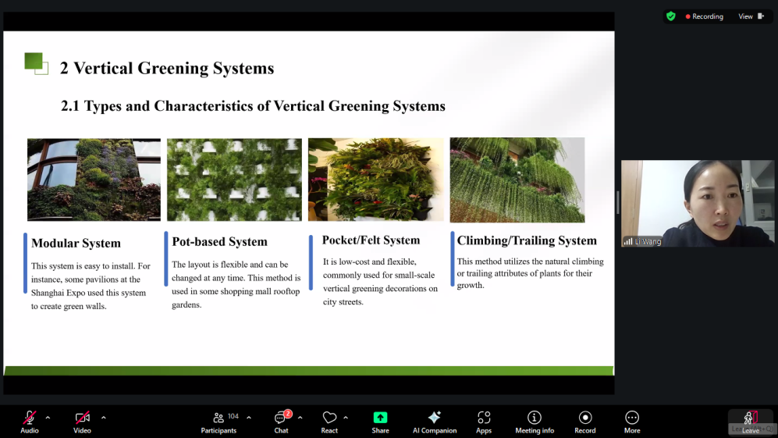、

Speaker: Mr. Chanly HASH
Head of Department, Department of Architectural Engineering, Institute of Technology of Cambodia, Cambodia.
Topic: Sustainable and Smart Phnom Penh
Mr. Chanly stated that Phnom Penh’s push toward becoming a sustainable and smart city is driven by rapid urbanization. He explained the pillars of sustainable development and smart-city systems, emphasizing the role of technology, data, and IoT in improving services and quality of life.

Mr. Chanly mentioned that key priorities include renewable energy, green buildings, smart waste and water systems, inclusive housing, digital governance, and a growing green economy. He highlighted the 2020–2035 Strategic Road Map and stressed that architecture and design—through sustainable, passive, and green approaches that are central to this transformation. He concluded that smart cities “think” and sustainable cities “feel,” both essential for Phnom Penh’s future.

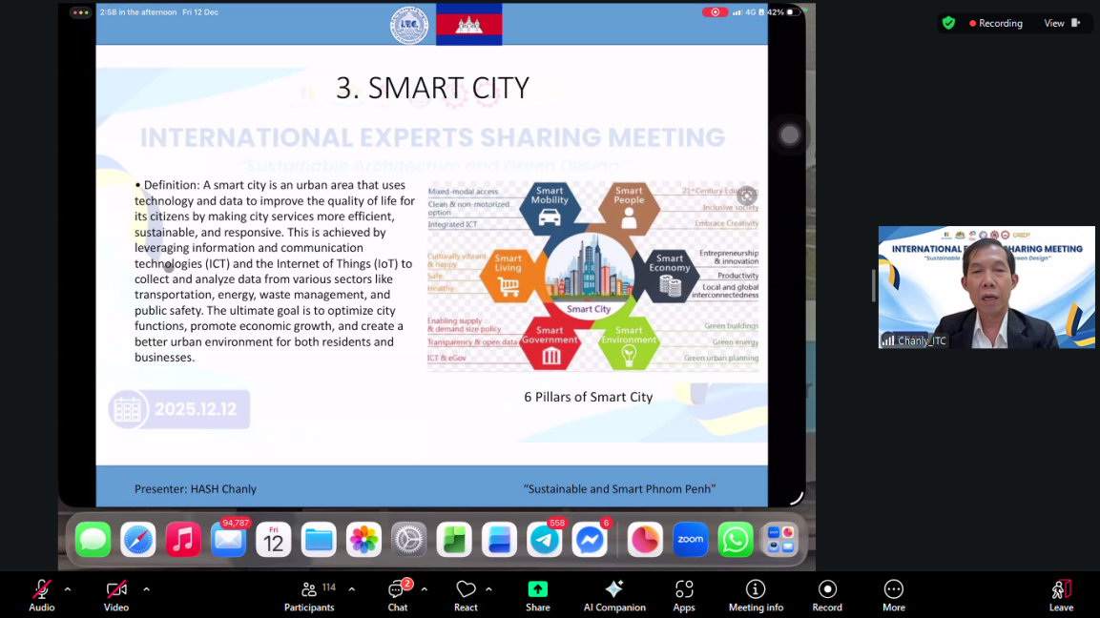

Speaker: Dr. Zulkefle Bin Ismail
Assistant Professor, School of Design, Universiti Teknologi Brunei, Brunei Darussalam
Topic: Sustainable Vision Towards Green Design for Residential Buildings
Dr. Zulkefle explained that sustainable architecture aims to minimize environmental impact while improving comfort and efficiency throughout a building’s lifecycle. He emphasized the need for sustainable housing that is open, adaptable, and upgradeable which aligned with SDG 11. He also mentioned key components that include strong energy performance through passive design, efficient material use, and reducing both embodied and operational carbon emissions.

Dr. Zulkefle highlighted the importance of life-cycle assessment and global green building standards such as LEED, BREEAM, and ASEAN codes. Green design transformations were grouped into adaptability and reconfigurability, supported by systems like Skeleton-Infill structures and adaptable architectural programming. He concluded that merging technology with adaptable housing design is critical and potential for achieving greener residential environments.

