13th ASEAN Connectivity Forum
10 December 2025

Seoul: on 10 December 2025, Dr. Songheang Ai, director of SEAMEO TED, participated in the 13th ASEAN Connectivity Forum that has been organized by ASEAN-Korea Center for purposes to support ASEAN’s connectivity efforts and promote Korea’s engagement in ASEAN connectivity priority projects and to prospect a way forward for ASEAN connectivity in partnership between ASEAN and Korea for greater synergy.
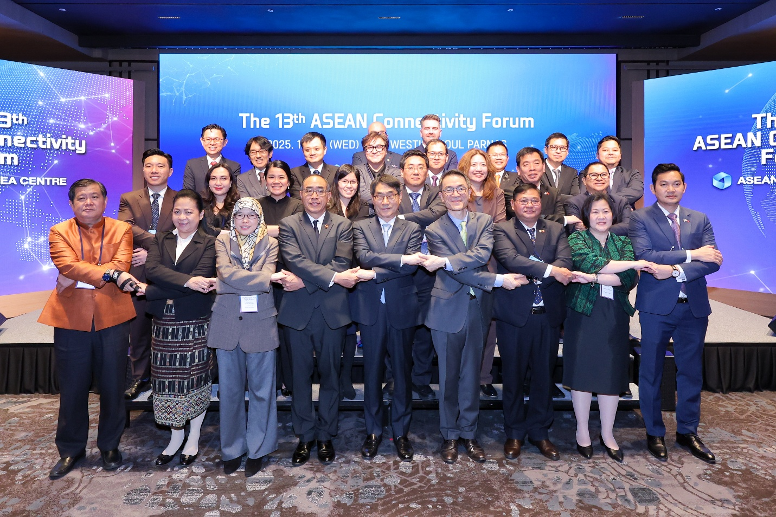
(Group Photo of all Speakers and Guests of Honors)
The forum has three sessions consisting of (1) Connecting the Connectivity: Driving Regional Connectivity through Indo-Pacific Cooperative Partnership; (2) From Policy to Practice: Building Resilient and People-Centered ASEAN through Reconfiguration of Supply Chains and Coordination of Cross-Sectoral Ecosystem; and (3) From Digitalization to Environment Sustainability: Shaping Innovative and Dynamic Future through the Twin Transitions.
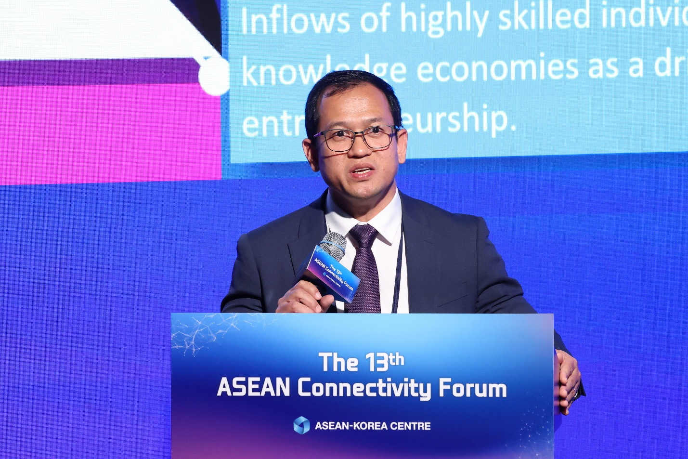
(Dr. Ai Delivering his Presentation)
During the forum, Dr. Songheang Ai, delivered his presentation on Labor and Talent Mobility: The Human Elements: Fostering Greater People Mobility in Session 2. He focused on four points: Labor and Talent Mobility, Intra-ASEAN Mobility for Labor and Talent, Korea and ASEAN Connectivity for Labor and Talent, and Policy Direction.
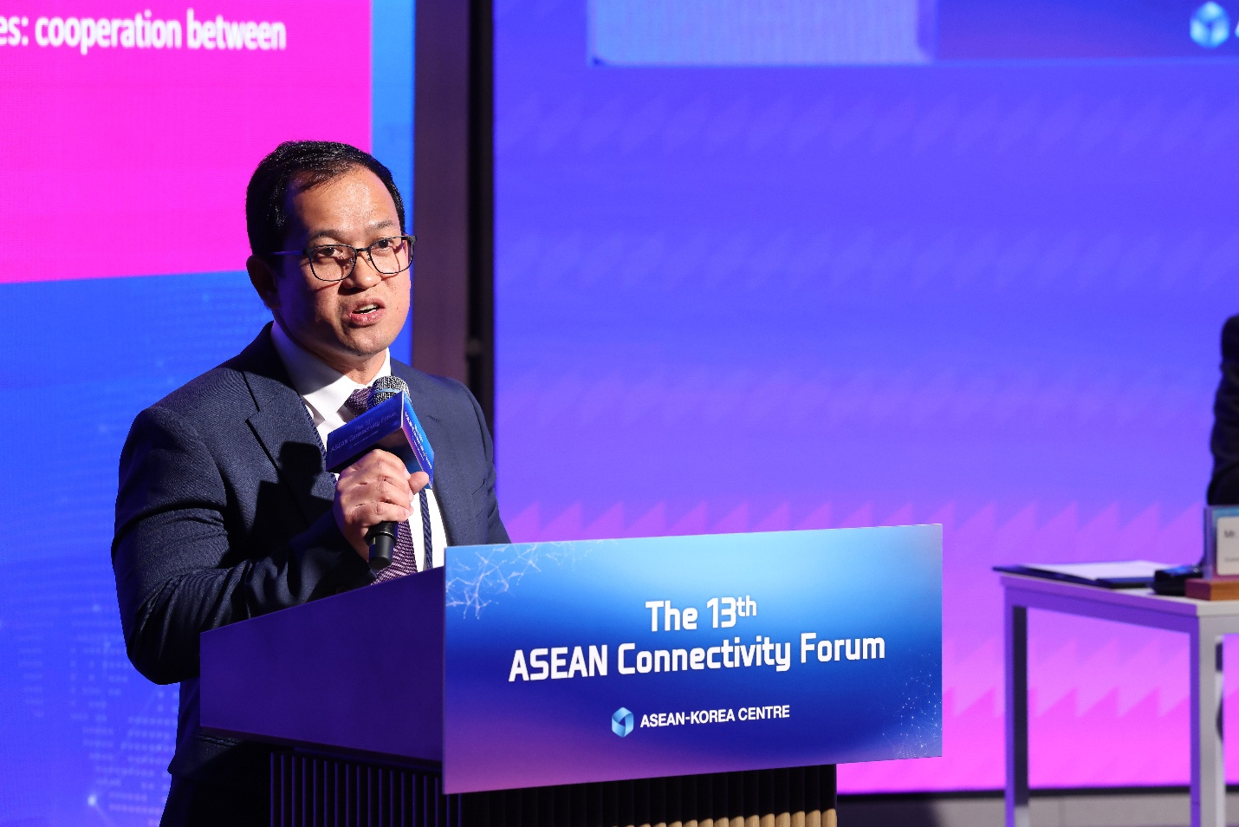
(Dr. Ai Explaining His Topic)

