MoU Signing between Korea Association of Secondary Vocational Education (KASVE) and Southeast Asian Ministers of Education Organization Regional Centre for Technical Education Development (SEAMEO TED)

Seoul: On December 09, 2025, in Seoul City, South Korea, Dr. Songheang Ai, director of SEAMEO TED and Mr. Chongkwan Kim, chairman of KASVE has signed memorandum of Understanding (MoU) to share and cooperate on development plans in the field of vocational education and training (VET) through a strategic partnership.
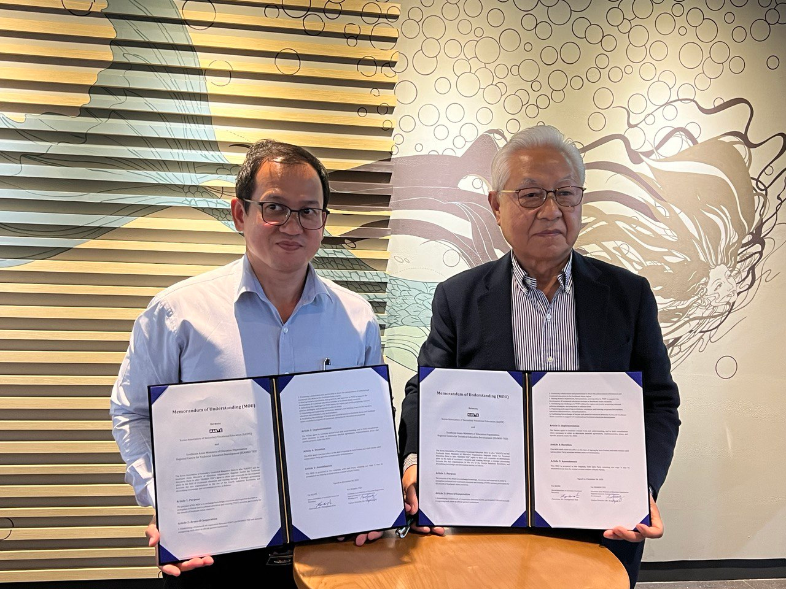
(Dr. Ai and Mr. Kim with MoU)

The purpose of the MoU is to exchange knowledge, resources, and expertise in order to strengthen technical and vocational education and training (TVET) system, particularly for the benefit of both sides.
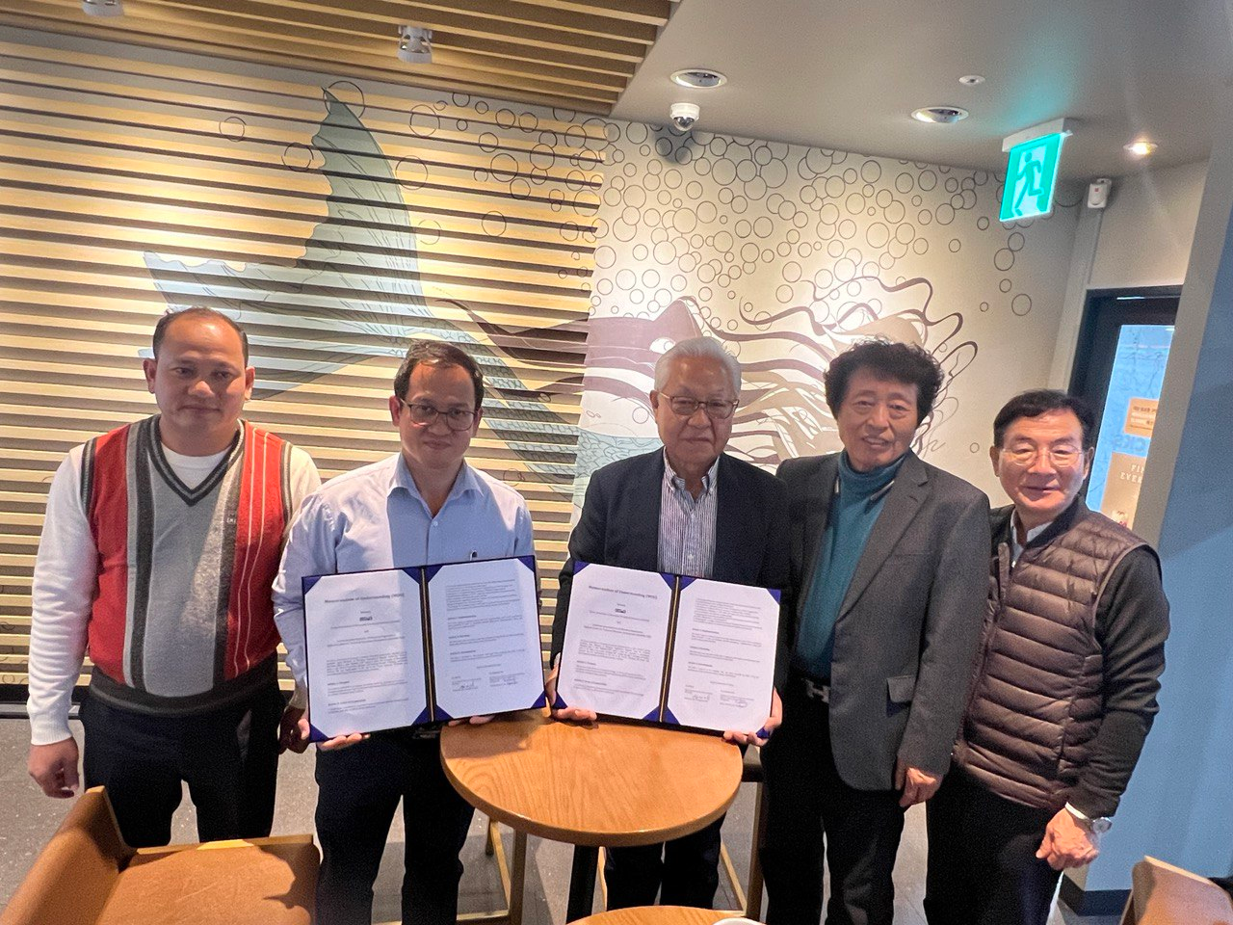
(Group Photo of Both Sides)
MoU focuses on some areas of cooperation consisting of (1) establishing a framework of cooperation between KSAVE and SEAMEO TED; (2) promoting collaboration and partnership to foster the advancement of technical and vocational education in the Southeast Asian region; (3) sharing Korea’s experiences, best practices, and expertise in TVET to support the development of vocational education systems in Southeast Asian countries; (4) identifying key challenges in TVET within the region and jointly proposing relevant policies, strategies, and programs to address them; (5) organizing and supporting workshops, seminars, and training programs for teachers, education administrators, and policy makers; and (6) facilitating the exchange of human and material resources between Korea and Southeast Asian countries in support of vocational and technical education development.
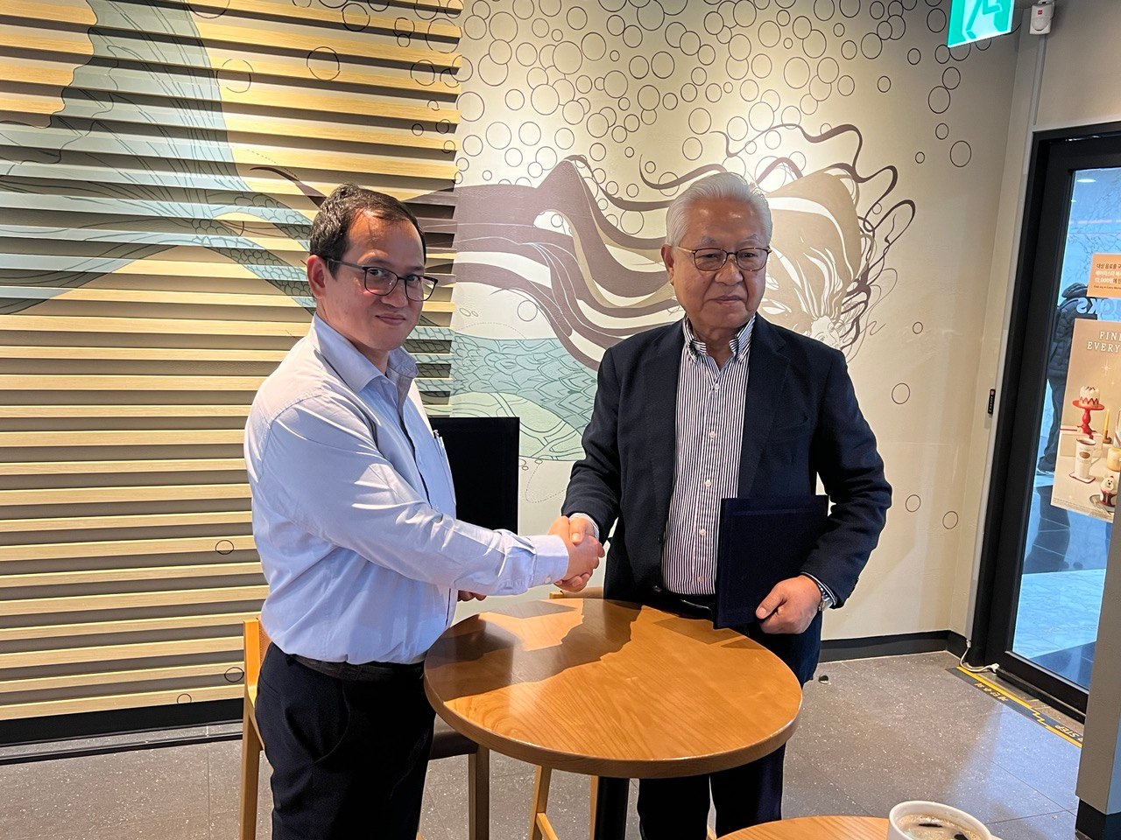
(Hand Shaking between Dr. Ai and Mr. Kim)

Both sides promised to work closely and cooperatively to realize MoU into reality coming out with some activities.

