International Youth Talk | Sustainable Architecture: How We Can Protect the Environment with Buildings
26 December 2025

On December 26, 2025, the 11th session of the “International Youth Talk,” jointly organized by the Southeast Asian Ministers of Education Organization Regional Centre for Technical Education Development (SEAMEO TED), the China-ASEAN Technical Education Cooperation Platform (CATECP), with support from PASITA, was successfully concluded online, with 77 participants from the around the world.
The events featured online presentations by youth representatives from universities across multiple countries including Indonesia, Vietnam, and the Philippines. Centered around the theme of “Sustainable Architecture: How We Can Protect the Environment with Buildings”, the youth showcased fresh perspectives with a global vision, sparking creative and cross-cultural exchanges.
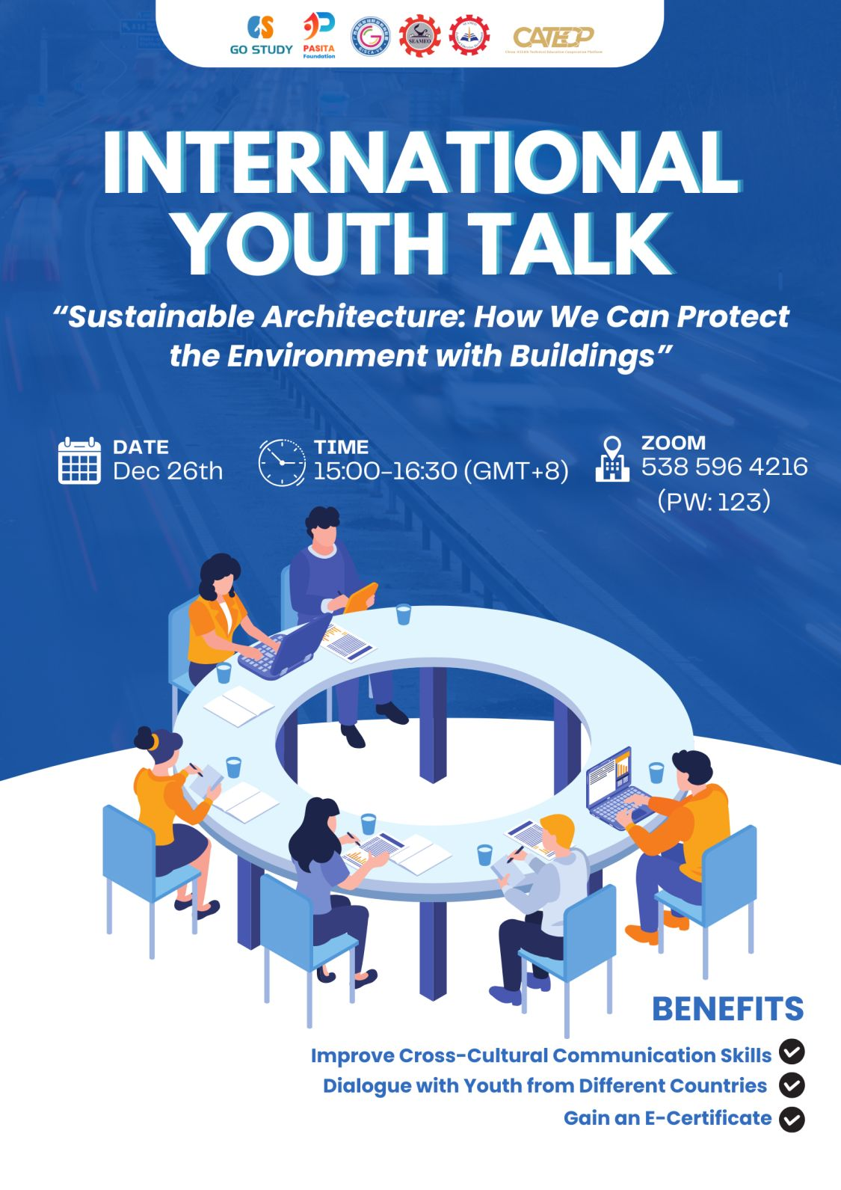
Opening Remarks
The opening remarks were given by Mr. Tim Vorn, Head of the Research and Development Division of SEAMEO TED. He emphasized three key aspects for youth: adopting eco-friendly materials and evaluating carbon footprints, adapting architectural designs to regional climates and resources, and mastering emerging technical skills such as robotics and energy modeling. He encouraged participants to use these insights to prepare for future careers in sustainable architecture and officially declared the session open.
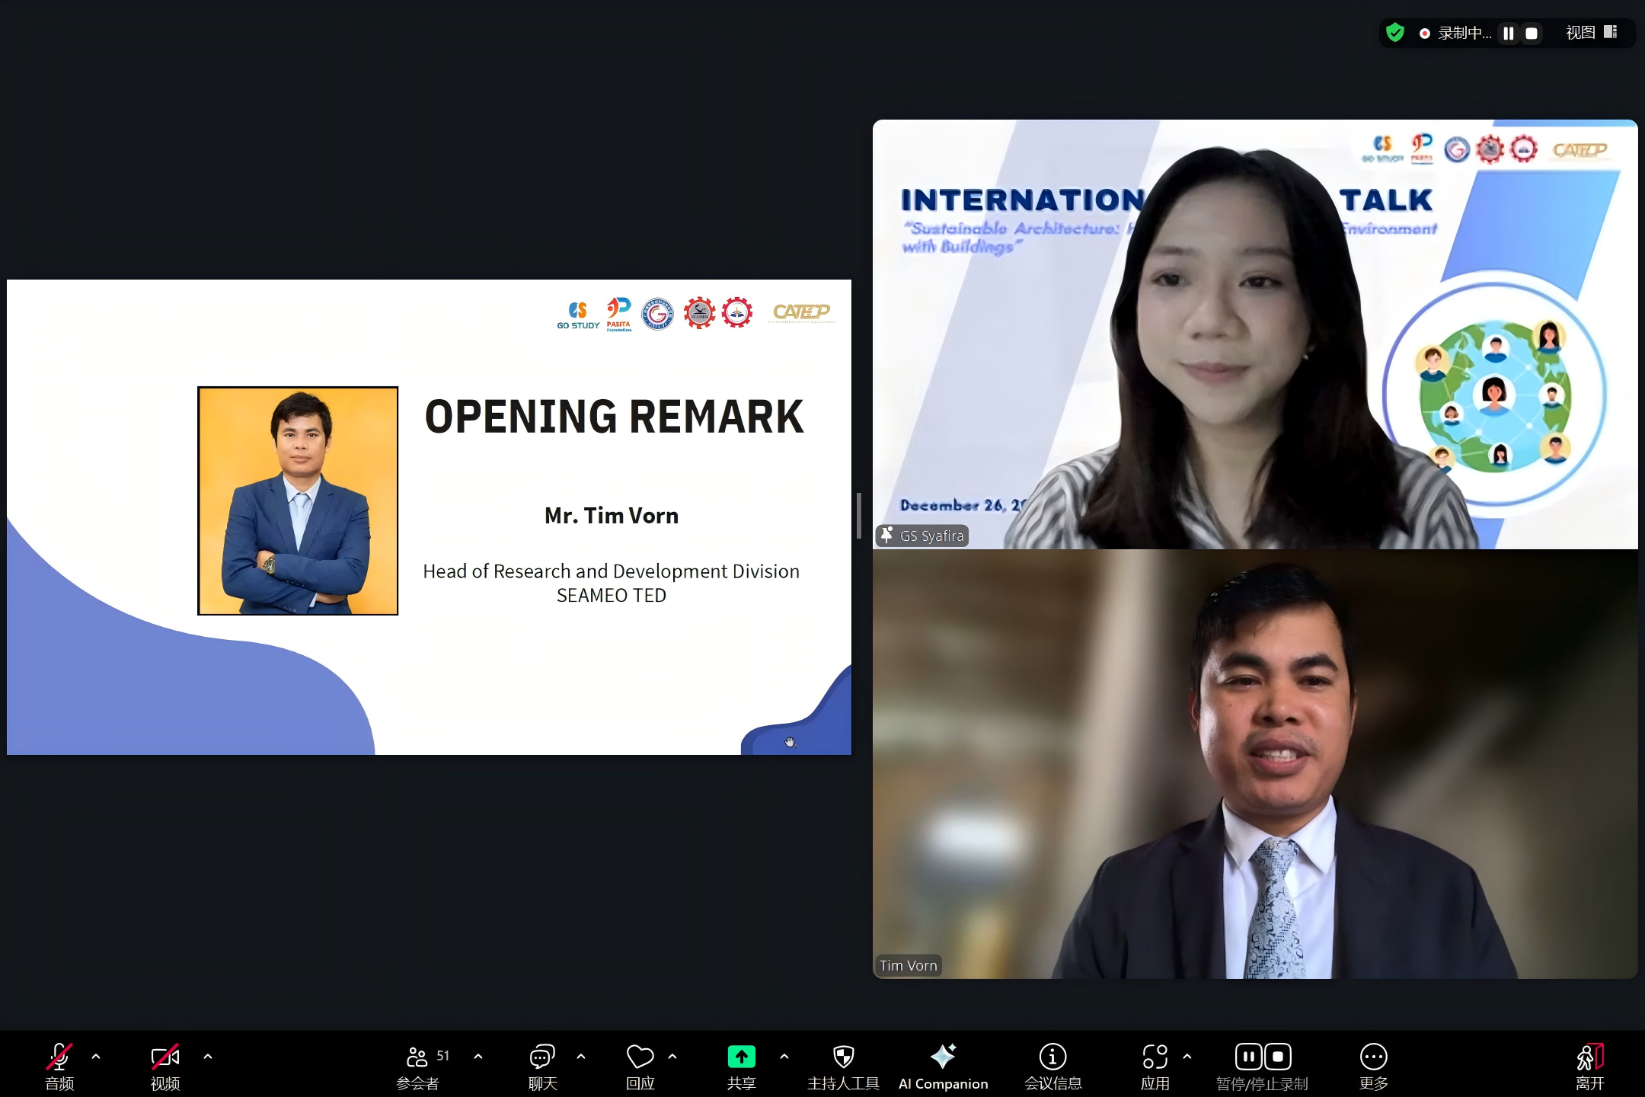

Presentation Highlights
Team 1 representatives from Universitas International Batam（UIB） presented youth-led perspectives on Ecological Architecture as an Integrated System for Environmental Protection, focusing on the benefits and implications of ecological architecture for the environment. The students emphasized architecture as an integrated system that should coexist harmoniously with nature rather than dominate it. Their discussion highlighted key issues such as environmental protection, human well-being, and the growing responsibility of architects to respond to climate and ecological challenges. The presentation clearly underlined the importance of thoughtful planning, responsible material selection, and sustainable building management as practical strategies to reduce environmental impact and support long-term sustainability.
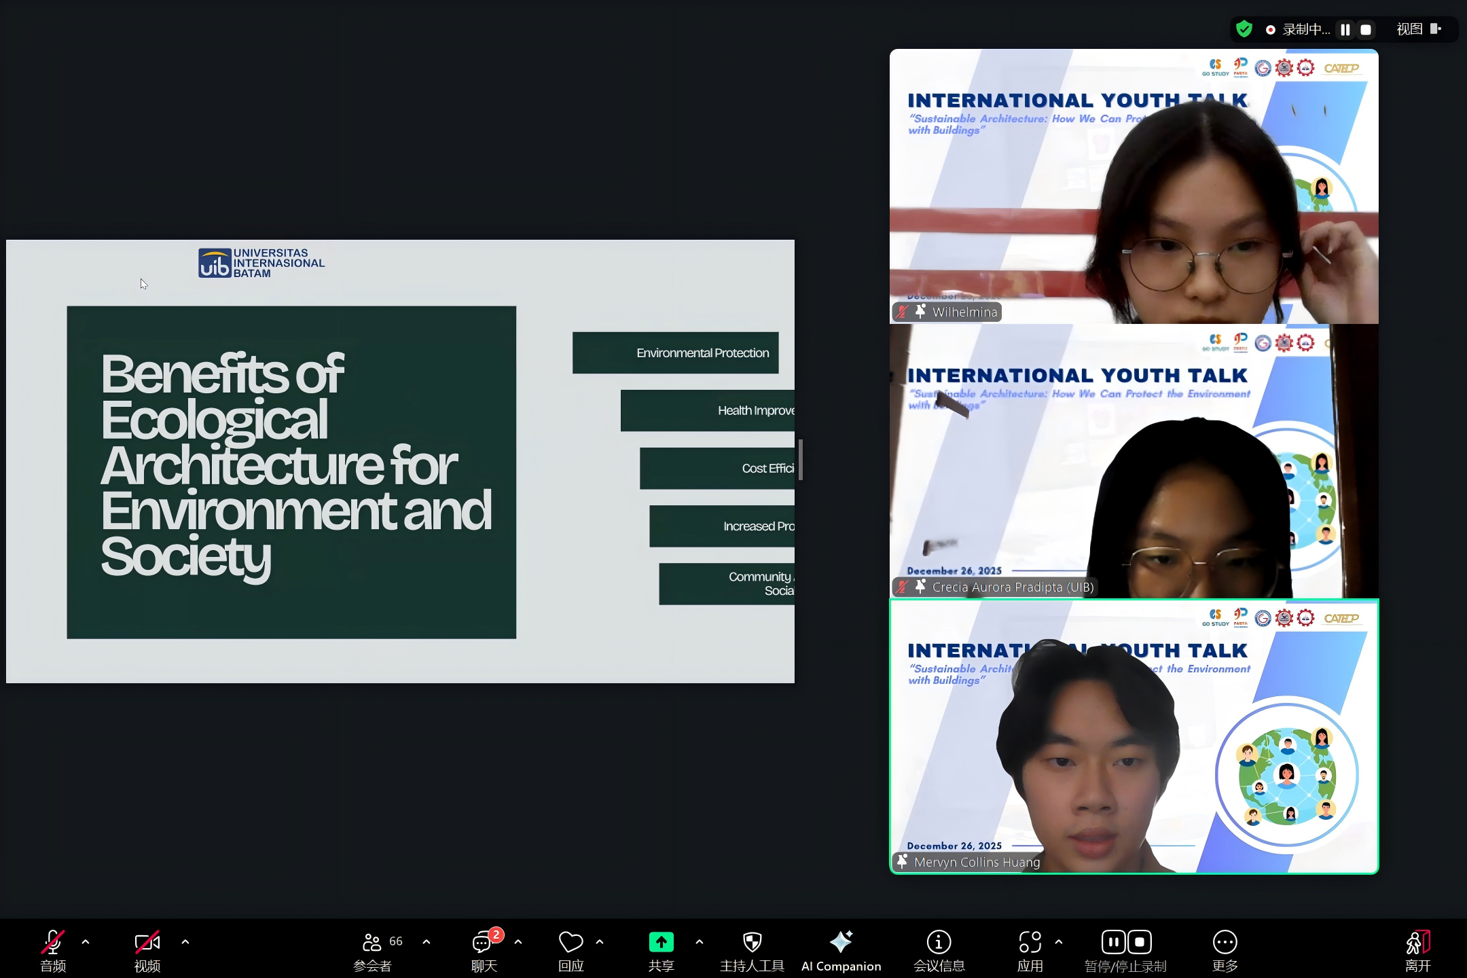
Team 2 representatives from UIB focused on Practical Green Design Strategies for Sustainable Urban Buildings, effectively translating sustainability concepts into tangible design solutions, including solar energy integration, green roof systems, vertical gardens, natural ventilation, and rainwater harvesting. Their presentation highlighted how these strategies not only reduce energy consumption and environmental impact but also improve building performance and user comfort. By showcasing real-world case examples, they demonstrated that sustainable design is achievable and adaptable, particularly in dense urban contexts. The presentation offered valuable insights into how green design principles can be realistically implemented and scaled to support environmentally responsible urban development.
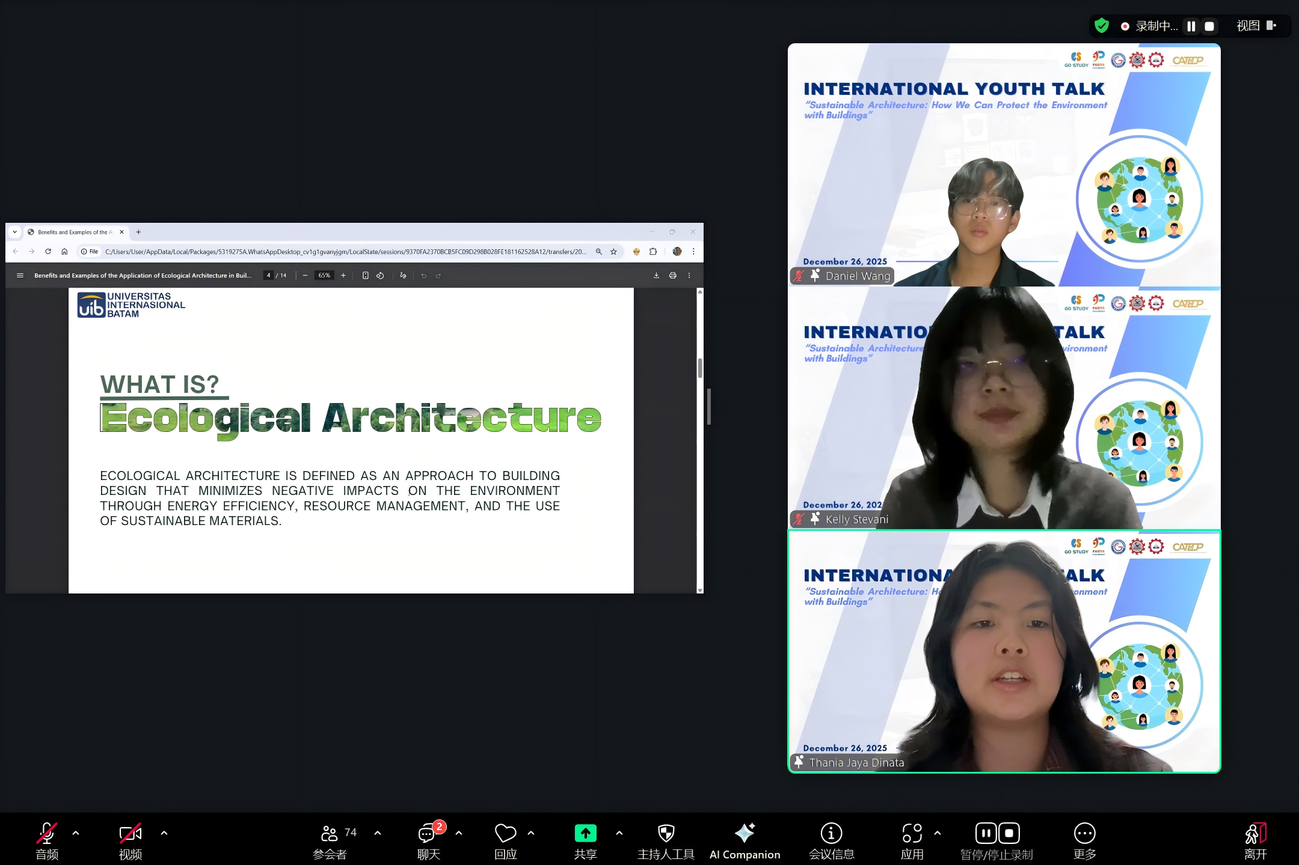
The speakers from UPN Veteran Jawa Timur introduced “The Agile Modular Pavilion” as an innovative response to urban density and environmental waste, under the theme of Modular and Circular Architecture for Adaptive Urban Public Spaces. The project addressed issues of urban rigidity by proposing a flexible, modular pavilion system designed for circular cities. The presentation highlighted how the use of standardized modular units enables reconfiguration, relocation, and reuse, significantly reducing construction waste and avoiding demolition. The team emphasized principles such as Design for Disassembly, material recovery, and energy independence through solar integration. By positioning architecture as adaptable infrastructure rather than permanent objects, the presentation strongly reflected the event’s theme of environmental protection through sustainable and resource-efficient building design.
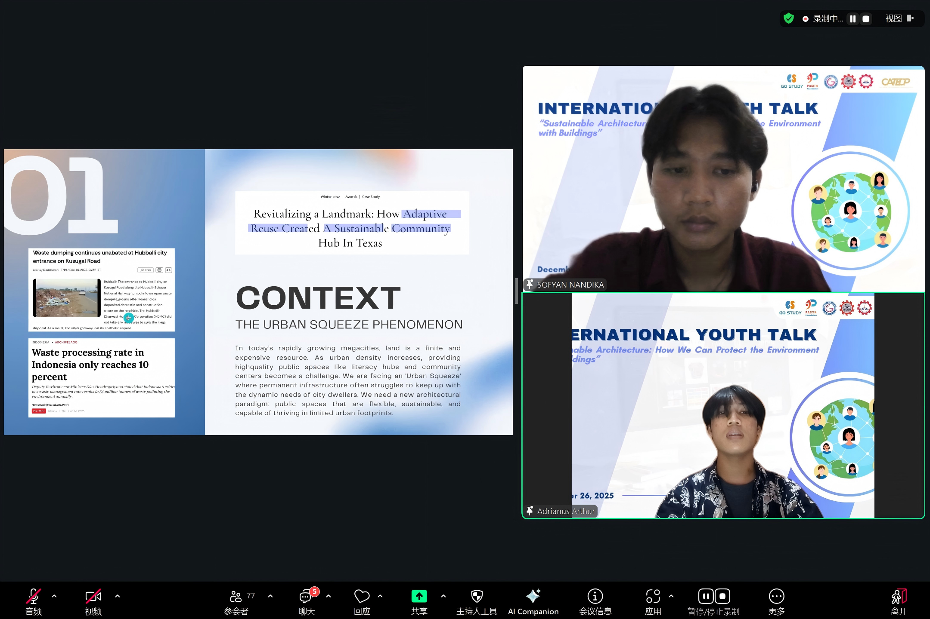
The students from Ho Chi Minh University of Technology (HUTECH), under the theme of Community-Based Modular Housing for Environmental and Social Resilience, introduced the project “Small Lots – Big Impacts,” which addressed environmental degradation and housing challenges in flood-prone riverbank areas. The project highlighted how architectural design can respond to both environmental and social issues simultaneously. The proposal utilized modular construction systems combined with recycled plastic materials, offering an innovative approach to reducing waste while improving living conditions for vulnerable communities. The presentation emphasized flexibility, scalability, and community-oriented design, allowing small housing modules to adapt to changing environmental conditions such as flooding. By transforming environmental problems into architectural solutions, the HUTECH team demonstrated how sustainable architecture can play a critical role in environmental protection and social resilience.
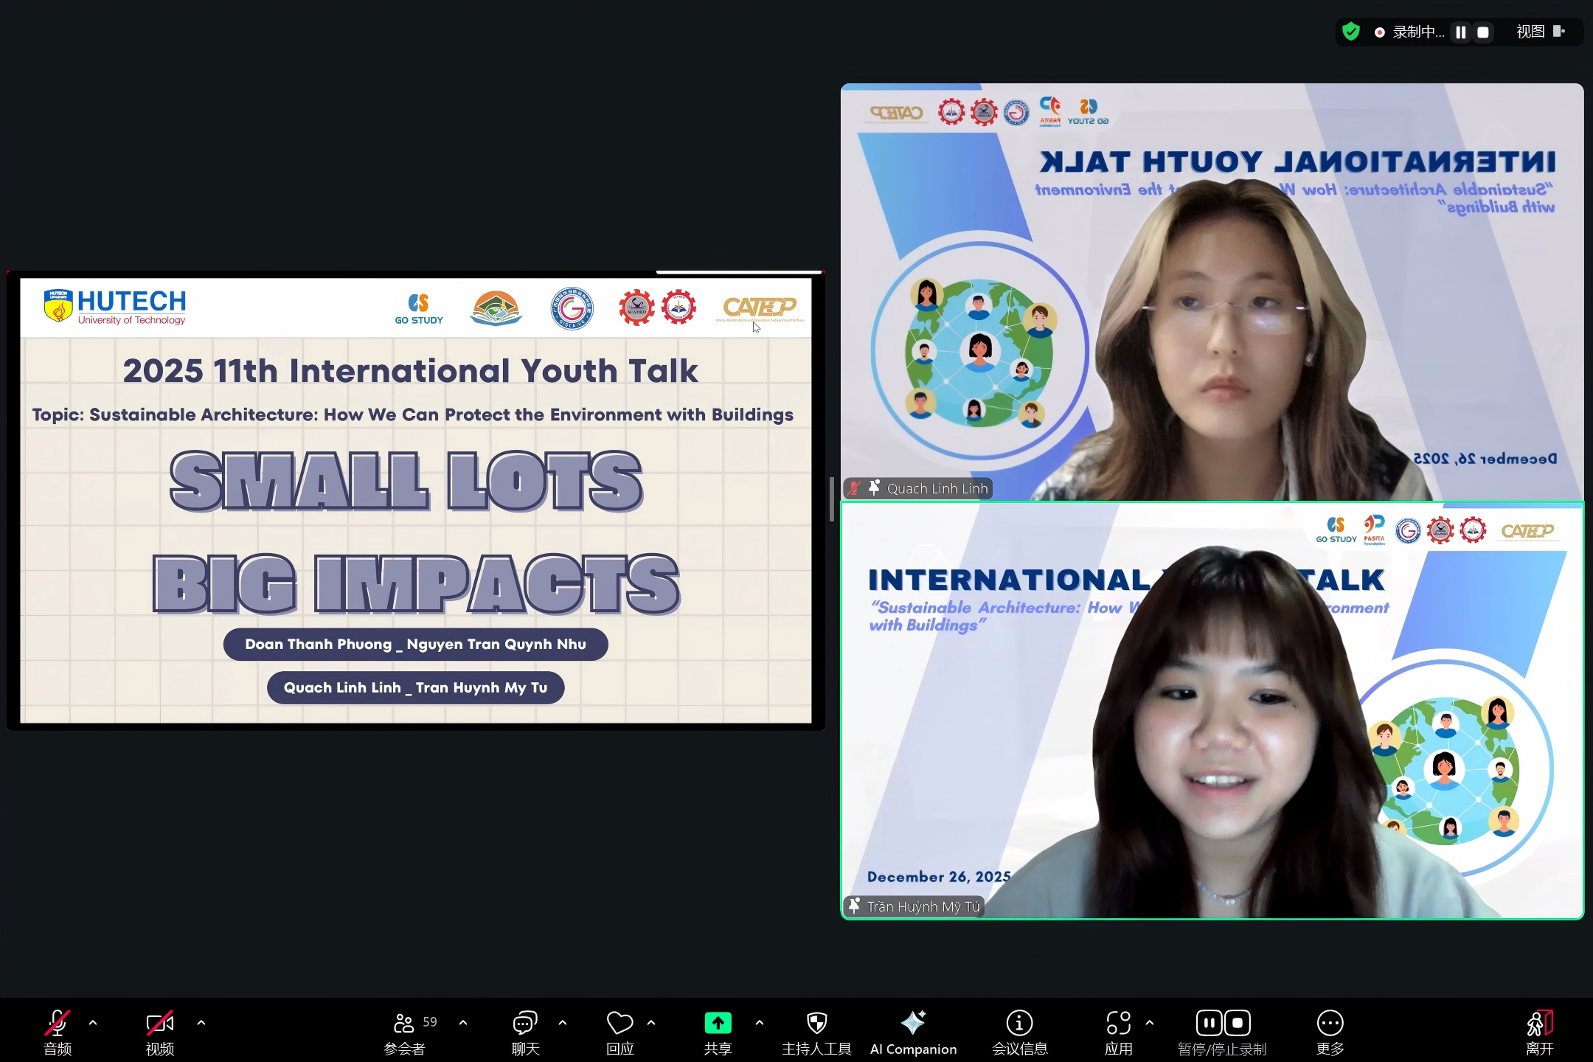
The speakers from Capiz State University presented a compelling discussion on sustainable architecture as a response to climate vulnerability, particularly within the Philippine context, under the theme of Climate-Responsive Architecture and Youth Advocacy for Sustainability. The presentation clearly illustrated how architectural design can contribute to environmental protection while enhancing community resilience. The team emphasized the importance of passive design strategies, including natural ventilation, daylight optimization, and climate-responsive building orientation, as effective approaches to reducing energy consumption. They also highlighted the use of indigenous and locally sourced materials as a way to lower embodied carbon and strengthen cultural identity. In addition, the presentation underlined the role of net-zero buildings and youth advocacy in promoting environmentally responsible architecture, reinforcing the importance of education and awareness in shaping a sustainable future.

