Report
International Expert Sharing Meeting on
“Digital Storytelling and Cross-Cultural Communication”
16 January 2026 (Online)
On the afternoon of January 16, 2026, the 12th session of the International Experts Sharing Meeting, jointly organized by the China-ASEAN Technical Education Cooperation Platform (CATECP), the Southeast Asian Ministers of Education Organization Regional Centre for Technical Education Development (SEAMEO TED), and Go Study Global Education, was successfully concluded online with 150 participants from around the world.
Themed “Digital Storytelling and Cross-Cultural Communication,” the meeting brought together experts and scholars from China, Thailand, the Philippines, and Indonesia. Discussions focused on digital storytelling, artificial intelligence in education, cross-cultural communication, student engagement, and innovative teaching practices, explored through keynote presentations, case sharing, and interactive exchanges.
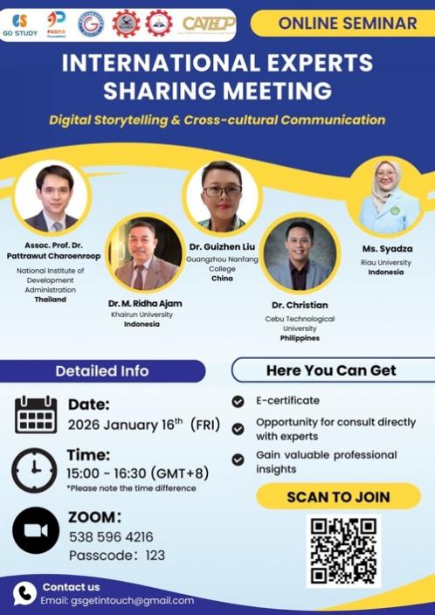

【Opening Remarks】
The opening remarks were delivered by Mr. Ravy Voeun, Vice Head of the Research and Development Division of SEAMEO TED. In his remarks, he emphasized that the rapid advancement of digital technology and artificial intelligence is reshaping education systems and teaching practices across the region, requiring educators and institutions to continuously adapt and innovate.
He further highlighted the importance of regional cooperation and knowledge sharing in responding to these changes. Mr. Voeun encouraged participants to actively engage in the session, exchange experiences, and explore innovative approaches that can support sustainable educational development and capacity building within the region.
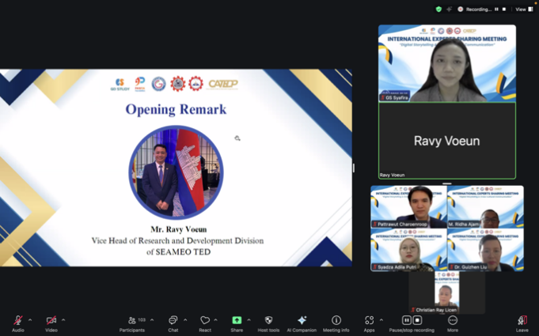

【Sharing Session】

Speaker: Assoc. Prof. Dr. Pattrawut Charoenroop
National Institute of Development Administration, Thailand
Topic: Speaking Across Cultures Through Digital Storytelling
Dr. Pattrawut Charoenroop presented digital storytelling as an effective teaching method for developing cross-cultural communication skills. By combining narrative structures with multimedia elements such as images, audio, and video, digital storytelling helps learners express ideas in more engaging and meaningful ways. He noted that storytelling has always played a vital role in education, and digital tools further enhance its potential by fostering creativity, self-expression, and active learner participation. Incorporating cultural themes into storytelling activities enables students to reflect on their own identities while gaining awareness of diverse cultural perspectives.
Furthermore, Dr. Charoenroop emphasized that digital storytelling supports language development, critical thinking, and audience awareness, as students learn to structure ideas clearly and consider cultural contexts in communication. The presentation illustrated how digital storytelling can strengthen people-to-people connections, promote intercultural understanding, and advance educational collaboration and cross-cultural communication across the region.

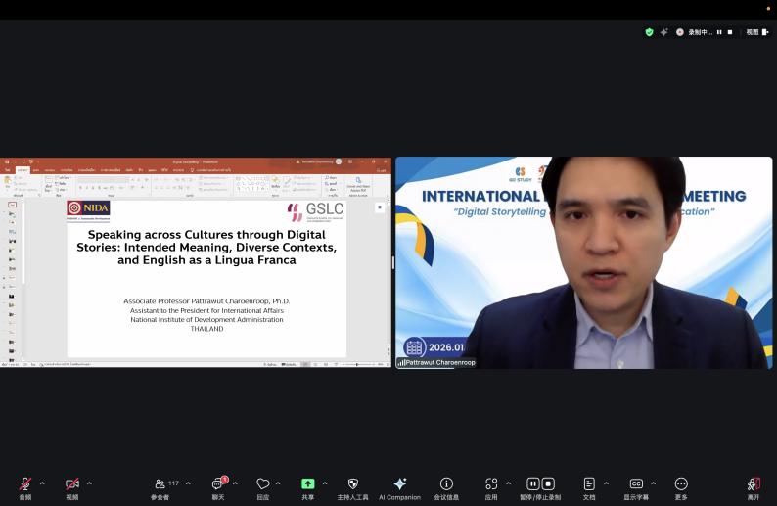

Speaker: Dr. Christian Ray Licen
Cebu Technological University, The Philippines
Topic: Enhancing Student Engagement Through Innovative and Technology-Supported Learning
Dr. Christian Ray Licen highlighted the critical importance of student engagement in achieving effective learning outcomes. He explained that contemporary learners increasingly need interactive and participatory learning environments, particularly in technology-enhanced contexts. His presentation discussed a variety of technology-supported strategies designed to promote active learning, collaboration, and learner autonomy. When used purposefully, digital platforms and interactive tools can transform students from passive recipients of information into active contributors to the learning process.
Dr. Licen further emphasized the role of instructional design, noting that educational technologies should be aligned with clear learning objectives. Educators play a vital role in guiding students to engage meaningfully with digital content rather than simply consuming information.
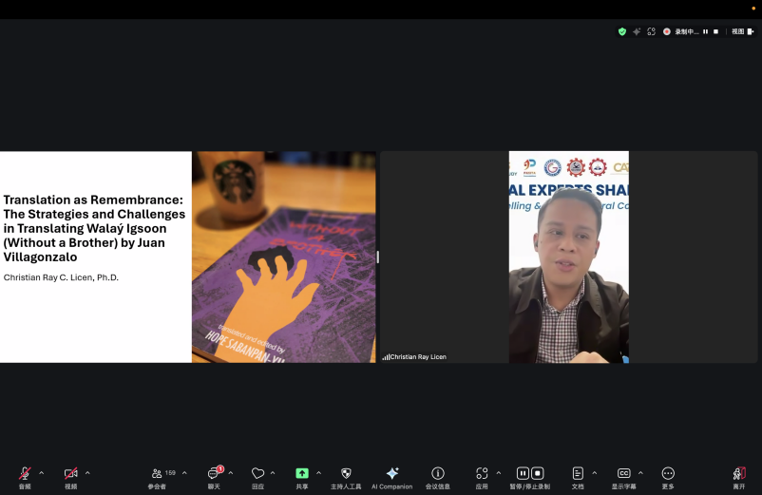

Speaker: Dr. Liu Guizhen
Guangzhou Nanfang College, China
Topic: Artificial Intelligence and Its Application in Modern Education
Dr. Liu Guizhen presented an overview of the growing application of artificial intelligence (AI) in education. She explained how AI technologies are increasingly used for personalized learning, adaptive assessment, and academic support, enabling more data-informed teaching practices. She highlighted that AI-powered systems allow educators to better understand student learning patterns and provide targeted feedback. Such applications help address diverse learning needs and improve learning efficiency.
At the same time, Dr. Liu emphasized the importance of ethical considerations and responsible AI use. She cautioned that technology should support, rather than replace, human judgment, creativity, and critical thinking in education. Her presentation highlighted the role of AI as a strategic tool for advancing educational innovation and digital transformation. Responsible AI integration supports sustainable, inclusive, and future-oriented approaches to education development.
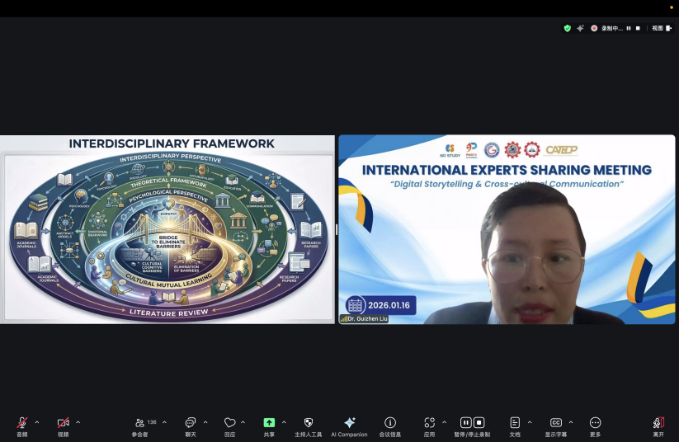

Speaker: Dr. M. Ridha Ajam
Khairun University, Indonesia
Topic: Integrating Digital Innovation into Higher Education Learning Practices
Dr. M. Ridha Ajam shared experiences on integrating digital innovation into higher education teaching and learning. He discussed the growing adoption of blended learning models and digital platforms to enhance flexibility and accessibility. He emphasized that effective digital transformation requires alignment between technology, pedagogy, and institutional readiness. Simply adopting digital tools without clear instructional planning may limit their educational impact.
Dr. Ajam also highlighted the importance of professional development for educators and institutional support mechanisms to ensure sustainable innovation in teaching practices. The sharing illustrated how digital innovation in higher education can strengthen institutional collaboration and capacity building. Such practices contribute to the promotion of quality education and innovation-driven learning across diverse educational contexts.
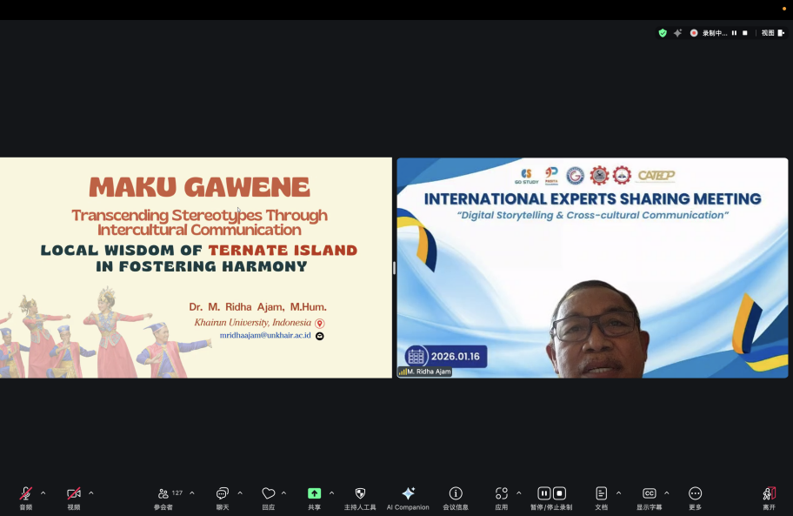

Speaker: Ms. Syadza Adila Putri
Riau University, Indonesia
Topic: AI-Assisted Learning and Student Participation in English Education
Ms. Syadza Adila Putri discussed the increasing use of AI-assisted tools in English language learning. She explained that AI can support students in generating ideas, practicing language skills, and improving learning efficiency. She also addressed challenges related to over-reliance on AI, including surface-level participation and reduced critical engagement. She stressed the importance of guiding students to use AI as a supportive tool rather than a substitute for independent thinking.
Ms. Syadza emphasized that educators must play an active role in fostering responsible AI use while maintaining academic integrity and learner originality. The presentation emphasized the importance of developing ethical and pedagogically sound AI practices in education. Encouraging balanced approaches to AI-assisted learning helps enhance teaching quality while safeguarding core educational values.

