Cheju Halla University Global Unit Attached to SEAMEO TED Officially Launched to Drive Digital Transformation between South Korea and ASEAN

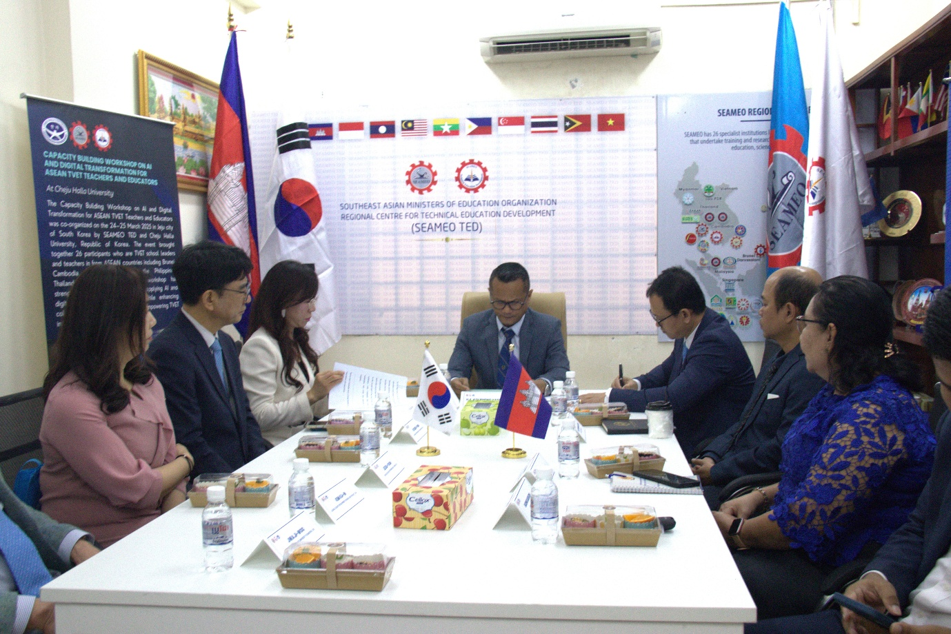
(H.E Dr. Kolpheng Vaddhana Chaired a Meeting)

PHNOM PENH, January 30, 2026: H.E. Dr. Kolpheng Vaddhana, Under-Secretary of State, Ministry of Education, Youth and Sport (MoEYS), presided over the official launching ceremony of the Cheju Halla University (CHU) Global Unit, attached to SEAMEO TED, participated by some relevant department representatives under the Ministry of Education, Youth and Sport, Cambodia.
This significant event marked a new chapter in international cooperation aimed at strengthening Technical and Vocational Education and Training (TVET) across the region. Supported by Official Development Assistance (ODA), the new unit will function as a Global AI and Digital Transformation (DX) education platform.
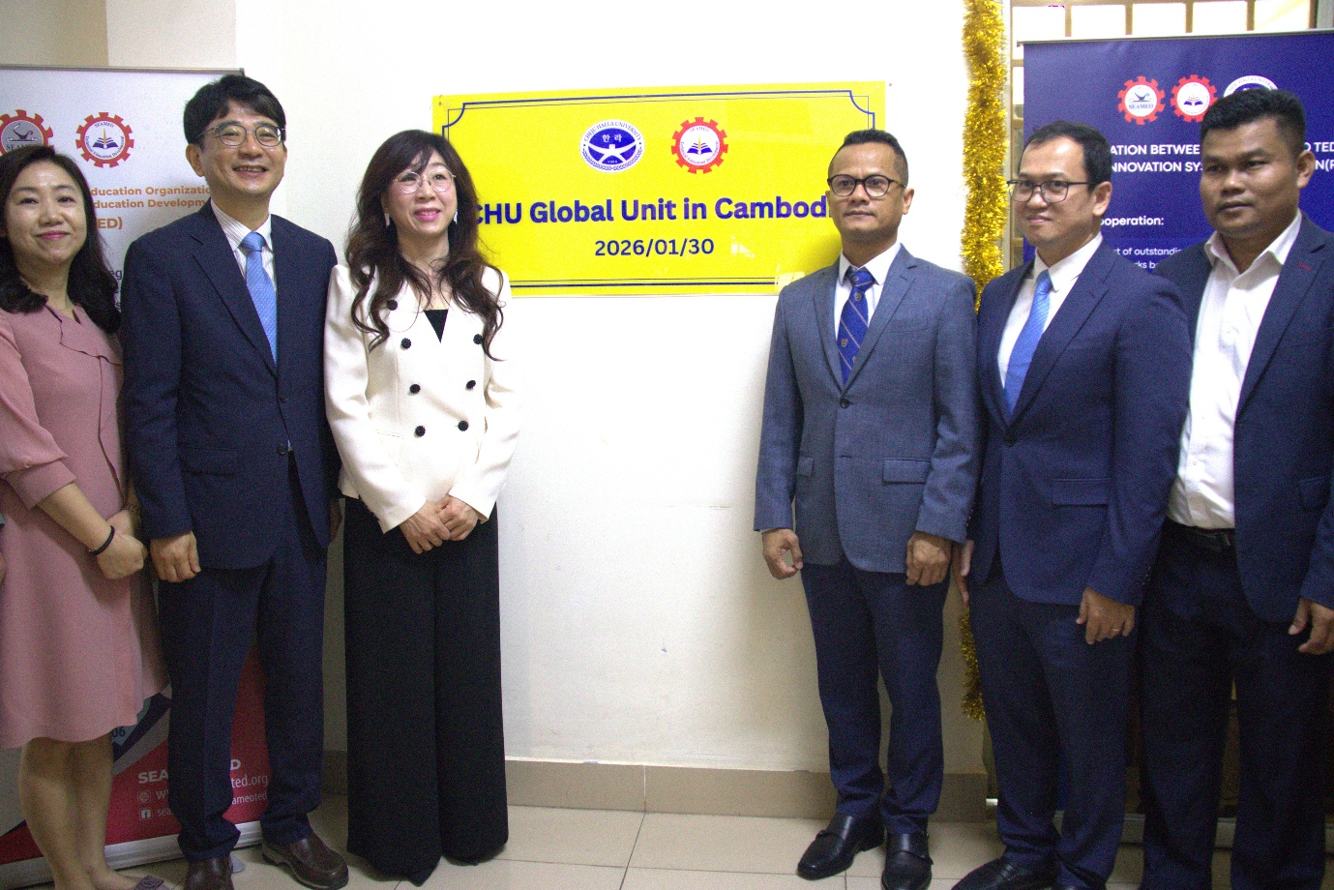
(Launching Ceremony of CHU Unit)

MOU Signed under the RISE Framework
Coinciding with the launch, SEAMEO TED and the RISE Project Group of Cheju Halla University officially signed a Memorandum of Understanding (MOU) on “Regional Innovation System & Education (RISE).”
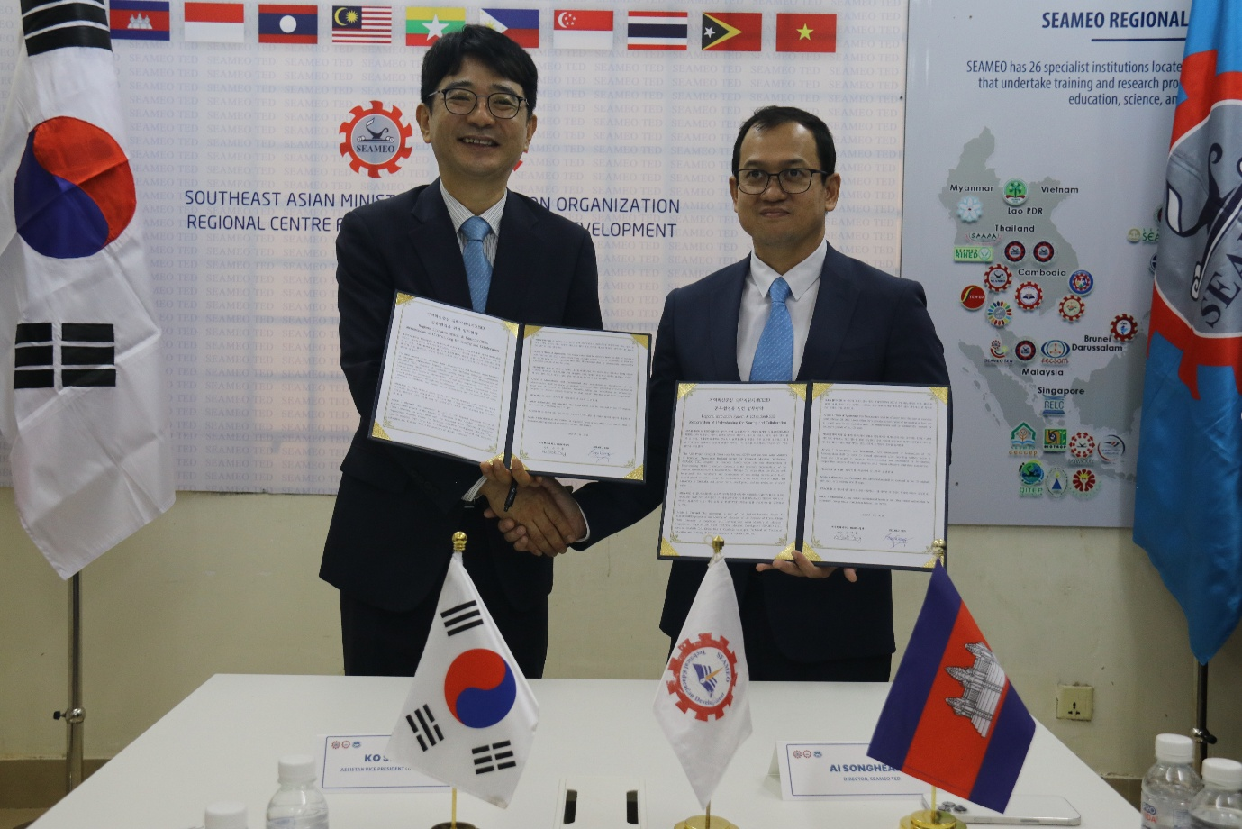
(MoU Signing between SEAMEO TED and CHU)

This agreement, effective from January 30, 2026, formalizes the establishment of the CHU Global Unit in Cambodia. It outlines a commitment to mutual development through the recruitment of outstanding international talent and the expansion of global networks using Phnom Penh as a strategic regional hub.

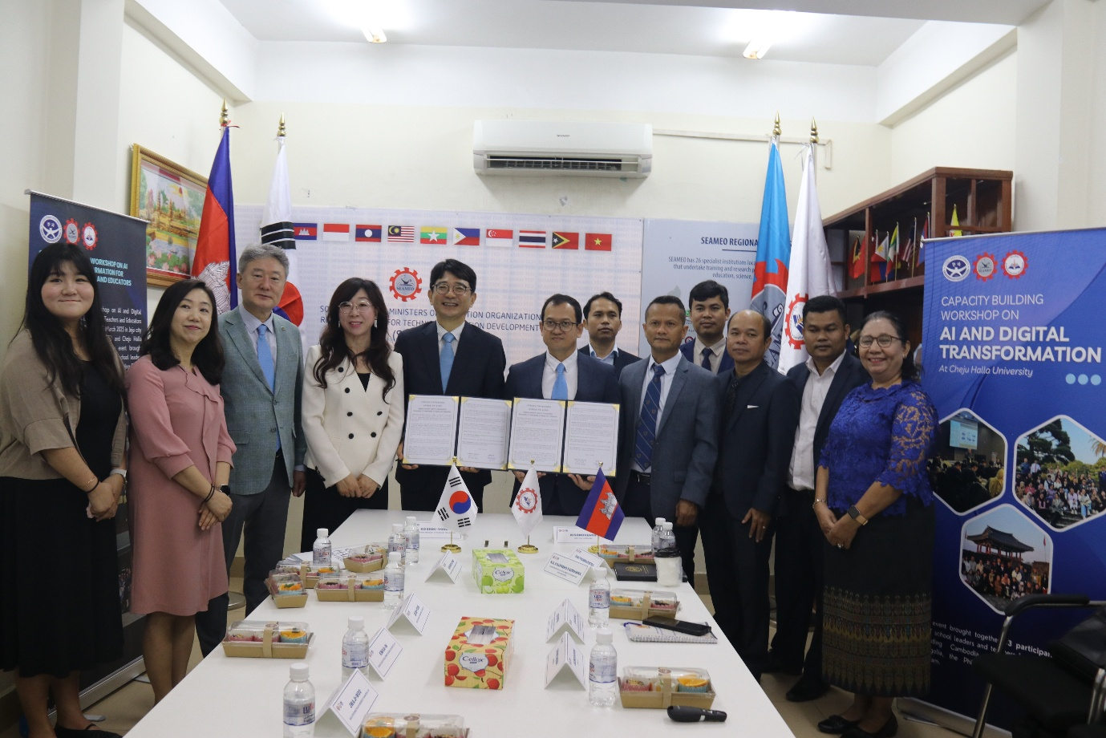
(Relevant Stakeholders join the Ceremony)

Key Areas of Cooperation
According to the signed MoU, the partnership will focus on several strategic areas to support the ASEAN community:
- The joint operation of workshops and training programs specifically designed for teachers and education professionals at both local secondary and higher education institutions in ASEAN countries.
- A collaborative effort to promote the “Study in Jeju” study abroad program through SEAMEO TED’s network of credible partner institutions.
- Joint planning and development of education and exchange programs tailored to foster Korea-Cambodia talent development.
- Strengthening the connection between ASEAN and the Republic of Korea to facilitate the exchange of digital technology and academic resources.
A Shared Vision for Future Education
During his opening address, H.E. Dr. Kolpheng Vaddhana emphasized the critical importance of this partnership, stating that “education plays a key role in developing a nation.” He highlighted that the Global Unit will “serve as a platform for innovation, collaboration, and capacity building—not only for Cambodia but for the ASEAN community.”
Representing the partner institution, Dr. Shin Wui-Kyung, Assistant Vice President of International Affairs at Cheju Halla University, affirmed the university’s dedication to the region. She stated that the project aims to “support TVET development in ASEAN countries" and build a “stronger AI/DX education cooperation network.”
Dr. Songheang Ai, Director of SEAMEO TED, welcomed the unit as a hub for “strengthening and expanding global networks.” He noted that this collaboration is the “first step toward realizing our long-term joint vision” and will focus on supporting the core educational platform that connects education and exchange across ASEAN.

Some annual activities have been agreed for 2026 between CHU and SEAMEO TED, including at least two times of capacity-building programs on AI and DX for ASEAN TVET teachers, policy makers, curriculum developers, and TVET school management to be held at CHU, South Korea.

