International Youth Talk | My Digital Story: How Social Media Shapes My Identity

On January 30, 2026, the 1st session of the “International Youth Talk,” jointly organized by Southeast Asian Ministers of Education Organization Regional Centre for Technical Education Development (SEAMEO TED), and China-ASEAN Technical Education Cooperation Platform (CATECP), with support from The Southeast Asia Youth Sustainable Development Foundation (PASITA), was successfully concluded online. The webinar was participated by 174 participants from around the world.
The event featured online presentations by youth representatives from universities across multiple countries including Laos, Malaysia, China, and Indonesia. Centered around the theme of “My Digital Story: How Social Media Shapes My Identity,” the youth showcased fresh perspectives with a global vision, sparking creative and cross-cultural exchanges.
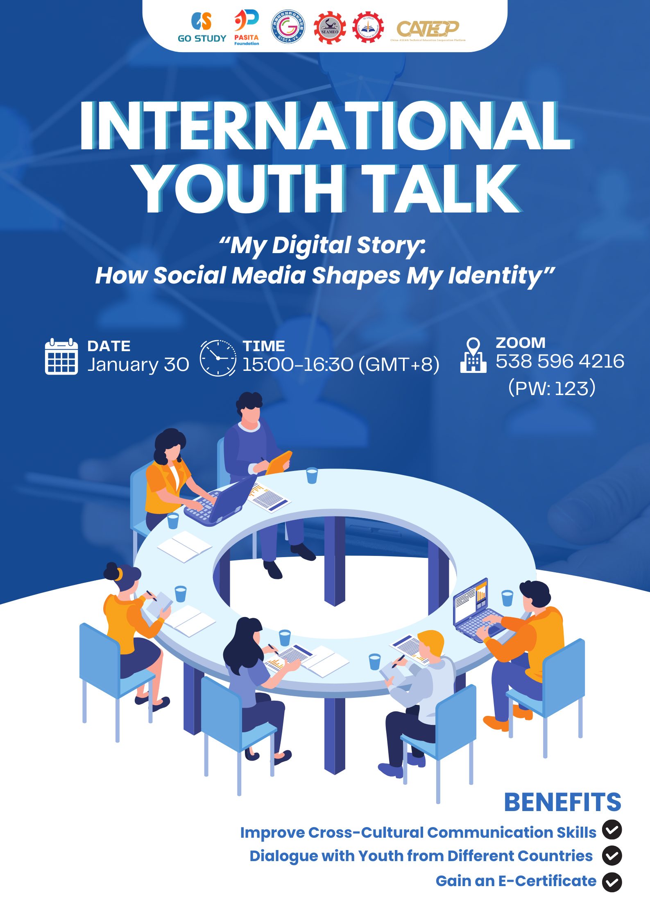

Opening Remarks
The opening remarks were given by Mr. Khat Prumsochetra, Deputy Director of SEAMEO TED, who explained that social media plays a significant role in shaping youth identity, particularly as a space for self-expression, connection, and influence. He underscored the importance of empowering young people to use social media responsibly and thoughtfully, with awareness of its impact on personal values, digital identity, and social relationships. He also expressed his hope that the webinar would serve as a meaningful platform for young people to share their stories, listen to one another, and engage in open dialogue about navigating social media in their everyday lives.
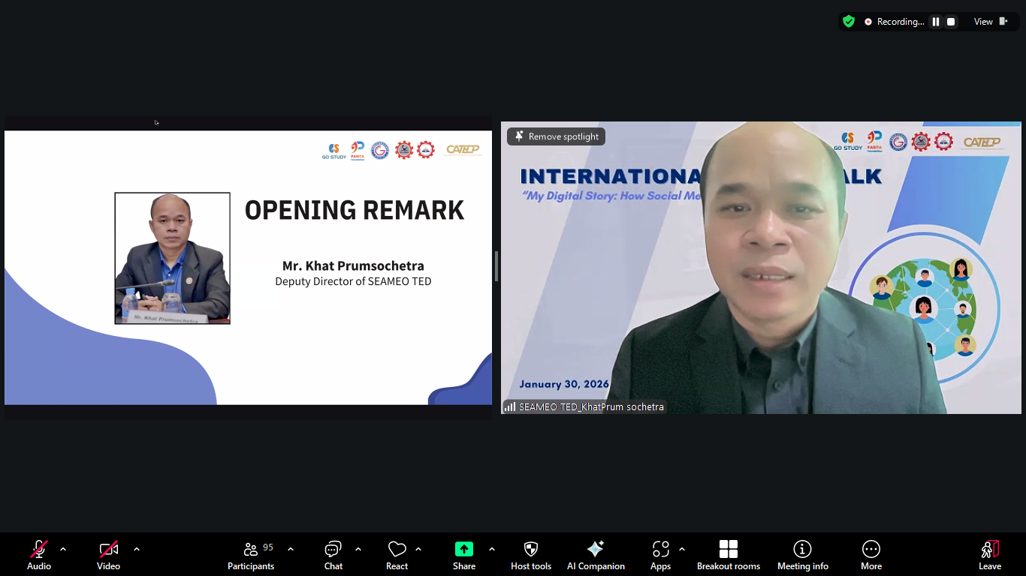

Presentation Highlights
Representative team from Souphanouvong University stated that social media plays a powerful role in shaping youth identity by providing a space for self-expression, fast and easy connection, and relationship-building beyond physical boundaries, allowing young people to reflect their personal growth through digital profiles. They explained that while social media can lead to comparison, self-doubt, and low confidence, it can gradually create self-understanding and self-awareness through reflection and experience. The team also highlighted social media as a gateway to opportunities such as education, jobs, and global networks, while acknowledging challenges including mental health pressure, cyberbullying, negative content overload, and the growing influence of AI on youth. They concluded that self-worth should not be measured by likes or followers, indicating that social media can positively support identity development when used mindfully, with balance, emotional awareness, and a focus on meaningful content.
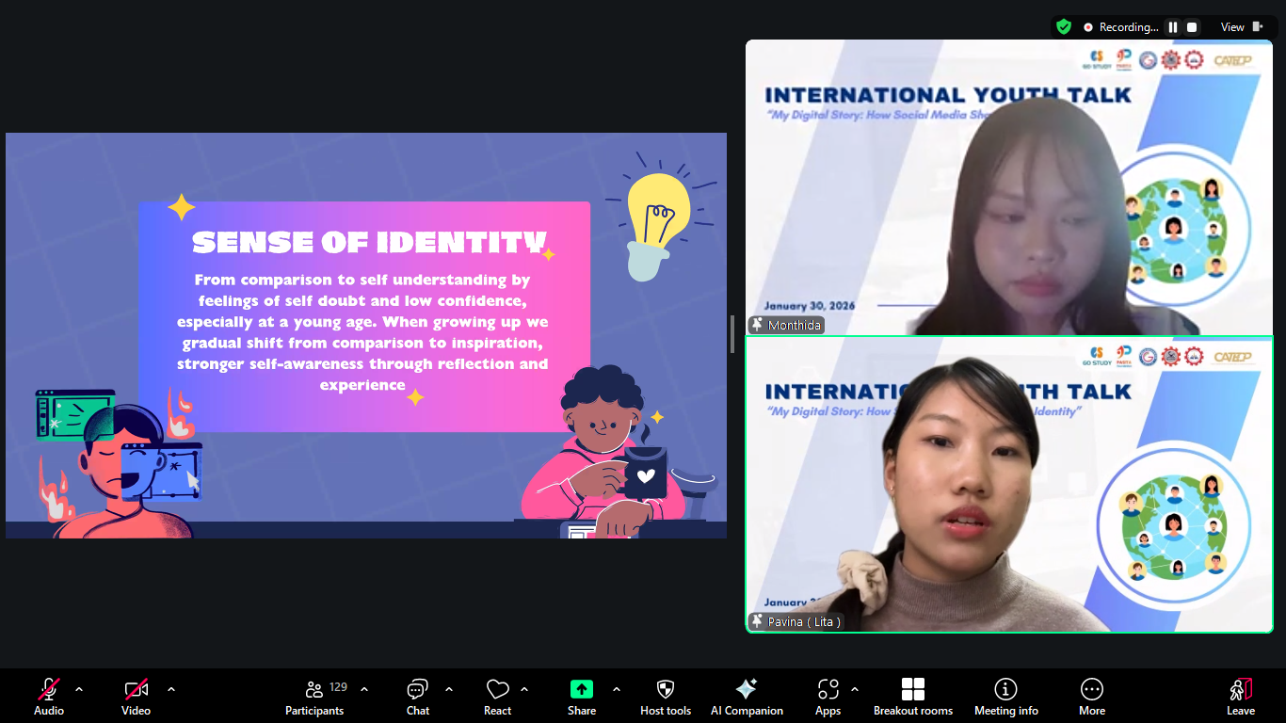
Mr. Ekansh Agarwal from Lincoln University College mentioned that social media functions as a global experience that encourages cross-cultural connectivity among youth through platforms such as Instagram, TikTok, YouTube, and LinkedIn. He highlighted that digital platform support self-expression by providing space for experimentation with personal identity, increasing public confidence, and offering freedom of opinion and voice. Mr. Ekansh also emphasized how social media shapes values by broadening access to global education, promoting social equality, encouraging engagement with diverse cultures, and raising awareness of mental health issues. Furthermore, he explained the importance of balance and digital responsibility, stressing conscious content consumption, balance between digital and physical life, and prioritizing authenticity over perfection. Lastly, Mr. Ekansh pointed out that the digital age offers significant opportunities for youth, concluding that digital platforms should be used responsibly with awareness, balance, and intent.
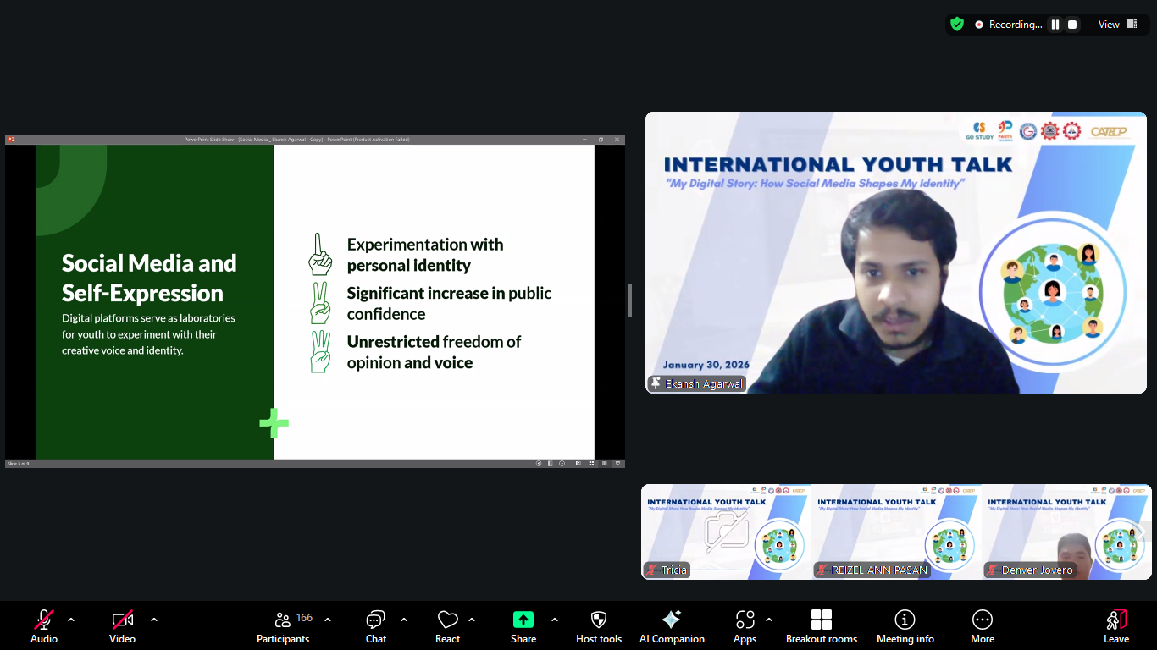
Team from Guangzhou Nanfang College stated that social media has played an important role in shaping youth identity by influencing how young people think, communicate, and see the world as part of their daily lives, not just as a form of entertainment. They explained that authoritative voices on social media, especially in collectivist cultures, help youth feel secure by providing clear and reliable information, while grassroots voices share real experiences and different opinions that encourage open thinking and understanding beyond one perspective. The team also pointed out that exposure to different cultures on social media has changed how young people express themselves, helping them adjust their communication style based on context, audience, and purpose. In addition, they shared that learning how to filter content and choose who to follow helps youth stay informed without feeling overwhelmed and supports the development of balanced thinking. They concluded that social media can be a positive tool for growth when used mindfully, as it supports cultural awareness, independent thinking, and personal development.
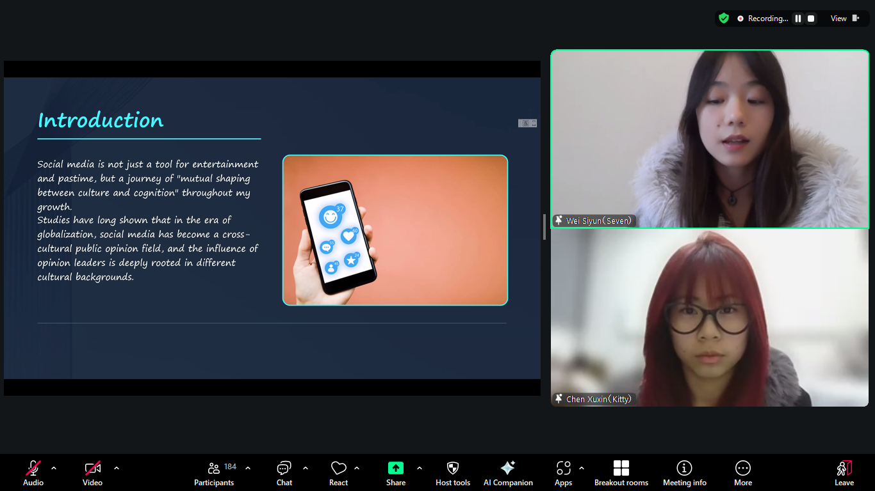
The students from Universitas Negeri Medan stated that social media plays a powerful role in shaping youth identity by acting not only as a communication platform but also as a space where individuals express and influence how they see and value who they are. They explained that digital identity goes beyond usernames and followers, reflecting how young people present themselves online by highlighting edited moments while hiding real struggles, which can create pressure to perform. At the same time, they emphasized that social media offers meaningful opportunities such as cross-cultural connection, giving youth a voice, and global visibility, while also presenting challenges driven by algorithm. They concluded by encouraging young people to use social media consciously by prioritizing honesty over perfection and to let authenticity guide their digital presence.
