Report on
International Expert Sharing Forum on
“Hands-On Training and Industry: Academic Cooperation”
February 13, 2026

February 13, 2026: The International Expert Sharing Forum on “Hands-On Training and Industry: Academic Cooperation” jointly organized by the China-ASEAN Technical Education Cooperation Platform (CATECP), the Southeast Asian Ministers of Education Organization Regional Centre for Technical Education Development (SEAMEO TED), and Go Study Global Education, was successfully concluded online. The meeting was attended by 64 male and 105 female participants, making a total of 169 participants. The forum brought together experts and scholars from Indonesia, Vietnam, Brunei Darussalam, and Malaysia. Discussions focused on strengthening practical skills training, aligning technical education with industry needs, developing collaborative training models between educational institutions and enterprises, and sharing best practices in work-integrated learning. These topics were explored through keynote speeches, case studies, and interactive exchanges.
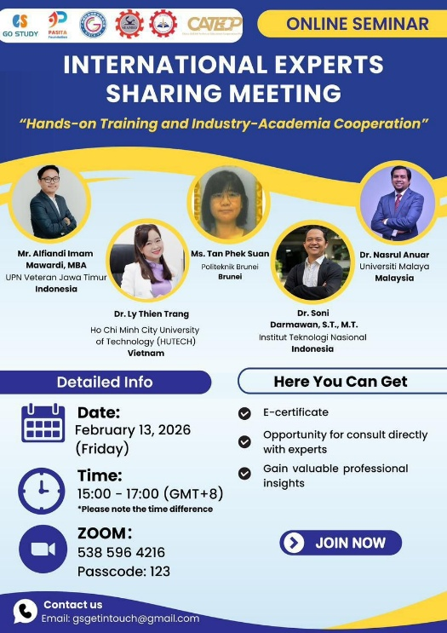

Speaker: Dr. Nasrul Anuar
Deputy Dean, Faculty of Engineering, Universiti Malaya, Malaysia
Topic: CAD/CAM In Prosthetics and Orthotics Engineering
Dr. Nasrul Anuar explained that his presentation focused on the use of CAD/CAM and 3D printing in prosthetics and orthotics engineering. He stressed that measuring residual limb volume accurately is very important because daily changes can affect comfort, fit, and user satisfaction. He discussed research questions about the best way to measure limb volume, the reliability of 3D scanners, and the factors that cause volume changes.
He described the process of making a prosthetic socket, starting from 3D scanning, CAD design, and fabrication using Nylon PA12 material. He also presented testing results, including finite element analysis and ISO 10328:2016 standards, showing that the prosthetic sockets passed safety and load tests. Dr. Nasrul emphasized that although 3D printing is growing rapidly in the prosthetics industry, proper standards and guidelines are necessary to ensure safety and quality. Hence, he concluded by outlining plans to develop standard procedures and move toward industrial application and patent development.
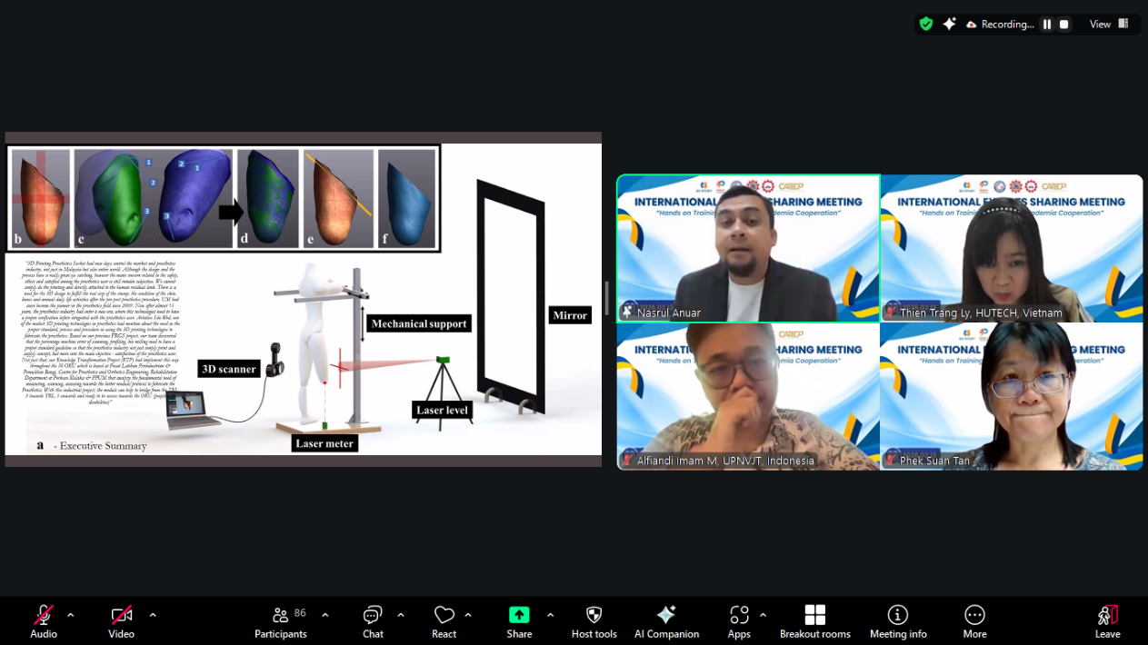

Speaker: Dr. Soni Darmawan, S.T., M.T.
Dean, Faculty of Civil Engineering and Planning, Institut Teknologi Nasional, Indonesia
Topic: Earth Science and Remote Sensing Technology.
Dr. Soni Darmawan explained that his presentation discussed Earth system science and the role of remote sensing in understanding the environment. He described the Earth as a connected system made up of the atmosphere, hydrosphere, geosphere, and biosphere, and showed how natural events like earthquakes, hurricanes, and El Niño are linked within this system. He introduced remote sensing as a way to observe the Earth using satellites, aircraft, and UAVs, and briefly explained different types of sensors and satellite imagery.
He also highlighted current trends such as AI, cloud computing, and open data. Through several research examples, he showed how remote sensing is used for oil palm monitoring, mangrove mapping, urban heat studies, and disaster analysis. Thus, he concluded that Earth system science is increasingly important, that remote sensing technology continues to grow alongside digital innovation, and that there are wide opportunities for research and practical applications in natural resource management and geospatial development.
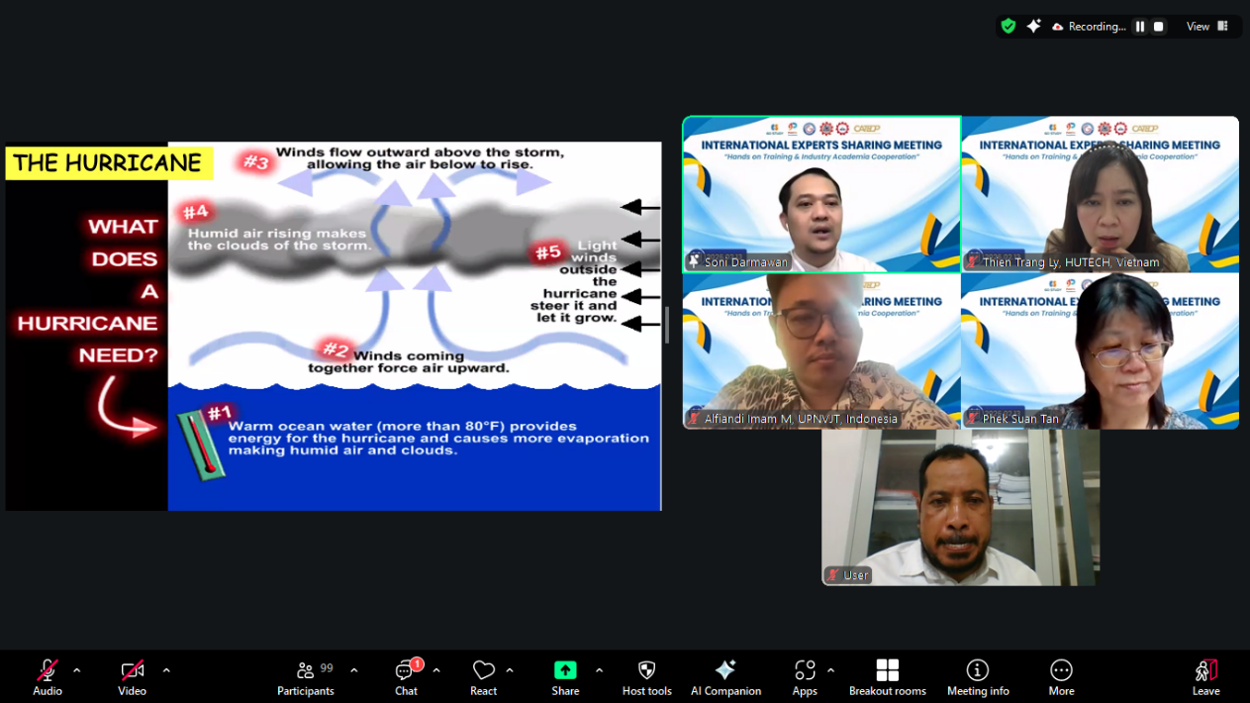

Speaker: Ms. Tan Phek Suan
Head of School, Politeknik Brunei, Brunei Darussalam
Topic: Level 5 Apprenticeship: Diploma in Hospitality Management & Operations
Ms. Tan explained that the presentation outlined the Level 5 Apprenticeship Diploma in Hospitality Management and Operations at Politeknik Brunei. She described it as a three-year full-time programme that combines school-based learning with structured, paid on-the-job training, leading to a nationally recognised qualification. She stated that the main aim is to develop skilled, industry-ready local talent who can progress into supervisory and middle-management roles, while supporting Wawasan Brunei 2035 and workforce localisation.
Ms. Tan highlighted close collaboration with industry partners through MoUs, workplace supervision, and continuous feedback to ensure training remains relevant to industry needs. She also addressed challenges in the hospitality sector, such as skill gaps and limited local participation, which the apprenticeship model seeks to improve. At last, concluded that the programme is designed as a practical and sustainable pathway to strengthen employability and build a stable local talent pipeline for the hospitality industry.
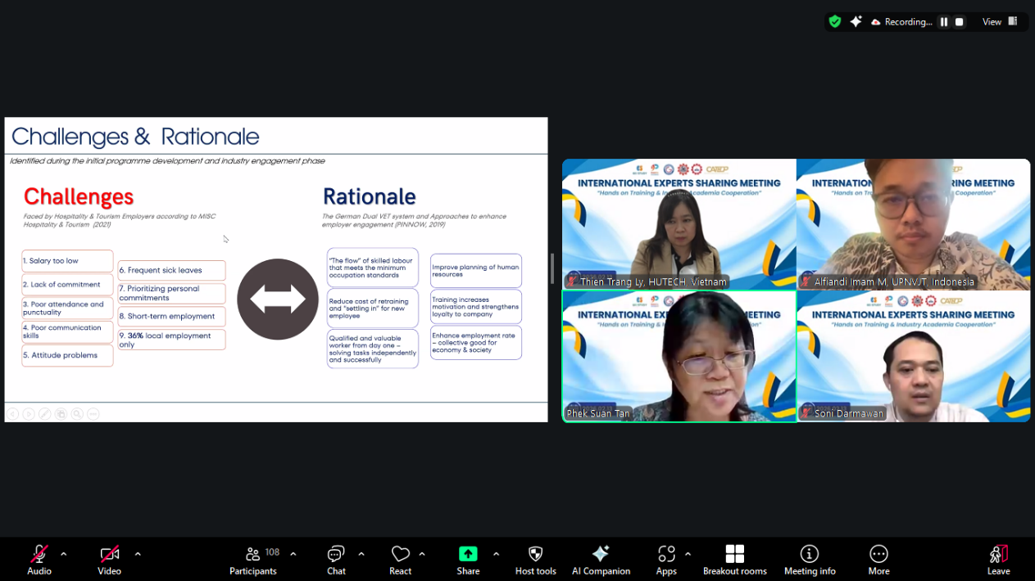

Speaker: Dr. Ly Thien Trang
Vice President, Ho Chi Minh City University of Technology (HUTECH), Vietnam
Topic: Outcome-Based and Hands-On Teaching for Sustainable Development
Dr. Ly explained that her presentation focused on outcome-based and hands-on teaching to support sustainable development at Ho Chi Minh City University of Technology (HUTECH). She began by defining sustainable development and Education for Sustainable Development (ESD), emphasizing the need to prepare students to make responsible decisions for environmental, social, and economic wellbeing. She described how universities contribute to the Sustainable Development Goals (SDGs) through education, research, governance, and community engagement. Dr. Ly outlined the SDG integration process, including mapping existing activities, identifying gaps, and embedding sustainability into institutional practices.
She also highlighted the eight UNESCO key competencies for sustainability, such as systems thinking, anticipatory thinking, critical thinking, collaboration, and problem-solving, and explained how learning outcomes are aligned with these competencies. She shared how HUTECH integrates sustainability into its curriculum through outcome-based education, project-based learning, work-based learning, and community engagement. Therefore, she concluded that a sustainable learning environment requires strong governance, inclusive policies, industry collaboration, and hands-on approaches to prepare students for social and environmental impact.
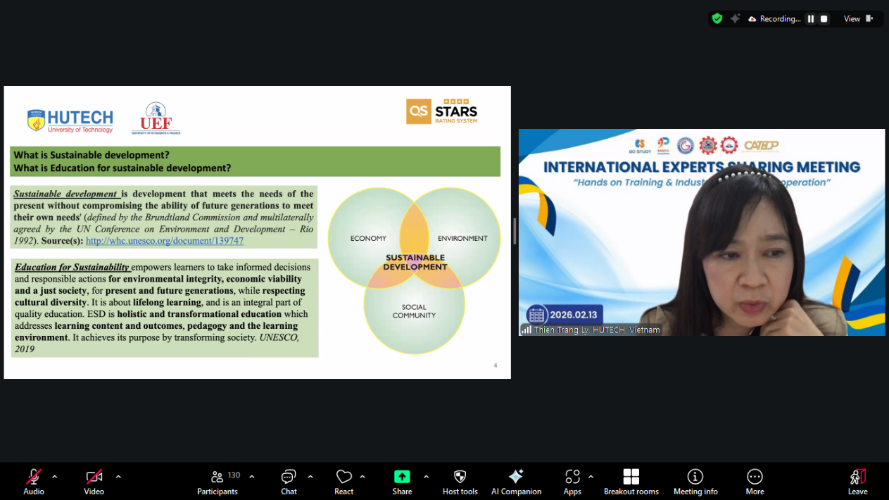

Speaker: Mr. Alfiandi Imam Mawardi, MBA
Lecturer in Management, UPN Veteran Jawa Timur, Indonesia
Topic: Bridging the Innovation Gap
Mr. Alfiandi explained that his presentation focused on how to turn university research into real innovation that can be used by industry. He described two main stages: the ideation stage and the innovation stage. In the ideation stage, he introduced a “triple pillar” filter. First is the technology filter, which checks whether the idea is scientifically valid, feasible, and ready based on its Technology Readiness Level (TRL). Second is the market filter, which examines whether the idea solves a real problem, has competitors, and has economic potential. Third is the regulatory and IP filter, which ensures the idea can be patented, protected, and aligned with national priorities.
In the innovation stage, he emphasized hands-on development, including building a minimum viable product (MVP), testing and improving it through repeated trials, and making sure it meets industry standards. He also highlighted the importance of business modeling, such as identifying customers, calculating production costs, and mapping key stakeholders. Lastly, he concluded that strong collaboration between universities and industry is essential to move innovations from the lab into real-world use.
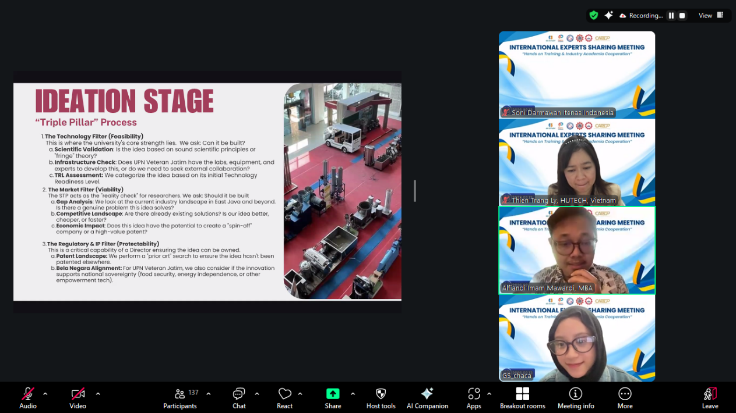

The closing remarks were delivered by Mr. Tim Vorn, Head of the Research and Development Division of SEAMEO TED. He expressed his gratitude to all organizers, speakers, and participants, and emphasized the importance of the theme in both academic and industrial settings, particularly in strengthening collaboration between education and industry.

He highlighted that closer cooperation in education, research, and industry engagement among ASEAN countries is essential to support practical training aligned with real workforce needs within the industry. He also encouraged participants to continue sharing insights and exploring innovative models of hands-on training and industry–academic cooperation.

