Report on
International Expert Sharing Forum on
“Automation and Intelligent Control in Equipment Manufacturing”
March 13, 2026

On the afternoon of March 13, 2026, the 14th session of the “International Experts Sharing Meeting,” jointly organized by the China-ASEAN Technical Education Cooperation Platform (CATECP), the Southeast Asian Ministers of Education Organization Regional Centre for Technical Education Development (SEAMEO TED), and Go Study Global Education, was successfully concluded online. The meeting was attended by 81 male and 88 female participants, making a total of 169 participants.

Themed “Automation and Intelligent Control in Equipment Manufacturing”, the meeting brought together experts and scholars from Indonesia, Thailand, Vietnam, and Malaysia. Discussions focused on intelligent manufacturing technologies along with competency-based education to prepare professionals for advanced automation and intelligent control. These topics were explored through keynote speeches, case studies, and interactive exchanges.

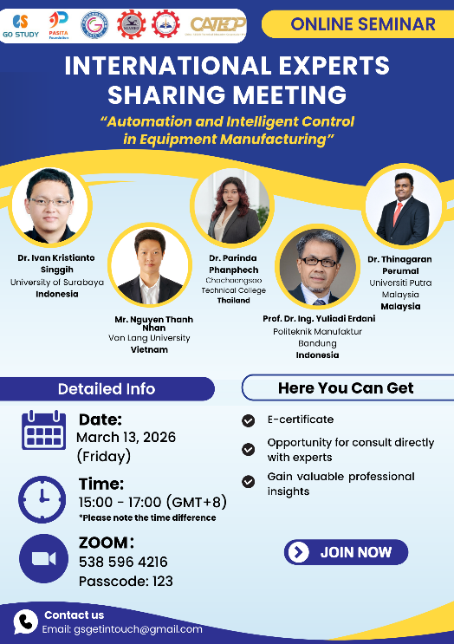

【Opening Remarks】
The opening remarks were delivered by Mr. Mara Pho, Head of Technical Education and Training Division of SEAMEO TED. Mr. Pho emphasized that in the digital era, technologies such as automation or artificial intelligence are widely transforming the industry by designing, producing, and managing equipment and thus fundamentally reshaping workforce development. He highlighted how knowledge exchange and international collaboration are needed so that we will understand the emerging phenomenon by learning about the trends and discussing how intelligent technologies can be applied in education industry and research, and the “International Expert Sharing” as a vital platform for knowledge exchange and regional collaboration. He encouraged participants to explore how intelligent technologies can be applied across education, industry, and research, and expressed confidence that the session would inspire meaningful discussion and strengthen cooperation among ASEAN countries to advance technical education and ensure industry alignment.

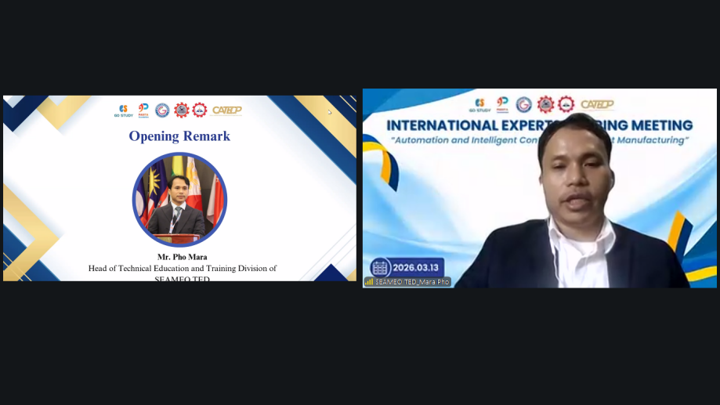

【Sharing Session】
Speaker: Dr. Ivan Kristianto Singgih
Head, System Engineering Laboratory, Department Of Industrial Engineering, University of Surabaya, Indonesia
Topic: Dynamic Problem Importance Identification Using Machine Learning in Production Systems
Dr. Ivan Kristianto Singgih explained about the transformative landscape of Industry 4.0, emphasizing that while modern technological improvements offer nearly limitless potential, they are fundamentally tethered to the quality and interpretation of data. He argues that without robust data collection, identifying the root cause of systemic inefficiencies becomes an impossible task. To bridge this gap, Dr. Ivan advocates for a methodology that integrates traditional Operations Research (OR) with Artificial Intelligence (AI). Using the complex logistics of crane movement in container terminals as a primary case study, he illustrates that the sheer volume of data generated every second is too vast for manual human analysis. While traditional OR provides the mathematical framework for optimization, AI is the essential filter used to prioritize issues within these massive datasets. By combining the two fields, he concludes that machine learning is an effective approach in identifying and prioritizing critical subproblems.
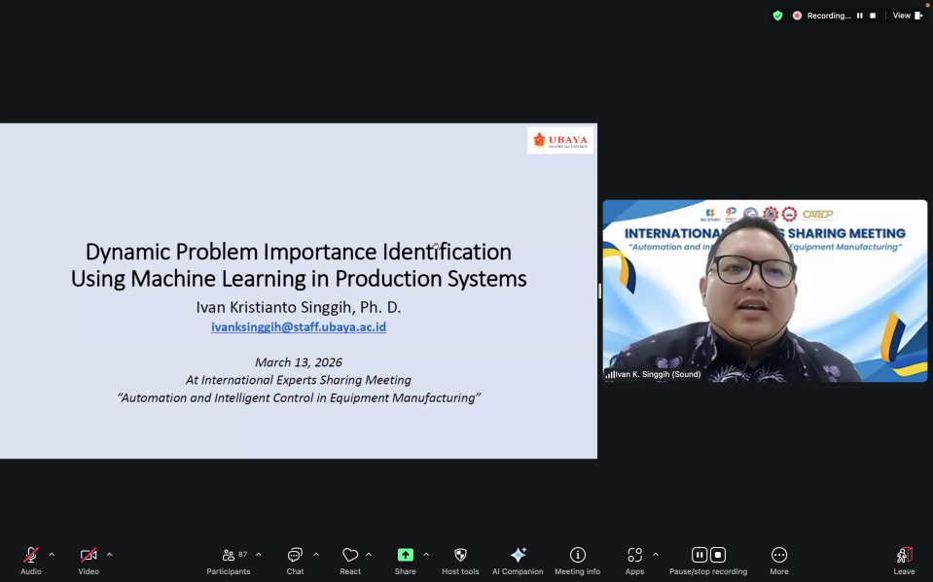

Speaker: Dr. Parinda Pahnpehch
Chair, Bachelor’s Degree Program of Electrical Technology, Chacheongsao Technological College, Thailand
Topic: From Intelligent Control to Competency-Driven Innovation: Advancing Smart Manufacturing and Sustainable Community Development in Thailand’s EEC
In the presentation, Dr. Parinda Pahnpehch focused on the topic of advancing smart manufacturing and sustainable community development in the specific case of Thailand’s Eastern Economic Corridor (EEC). She explained that industrial transformation is driven by automation, intelligent control, and digital manufacturing while sustainable development requires competent workforce, innovative learning system, and industry-education collaboration. She mentioned that intelligent machines need intelligent control where it leads to smart manufacturing environment. In this environment machines are considered as intelligent systems capable of sustaining, processing, and responding to operating conditions in the long term. The key technologies include industrial automation, PLC, smart sensors, IoT integration, and data-driven manufacturing. These intelligent control enables higher production efficiency, operational reliability, energy optimization, and industrial safety. However, these intelligent systems will have to rely on humans, specifically smart engineers, to control them. Smart engineers have key competencies such as electrical system design, IoT and digital integration, professional ethics, etc. These competencies can be gained through education. Once it is done, engineers can hopefully bring impact to both the industry and community.

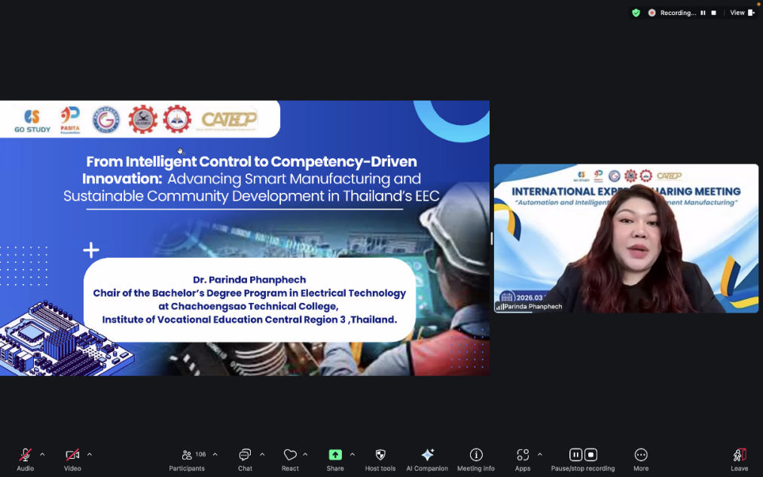

Speaker: Mr. Nguyen Thanh Nhan
Lecturer, Van Lang University, Vietnam
Topic: Smart Robots: An Executive Briefing With Case Studies
Mr. Nguyen Thanh Nhan defines the smart robot as the physical intersection of Artificial Intelligence and the real world. These machines distinguish themselves by their ability to adapt to changing environments, learn from human experience, and perform tasks beyond their original programming. Mr. Nhan categorizes AI into two realms: Digital AI, such as recommendation engines, and Physical AI, which includes industrial robots and wearables. Critically, he argues that robots must operate within local hardware constraints to ensure safety and efficiency, even when disconnected from a network. As robotics expands into domains like human augmentation (medical/space), social interaction (education), and smart automation (logistics), robots are evolving from mere tools into collaborative partners. This transition is exemplified by real-world cases like Cargill Amsterdam and John Lewis, where Hai Robotics was implemented to optimize warehouse efficiency. Mr. Nhan cautions that successful deployment depends on focusing on tangible value generation rather than hardware hype. Looking toward 2030, he predicts that robotics will become omnipresent in human society, moving from common industrial applications into more complex sectors like healthcare and construction, fundamentally changing how we communicate and work alongside technology.

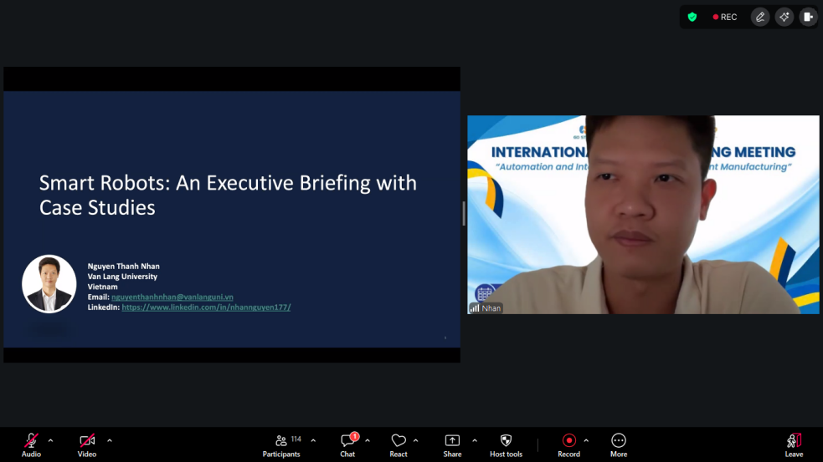

Speaker: Dr. Thinagaran Perumal
Associate Professor, Head Department of Computer Science, Faculty of Computer Science and Information, Universiti Putra Malaysia, Malaysia
Topic: Artificial Intelligence of Things (AIoT): Powering the Next Wave of Smart Manufacturing
Dr. Thinagadan Perumal highlights the growing influence of AI and IoT within Malaysia’s manufacturing sector, noting a high readiness level of 18%. To capitalize on this, the Malaysian government has allocated RM25 billion for the National Semiconductor Strategy, with a specific focus on Neuromorphic Computing. This field applies neuroscience principles to mimic the human brain's structure, offering a breakthrough in energy and space efficiency that could eventually outpace traditional computing. Its applications are broad, ranging from scientific computing to augmented and virtual reality, with future global university collaborations expected to drive further innovation. Beyond manufacturing, Dr. Perumal explores the application of AIoT in Multi-Resident Smart Homes (MHAR). Shared living environments present unique challenges, such as complex behavioral overlaps and the need for interpretable data. To address these, the MHAR framework was developed to accurately distinguish the activities of multiple residents in real time. This system provides transparent explanations for recognized behaviors and offers context-aware automation that adapts to both individual and group patterns. By combining high-level semiconductor strategy with practical smart-home solutions, Dr. Perumal illustrates how integrated AIoT systems can enhance both industrial productivity and the quality of daily life through more "human-like" and efficient computing architectures.
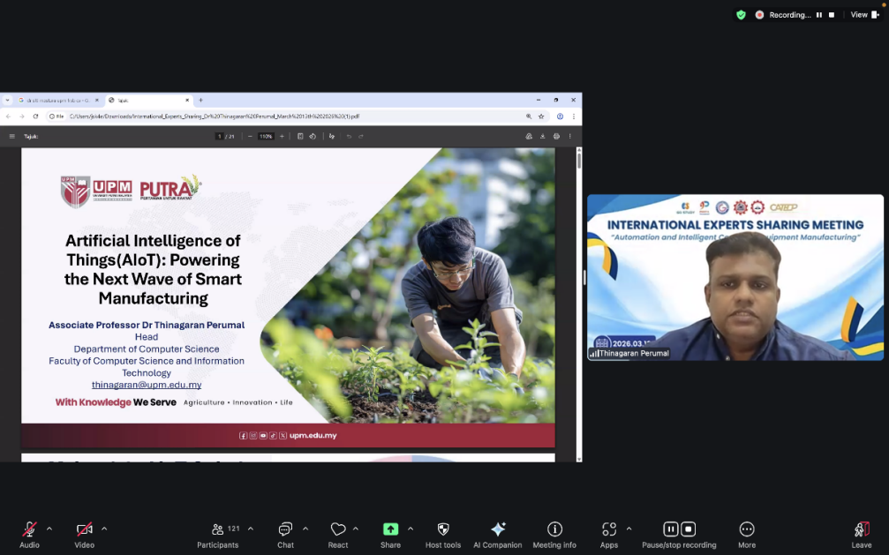

Speaker: Prof. Dr. Ing. Yuliadi Erdani, M.Sc, IPU
Professor, Politeknik Manufaktur Bandung, Indonesia
Topic: Digital Twin-Driven Intelligent Control For Equipment Manufacturing Optimization
Prof. Dr. Ing. Yuliadi Erdani presents a comprehensive framework for Digital Twin-driven intelligent control designed to optimize equipment manufacturing systems within the Industry 4.0 paradigm. The research addresses a critical gap by integrating digital twin (DT) modeling, real-time synchronization, and multi-objective optimization into a unified cyber-physical closed-loop architecture. This system utilizes industrial-grade sensors and edge computing to maintain a virtual representation of physical assets, such as CNC machines and robotic manipulators. By employing Kalman filtering for continuous synchronization and Model Predictive Control (MPC) for generating optimal inputs, the framework ensures high-precision tracking and robust disturbance rejection. The implementation focuses on predictive analytics—including fault detection and Remaining Useful Life (RUL) estimation—leveraging machine learning techniques like LSTM networks. Simulation results demonstrate that this DT-driven approach significantly outperforms conventional feedback control by reducing downtime, improving system stability, and increasing production throughput. Despite challenges such as computational complexity and data security, the study concludes that such integrated frameworks are essential for advancing manufacturing efficiency. Future work aims to incorporate reinforcement learning and distributed architectures to meet the evolving demands of Industry 5.0.
