International Youth Talk (Online) on

“Why Young People Should Care About Agriculture”

April 24, 2026
On Friday afternoon of April 24th, the 4th session of the “2026 International Youth Talk” was successfully held online. The session attended by 185 participants, comprising of 113 females and 72 males. This event jointly organized by the Southeast Asian Ministers of Education Organization Regional Centre for Technical Education Development (SEAMEO TED), UNESCO International Research and Training Centre for Rural Education (INRULED), the China-ASEAN Technical Education Cooperation Platform (CATECP), with the support from The Southeast Asia Youth Sustainable Development Foundation (PASITA) and Go Study Global Education.
Themed “Why Young People Should Care About Agriculture”, the meeting brought together experts and scholars from Malaysia, Thailand, the Philippines, and Indonesia. Discussions focused on raising awareness and encouraging youth engagement in agriculture. These topics were explored through keynote speeches, case studies, and interactive exchanges.
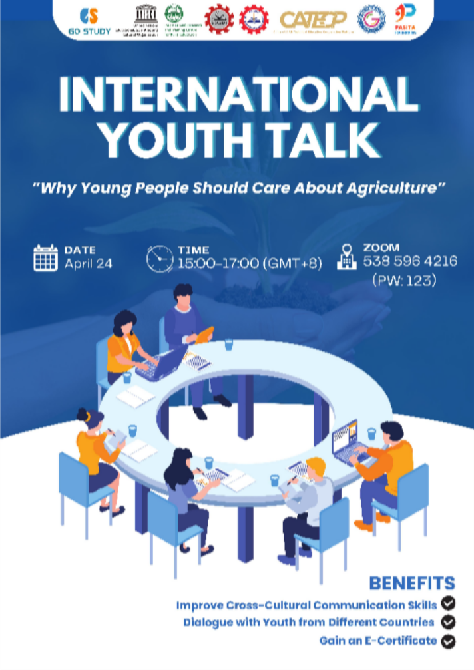

Opening Remarks
The first opening remark was delivered by Mr. Tim Vorn, Head of the Research and Development Division of SEAMEO TED. He emphasized the importance of raising awareness among young people about the role of agriculture in sustainable development. In today’s rapidly changing world, agriculture is not only about food production but also about innovation, environmental sustainability, and future economic opportunities. He highlighted the need to encourage youth involvement in the agricultural sector by promoting knowledge, skills, and modern approaches to agriculture. Furthermore, he mentioned that collaboration, knowledge exchange, and exposure to new technologies are essential to make agriculture more appealing and relevant to the younger generation. Lastly, he encouraged participants to actively engage in the discussions and gain insights from experts to better understand the importance of agriculture for the future.
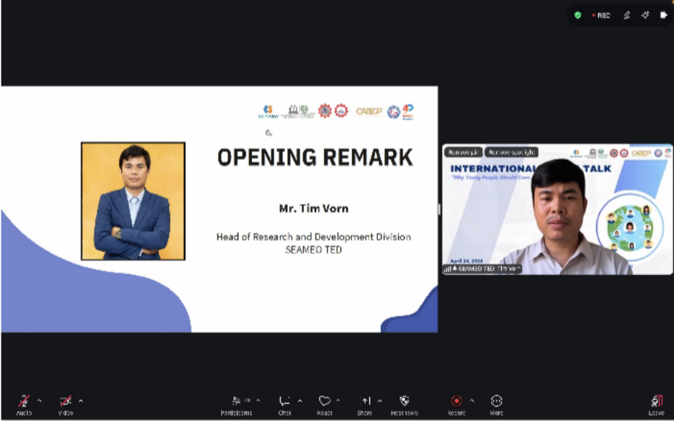
The second opening remark was delivered by Dr. Zhao Yuchi, Executive Director of UNESCO INRULED. He emphasized that the future of agriculture depends not only on technological advancement but also on active participation from the younger generation. Agriculture today faces various challenges, including climate change, declining interest among youth, and evolving global demands. At the same time, these challenges present opportunities for innovation, sustainability, and economic growth. Dr. Zhao highlighted that engaging young people in agriculture is essential to ensure long-term food security and sustainable development. He also stressed the importance of education, collaboration, and accessible knowledge to make agriculture more appealing and relevant to youth. Dr. Zhao encouraged participants to reflect on how they can contribute to the agricultural sector, foster collaboration among stakeholders, and promote inclusive approaches to attract more young people into agriculture. He hoped the event would inspire new perspectives, strengthen partnerships, and encourage greater youth involvement in shaping the future of agriculture.

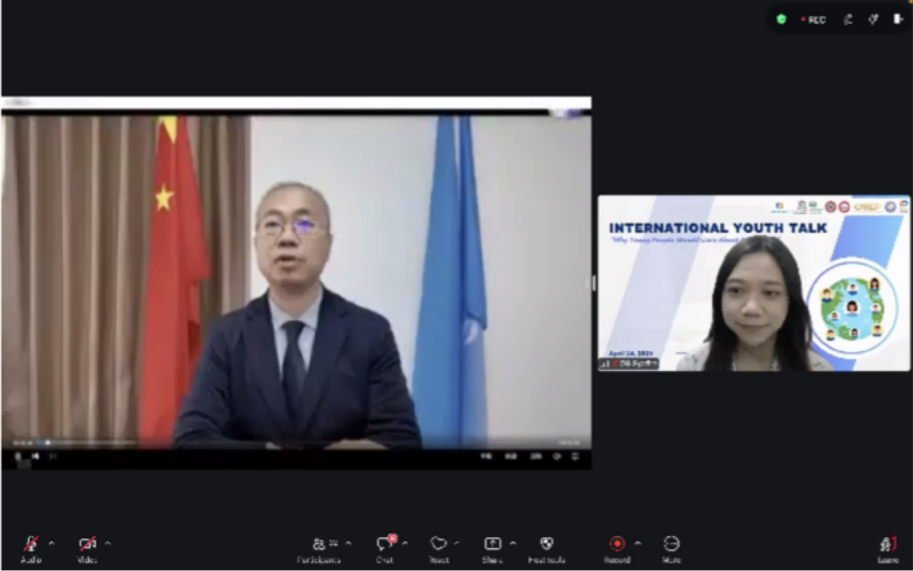

Presentation Highlight
The representative team from Universiti Putra Malaysia presented their topic titled “A Call for Gen Z,” emphasizing the importance of agriculture in everyday life. They highlighted that all food originates from agricultural processes, making the sector essential for human survival. The team explained how agriculture has evolved into a more modern and technology-driven field, incorporating innovation and digital advancements to improve productivity and sustainability. They also emphasized that without farmers and the agricultural sector, it would be difficult to sustain daily life and global food systems. Additionally, they shared their experiences engaging in various communities, where they actively promote awareness and involvement in agriculture among young people. Through their presentation, they encouraged Gen Z to recognize the significance of agriculture and consider contributing to its future development.
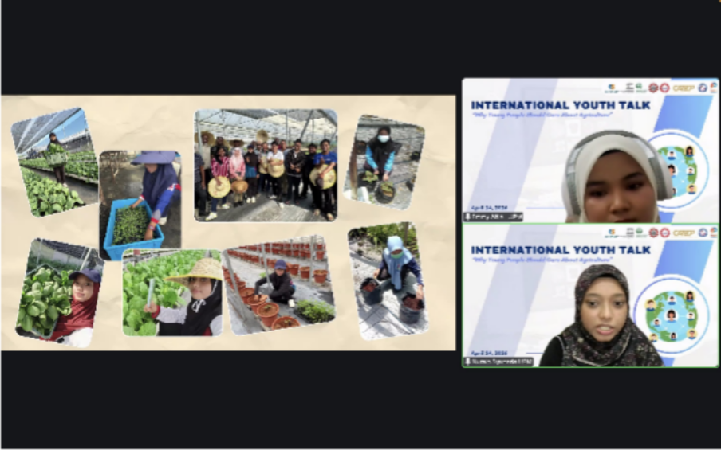

The representative team from the Asian Institute of Technology, Thailand presented their topic titled “Empowering Youth as Catalysts for Sustainable Agriculture and a Zero Hunger Future.” They emphasized the importance of agriculture in addressing global challenges such as population growth and increasing food demand, highlighting the critical role of agriculture in ensuring food security. The team discussed current challenges in the agricultural sector, including climate change, abiotic and biotic stress, post-harvest losses, and land degradation. They also introduced several innovative solutions, such as automated farming and the integration of advanced technologies to improve efficiency and sustainability. Furthermore, they highlighted various opportunities for young people to engage in agriculture, including involvement in agritech startups, environmental solutions, global development, leadership, as well as research and innovation. Through their presentation, they encouraged youth to actively participate in transforming the agricultural sector towards a more sustainable and resilient future.
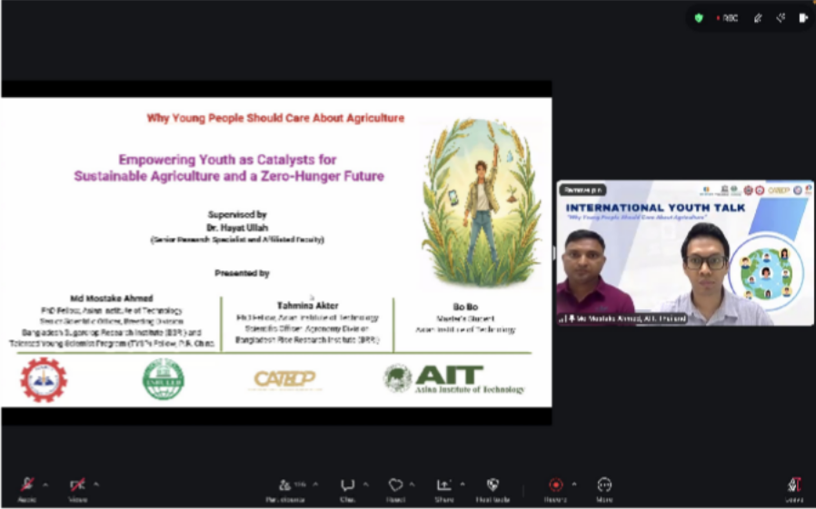
The representative team from Capiz State University, the Philippines opened their presentation by posing a thought-provoking question: what if the next global heroes were not celebrities, but farmers? They highlighted the common perception that agriculture is boring, unprofitable, and lacks prospects. However, they emphasized that without farmers, there would be no food and no future. The team also discussed various technological advancements in agriculture, including the use of drones and remote sensing, sustainable irrigation systems, precision farming, as well as automation and robotics. These innovations demonstrate how agriculture is evolving into a modern and dynamic sector. In conclusion, they encouraged the younger generation to recognize the importance of agriculture and to actively care about and contribute to its development, emphasizing that youth involvement is essential for a sustainable future.

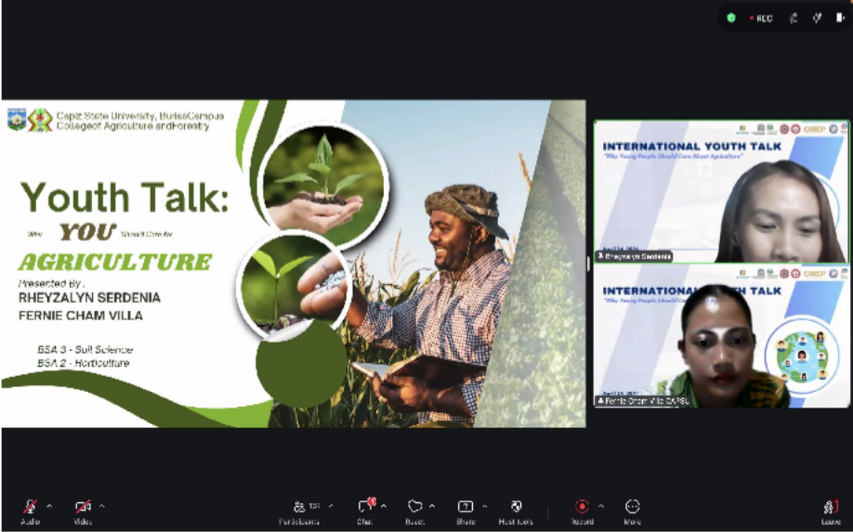

The representative team from Universitas Riau, Indonesia presented their topic titled “The Young Generation is Ready to Contribute Without Any Excuses.” They began by emphasizing that without agriculture, there is no life, highlighting the essential role of agriculture in sustaining human existence. However, they pointed out that the agricultural sector is currently under pressure due to increasing food demand, climate impacts, and the aging population of farmers, raising the question of who will feed the future. While global demand continues to rise, youth participation in agriculture remains relatively low. The team further explained why the younger generation must take the lead in today’s agricultural revolution. As a solution, they introduced hydroponics as an ideal gateway for youth involvement, highlighting its efficiency, sustainability, and accessibility. They explained why hydroponics matters in modern agriculture and how it can address current challenges. In conclusion, they emphasized the importance of empowering the next generation, positioning hydroponics as a catalyst for modern agriculture.
