Training Course on “Fish Breeding Techniques”
28-29 April 2026
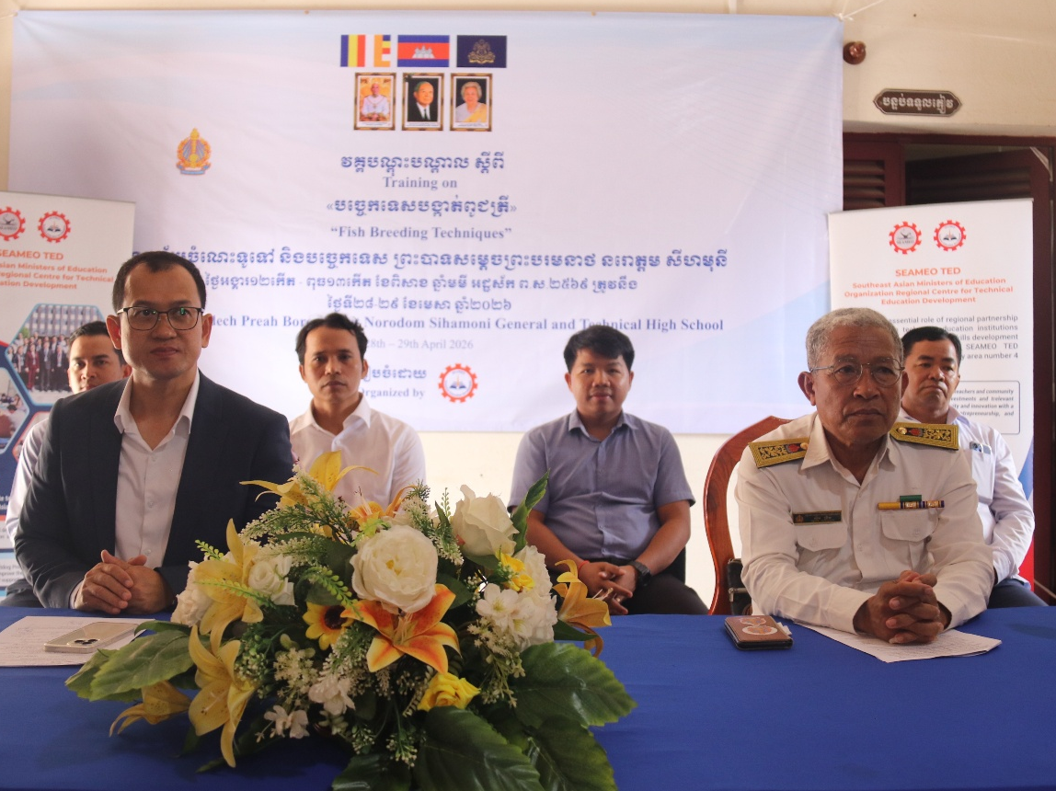
(Dr. Ai and Mr. Sim Prim on stage for opening ceremony)
Kampong Chhnang Province: A two-day training course on “Fish Breeding Techniques” for Technical Education Teachers, took place at Samdech Preah Bat Preah Boromneath Norodom Sihamoni General and Technical High School in Kampong Chhnang Province, Cambodia. Forty-five participants (19 females), mainly agriculture teachers from 11 General and Technical High Schools across Cambodia, attended the course.
Mr. Sim Prim, director of Kampong Chhnang Provincial Department of Education, Youth and Sport stressed that “It would be a great honor for the province and school to host such good training for technical education teachers that enable them to learn and witness the progress of the school”. Dr. Songheang Ai, director of SEAMEO TED, emphasized that “Training is one of the continuous professional development programs (CPDs) for teachers to be accredited that the Ministry of Education, Youth and Sport motives them to join”. He encouraged all participants to learn from each other and shared what have learned with their peers upon going back to school.
The program aims to strengthen teachers’ practical and theoretical skills in fish breeding so they can transfer knowledge to students and foster entrepreneurial opportunities. Topics covered included planning and selecting hatchery locations; selection and management of broodstock; water quality and pond environment management; fish breeding techniques; production of natural feeds; and feeding and care of fry. The course balanced classroom theory with hands-on practical sessions.
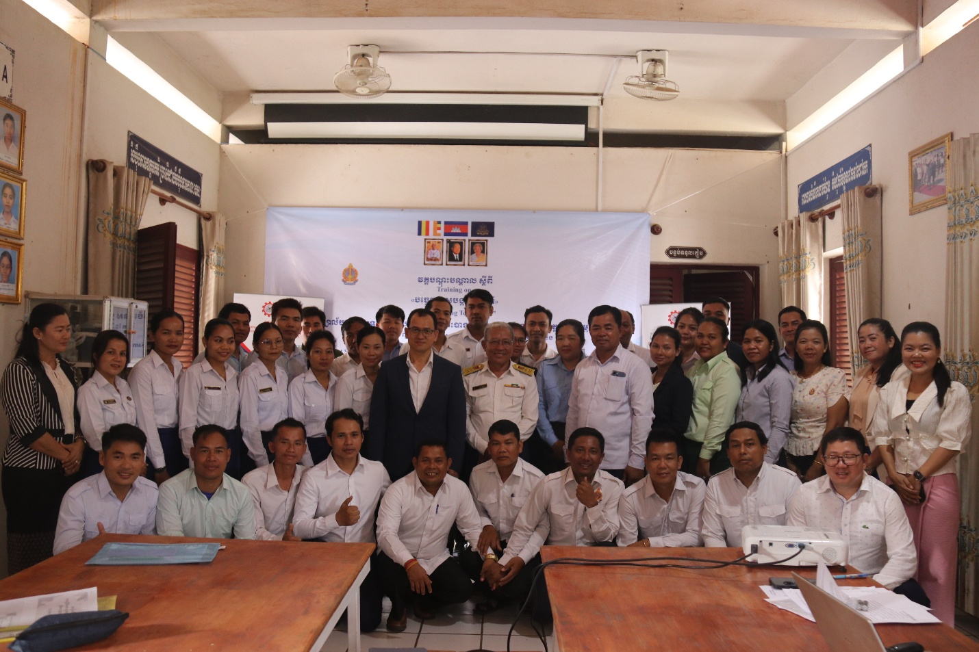
(Group Photo of All Participants)
The course responded to the needs assessment results identified in prior assessments and emphasized student-centered, entrepreneurship-linked applications to help schools develop income-generating aquaculture projects.
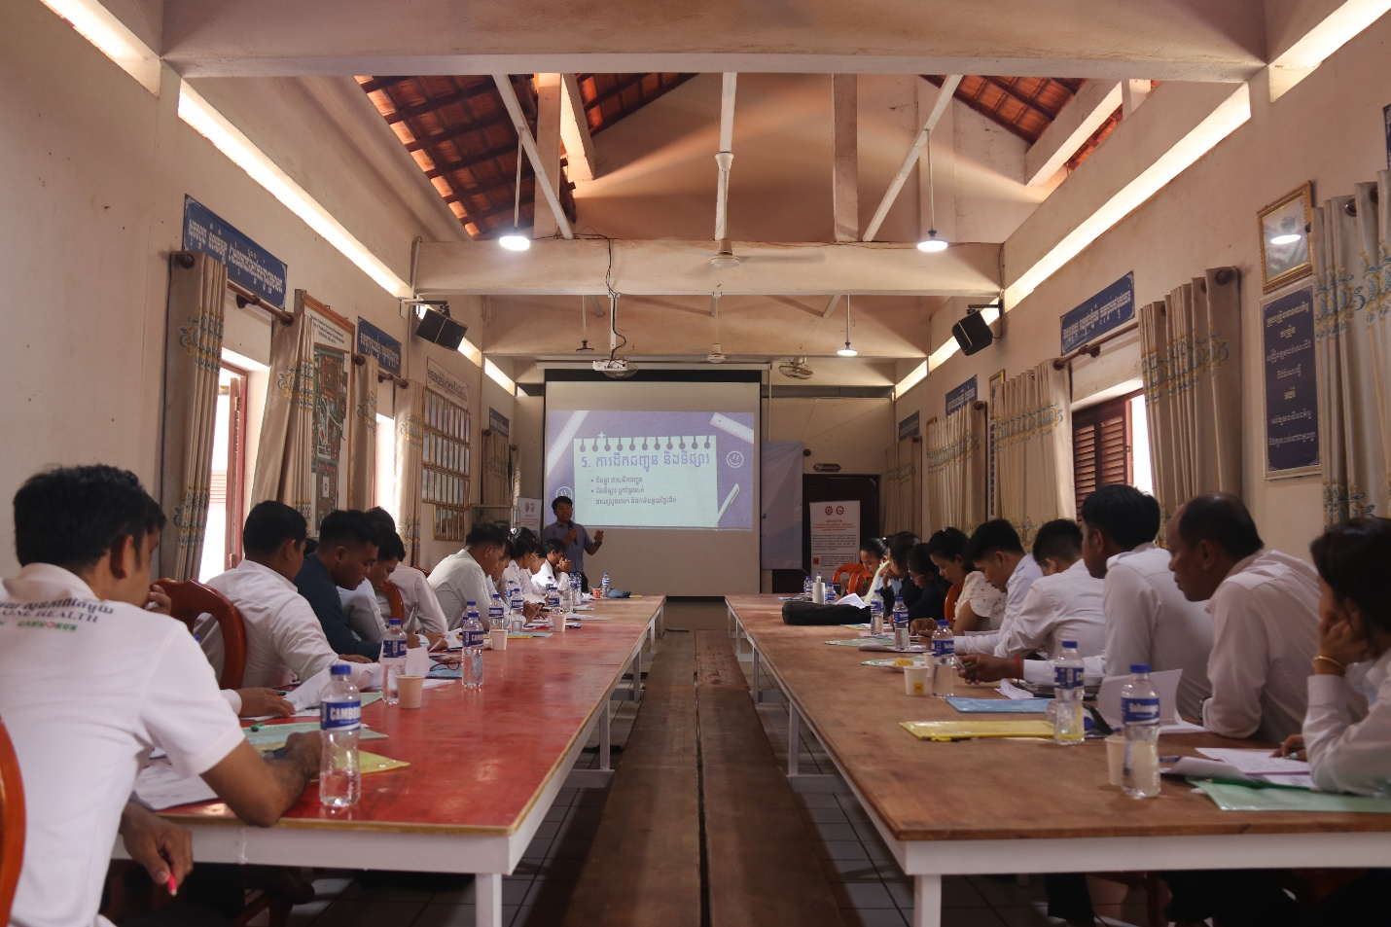
(A Trainer’s Explanation)
Key outcomes
• Enhanced capacity in hatchery planning, broodstock management, water quality, breeding methods, natural feed production, and fry care
• Emphasis on practical skills for classroom teaching and school-level entrepreneurial projects
• Prepared teachers to disseminate knowledge to students and support school aquaculture initiatives.
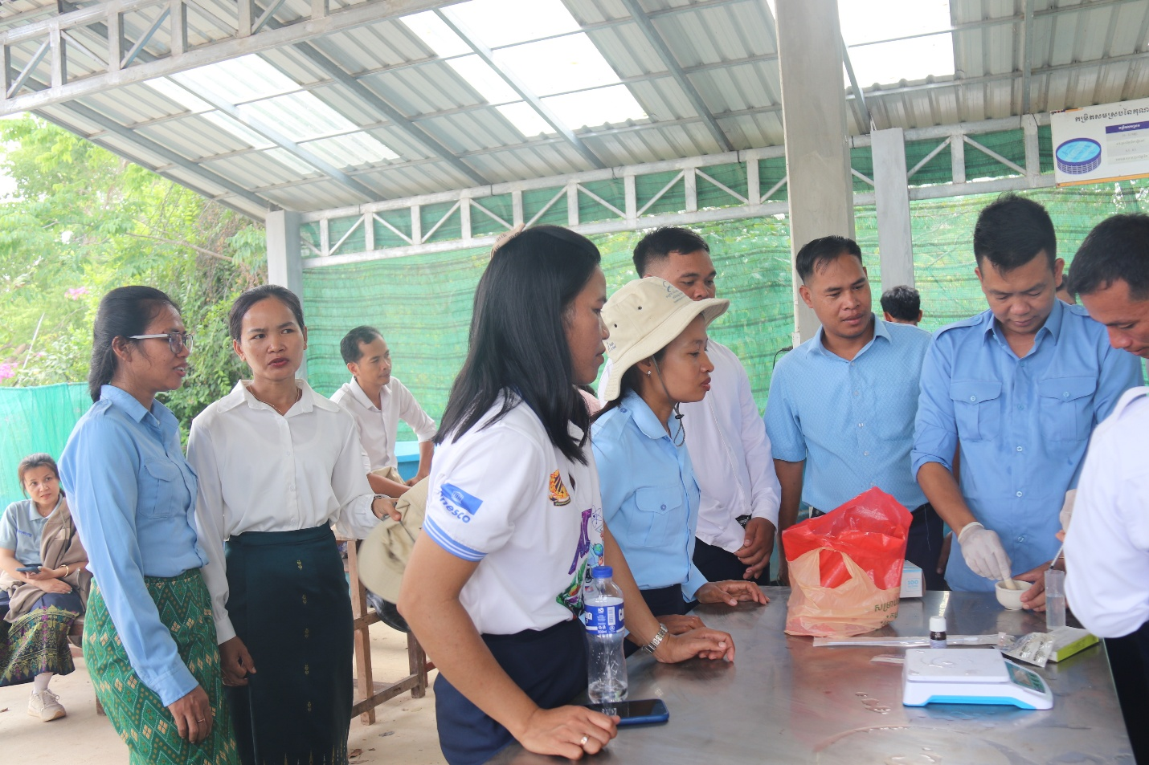
(Practicing Activities for Participants)

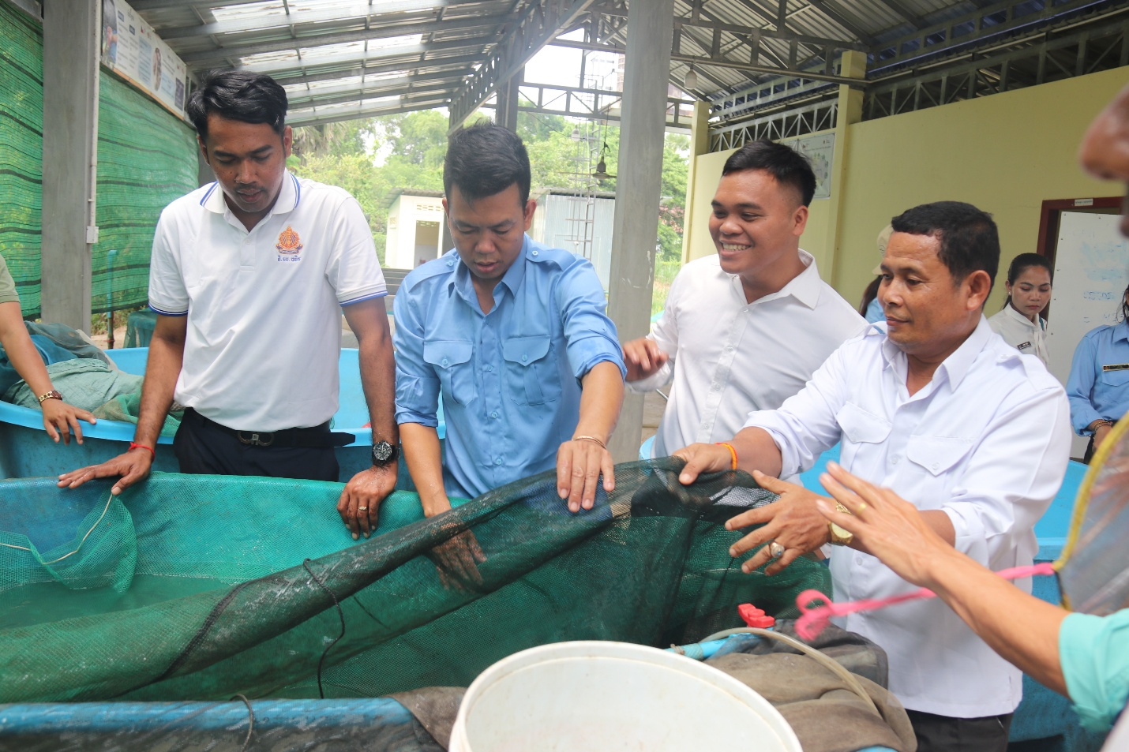
(Practicing Activities)
Finally, Dr. Ai closed the course by highlighting the takeaway messages that “keep learning and applying what you learned today to the real settings at your schools with your students”. The participation certificates have been awarded to all participants thereafter.
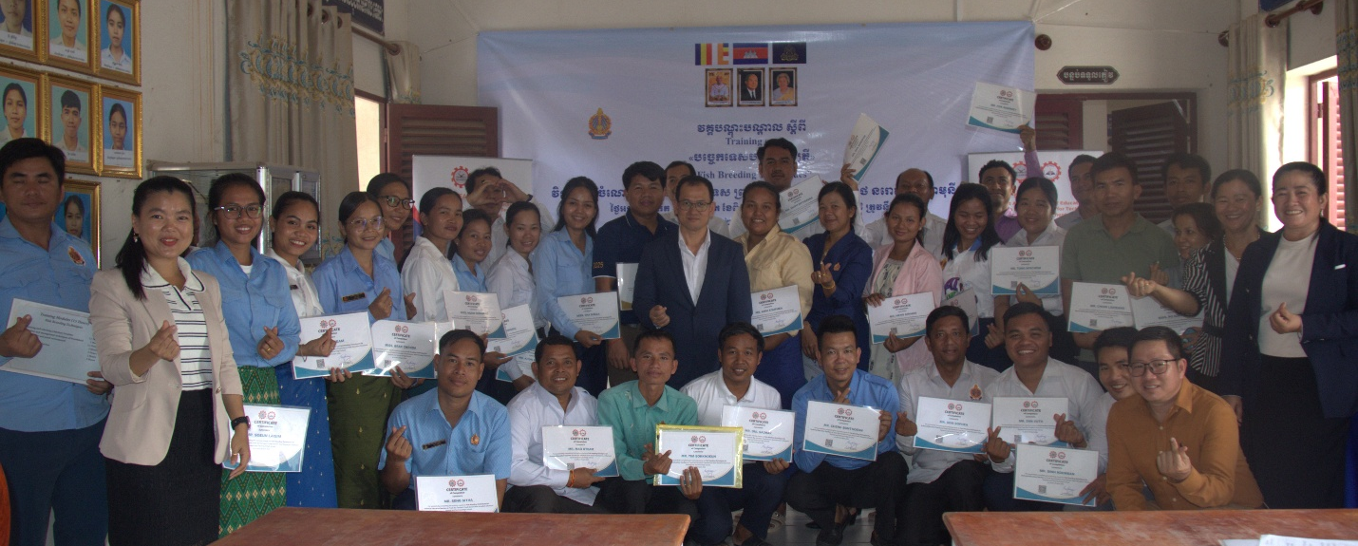
(Group Photo with Participation Certificates)

