2026 Global Capacity-Building Workshop on AI and Digital Transformation under the theme “Human Resource Development for an AI-Driven World”

Jeju, Republic of Korea | 27–30 April 2026

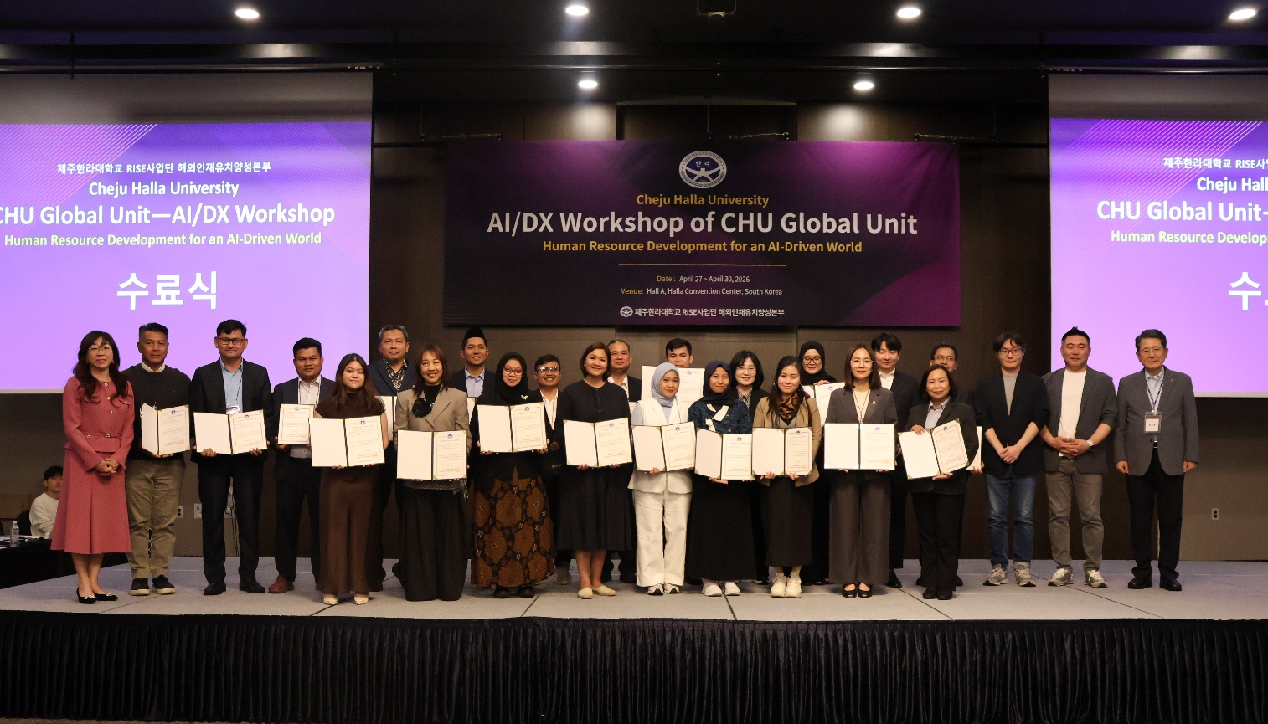
The 2026 Global Capacity-Building Workshop on AI and Digital Transformation was successfully conducted from 27–30 April 2026 in Jeju, Republic of Korea. The workshop was jointly organized by the CHU Global Unit of Cheju Halla University and SEAMEO Regional Centre for Technical Education Development (SEAMEO TED). The event brought together educators, university leaders, policymakers, researchers, and industry experts from ASEAN and Asia to strengthen collaboration on artificial intelligence (AI), digital transformation, and future-oriented human resource development. The workshop served as an important regional platform for exchanging knowledge, promoting innovation, and discussing practical approaches for preparing institutions and societies for an AI-driven future.
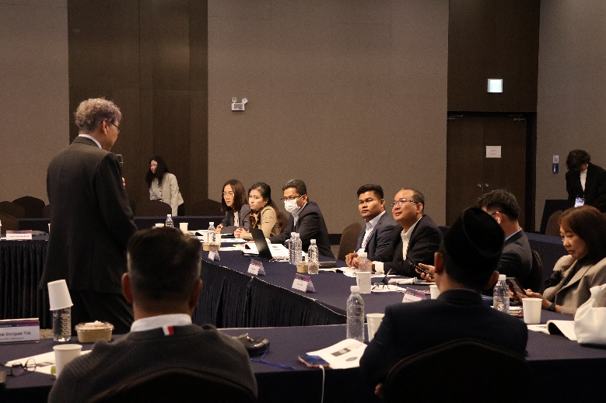
The workshop highlighted the rapidly growing influence of AI and digital transformation on education systems, workforce development, and institutional management. In the keynote sessions, Dr. Yong Wook Jun emphasized the urgent need for educational institutions to move beyond traditional teaching models toward personalized, AI-assisted, and borderless learning ecosystems. Participants discussed how educational leaders must evolve from being “gatekeepers” to becoming “architects” who design inclusive, innovative, and future-ready learning environments supported by AI technologies. The sessions also highlighted common regional challenges across Asia, including digital inequality, language diversity, limited AI infrastructure, and unequal access to quality education.
A key learning point from the workshop was that AI should not be viewed merely as a technological tool, but as a strategic partner for improving education quality, learning accessibility, and institutional efficiency. Through the presentation by Diquest Inc., participants explored “The Companion,” an AI-powered educational platform that supports students through personalized tutoring, learning analytics, academic planning, and career guidance, while also assisting teachers with lesson planning, assessment analysis, and administrative tasks. Participants recognized that AI has strong potential to reduce teacher workload, improve student support systems, and address challenges such as teacher shortages and learning poverty, particularly in developing countries.
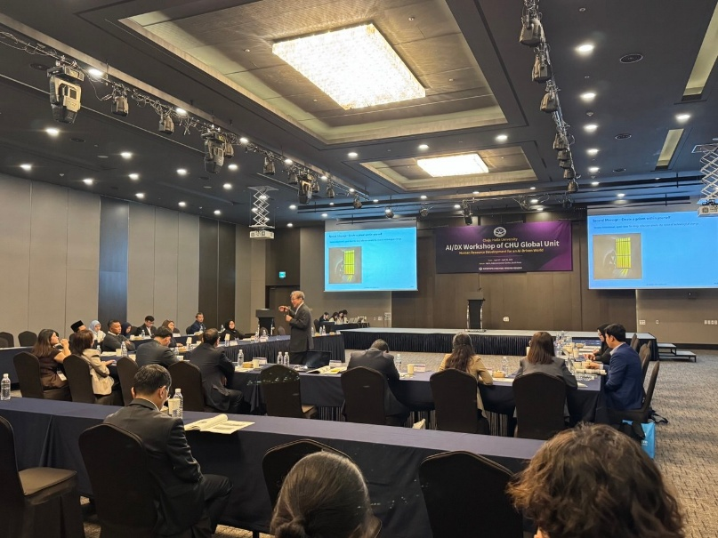
The workshop also provided valuable insights into Digital Twin and Spatial Computing technologies presented by Mr. Moses Jung from Pix4D. Participants learned how drones, photogrammetry, AI, cloud systems, and spatial computing can improve operational efficiency, safety, and decision-making in education, infrastructure, and industry. The sessions demonstrated that digital technologies can create immersive learning environments, strengthen practical skills development, and support future workforce training through real-time simulation and data-driven systems.
One of the major achievements of the workshop was the strengthening of international partnerships through the signing of several Memoranda of Understanding (MoUs). During the MOU/MOA Signing Session on 28 April 2026, Cheju Halla University signed collaboration agreements with Universitas Muhammadiyah Surakarta, Universidad de Manila, and Politeknik Siber Cerdika Internasional under the Regional Innovation System & Education (RISE) framework. These agreements focused on strengthening cooperation in AI and digital transformation education, international talent development, research collaboration, practical training, and the expansion of the CHU AI/DX Education Platform network across Asia.
In addition to the academic and partnership activities, participants also had the opportunity to engage in cultural visits and island exploration activities in Jeju. The program included visits to Seongsan Ilchulbong and Ilchul Land, where participants experienced the natural beauty, culture, and tourism attractions of Jeju Island. These cultural exchange activities strengthened networking, enhanced mutual understanding among participants, and promoted greater appreciation of Korean culture and heritage.
Lessons Learnt
Several important lessons were learned from the workshop. First, regional cooperation is essential for ensuring inclusive and sustainable AI development in ASEAN and Asia. No single institution or country can independently address the growing demands of AI infrastructure, policy development, and digital transformation. Second, AI implementation in education must be accompanied by ethical governance, teacher capacity-building, and culturally responsive learning systems. Third, practical collaboration between universities, industries, and international organizations is critical for developing future-ready skills and digital innovation ecosystems. Finally, accessible and affordable AI-supported education is necessary to reduce digital divides and create equal learning opportunities for all learners.
Based on the discussions and outcomes of the workshop, several follow-up actions were recommended. These include strengthening the collaboration network between SEAMEO TED, Cheju Halla University, and partner institutions; organizing future AI and digital transformation training programs for educators and TVET institutions across ASEAN; promoting joint research and pilot projects on AI-assisted learning systems; and expanding institutional partnerships through faculty and student exchanges. Participants also recommended the development of regional AI ethics guidelines, multilingual AI learning platforms, and collaborative digital education programs to support inclusive human resource development in ASEAN and Asia.
Overall, the workshop successfully enhanced participants’ understanding of AI technologies, digital education ecosystems, and future human resource development strategies. The event reinforced the importance of ethical AI governance, inclusive digital transformation, and regional partnership in preparing institutions and societies for the opportunities and challenges of the AI-driven era. Participants concluded the workshop with stronger international networks, practical knowledge, and renewed commitment to advancing AI and digital transformation initiatives within their institutions and countries.
