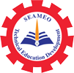
Training Course
on
“Curriculum Development and Teaching Methodologies for Technical Education Teachers”
Kampong Chheuteal Institute of Technology, 2-3 July 2026
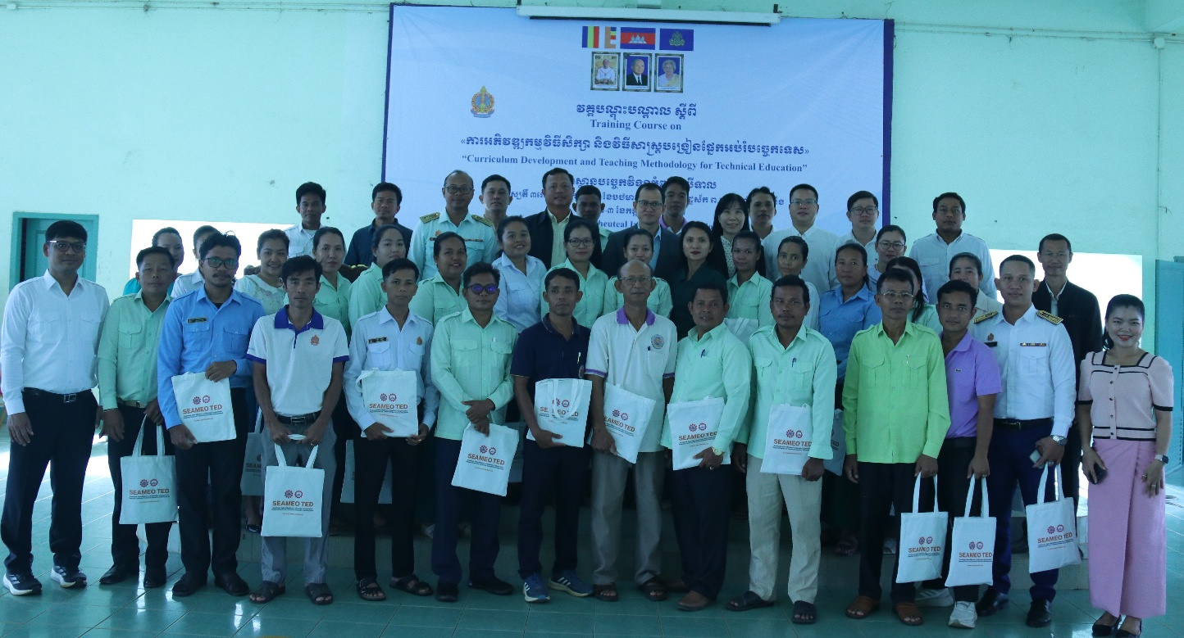
(Group photo)

Southeast Asian Ministers of Education Organization Regional Centre for Technical Education Development (SEAMEO TED) co-organized the Training Course on “Curriculum Development and Teaching Methodologies for Technical Education Teachers” with Kampong Chheuteal Institute of Technology, Kampong Thom Province which was participated by 42 teachers (14 females) from six General and Technical High Schools across Cambodia. The course aimed to enhance teachers ‘capacity with techniques in developing curriculum and textbooks and teaching methodologies for technical education teachers in Cambodia.

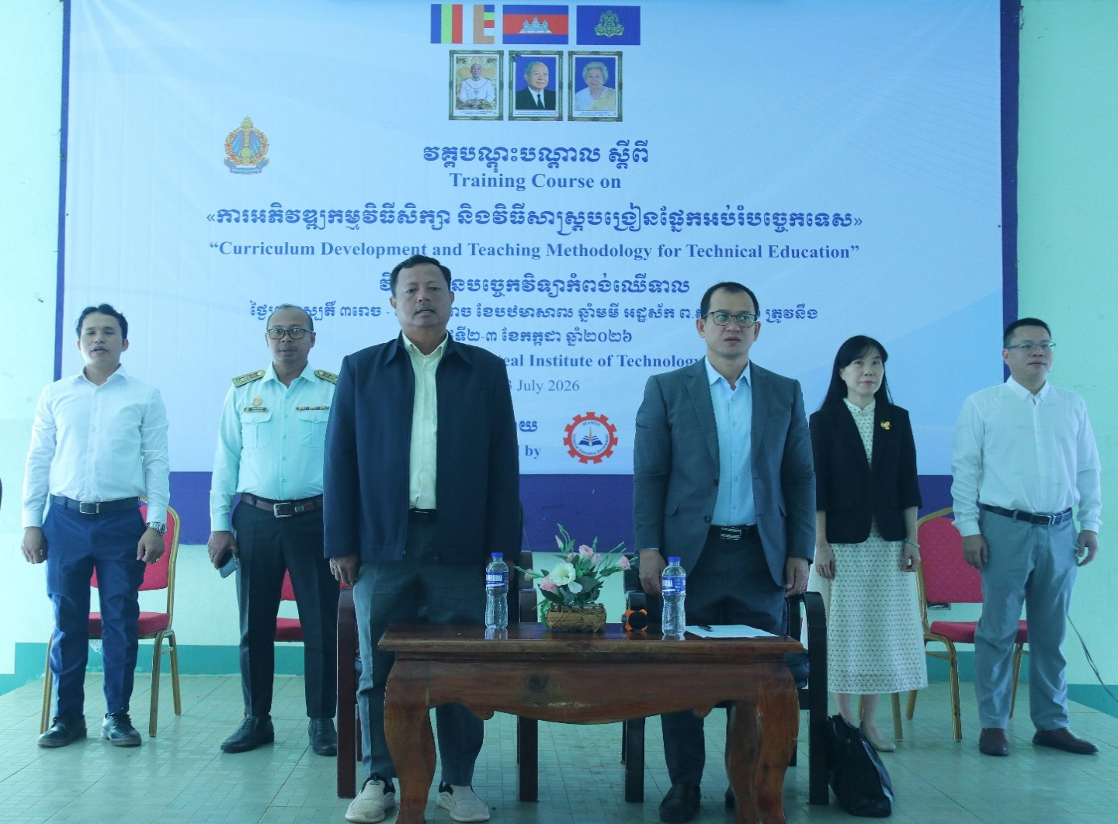

(Opening Ceremony Presided over by Dr. Songheang Ai, Director of SEAMEO TED)
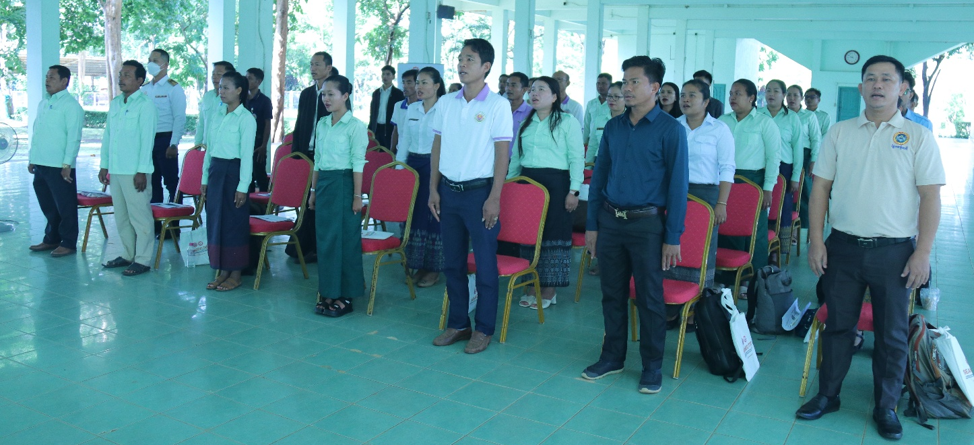

(Participants rose for Cambodia’s National Anthem)

During the opening ceremony, Dr. Songheang Ai highlighted that Continuous Professional Development (CPD) for teachers is very crucial in improving students’ learning outcomes. He also stressed that teachers of technical education need to possess knowledge of curriculum development and instructional system design constantly to stay relevant due to the fast pace of technological innovations. Therefore, teachers could adjust existing teaching modules or develop new teaching content based on these changes.

Additionally, teaching methodologies for technical education are equally important for teachers. Teachers need to update their skills, adapt to new ways of teaching and learning processes and how they can make their lessons captivating to actively engage the students and maximize the learning outcomes of the students.
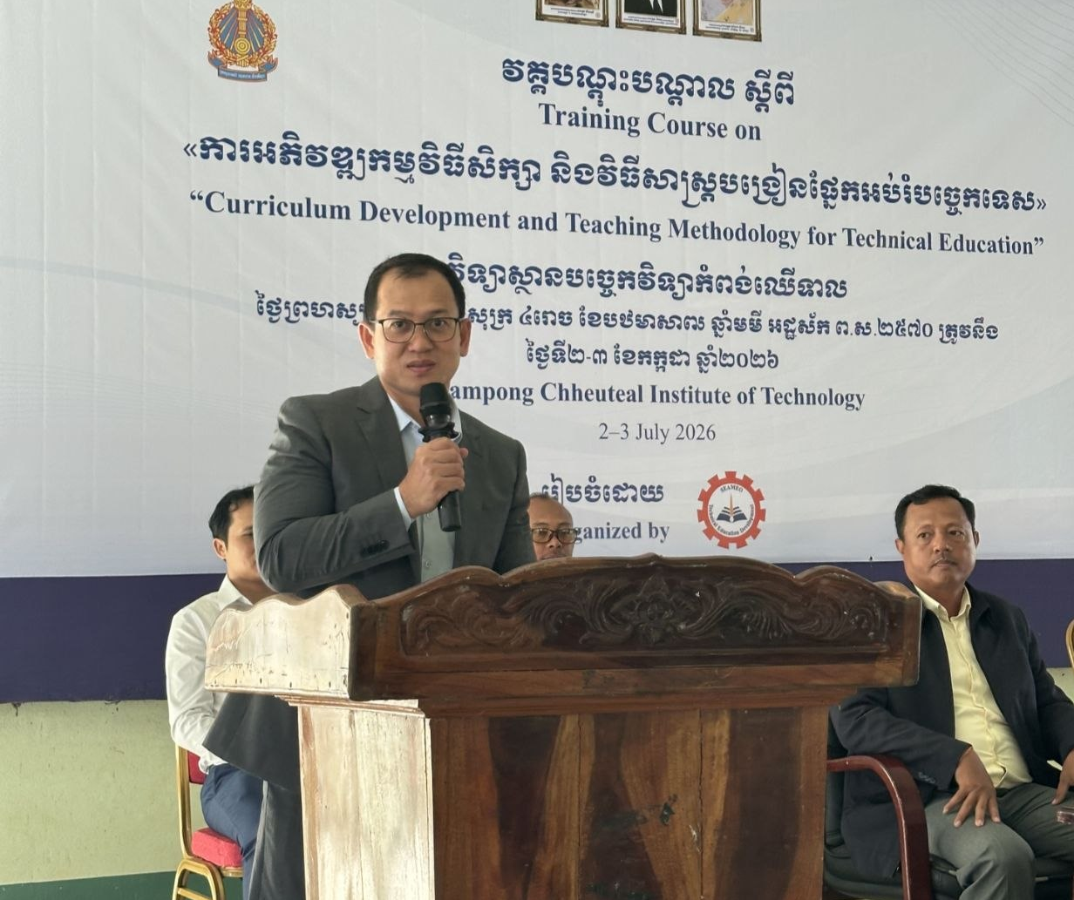

(Dr. Songheang Ai delivered opening remarks.)

This training was lectured by three experts: Dr. Songheang Ai, Centre director of SEAMEO TED, and two Chinese experts— Ms. Wei Qin, Professor of Guangxi Vocational College of Water Resources and Electric Power, and Mr. Li Jiahong, Senio Engineer of Guangxi Polytechnic of Construction. The three trainers covered five different topics with a balance of theory and practices: (1) Curriculum Development & Implementation; (2) Process of Curriculum and textbook development in China; (3) Textbook development; (4) Teaching methodologies in Technical and Vocational Education, and (5) Practical lesson design analysis based on Vocational Education Theories.
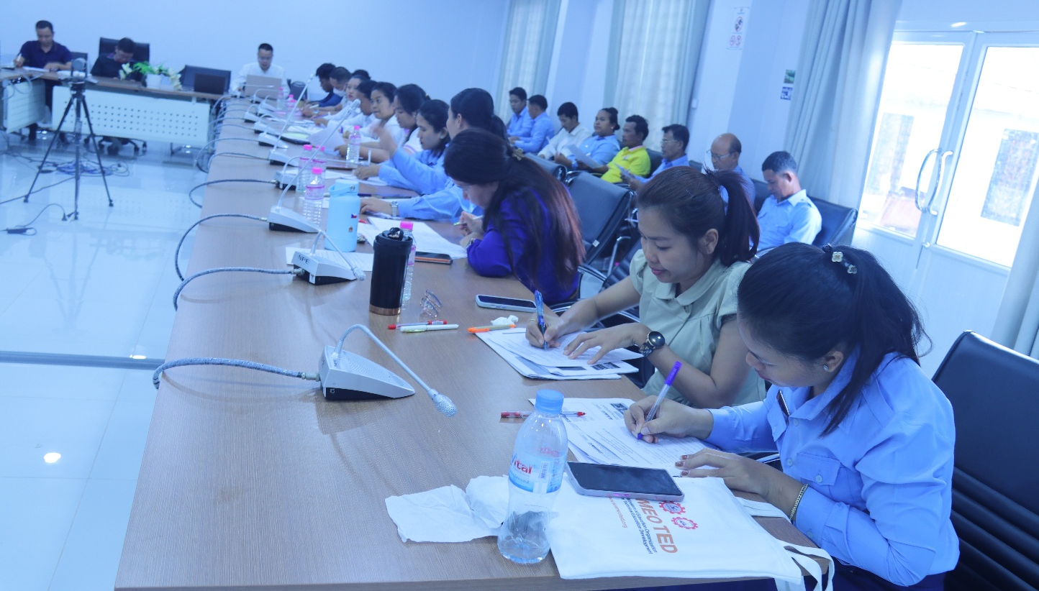
(Participants Filling Out the Pre-test form)
As part of lecturing methods, trainers enabled participants to practice what they have learnt by engaging them in group work, discussion and hands on activity. The course evaluation was also undertaken to measure the level of their learning and satisfaction with the course.
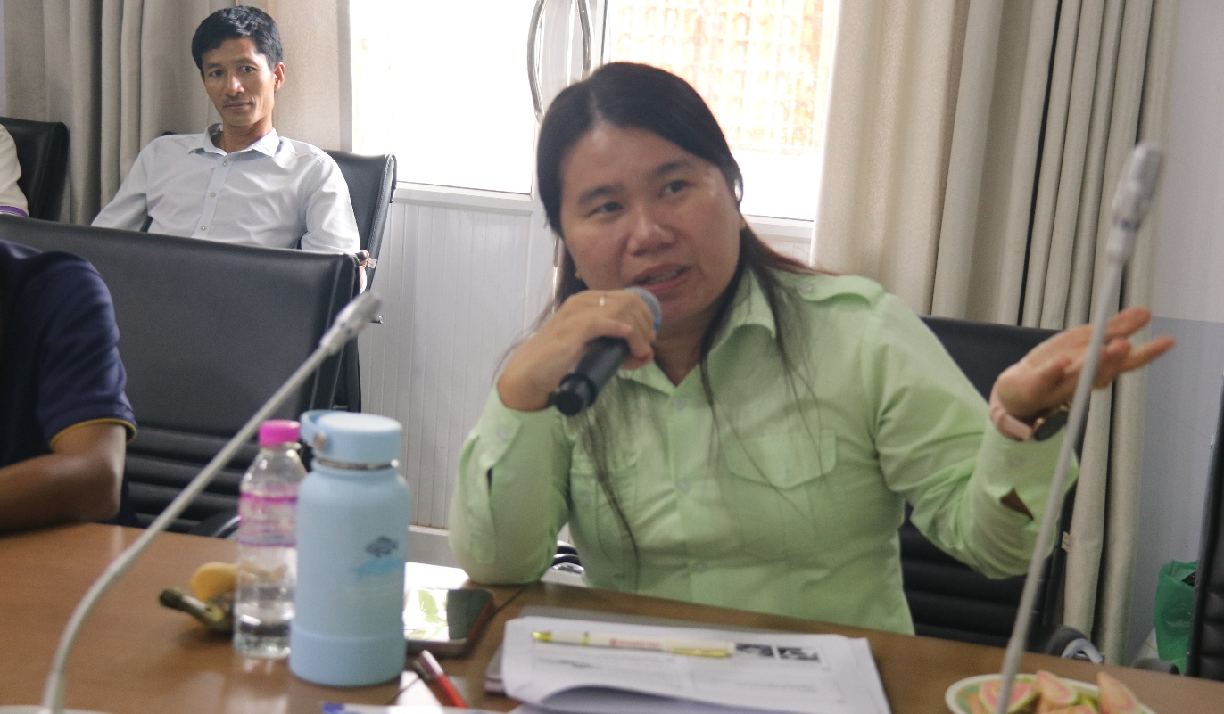
(Participant raised a question)

