International Experts Sharing Forum on
“Regional Cooperation & Mobility for Youth Skills Development”
July 3, 2026 (Online)

July 3, 2026: the 7th session of the “International Experts Sharing Forum,” jointly organized by the China-ASEAN Technical Education Cooperation Platform (CATECP), the Southeast Asian Ministers of Education Organization Regional Centre for Technical Education Development (SEAMEO TED), and Go Study Global Education, was successfully concluded online. The meeting was attended by 53 male and 56 female participants, making a total of 109 participants.
Themed “Regional Cooperation & Mobility for Youth Skills Development”, the meeting brought together experts and scholars from Indonesia, Philippines, and Vietnam. Discussions focused on cross-cultural online education, boosting youth employability, understanding local cultural values, and investing in green finance. These topics were explored through keynote speeches, case studies, and interactive exchanges. These topics were explored through keynote speeches, case studies, and interactive exchanges.
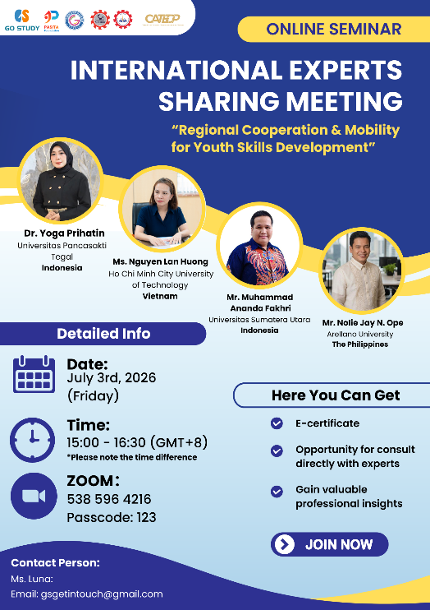

Dr. Yoga Prihatin, Dean, Teacher Training and Education Faculty, Universitas Pancasakti Tegal, Indonesia, shared the topic: From Comprehension Gaps to Collaborative Competence: Preparing Youth for Regional Skills Mobility. Dr. Yoga addresses the essential need to prepare youth for regional skills mobility by analyzing cross-cultural online education exchanges between Indonesia, Russia, and Poland. Synthesizing three studies, she highlights that while international virtual guest lectures effectively broaden global mindsets, persistent barriers remain. These include language accents, direct versus indirect communication styles, and internet connectivity disruptions. To bridge these gaps, she recommends that educators adopt multimodal communication, clear language accommodation, and culturally responsive pedagogy. Ultimately, she concludes that governments and universities must invest in digital infrastructure and curriculum design to foster globally competent professionals.
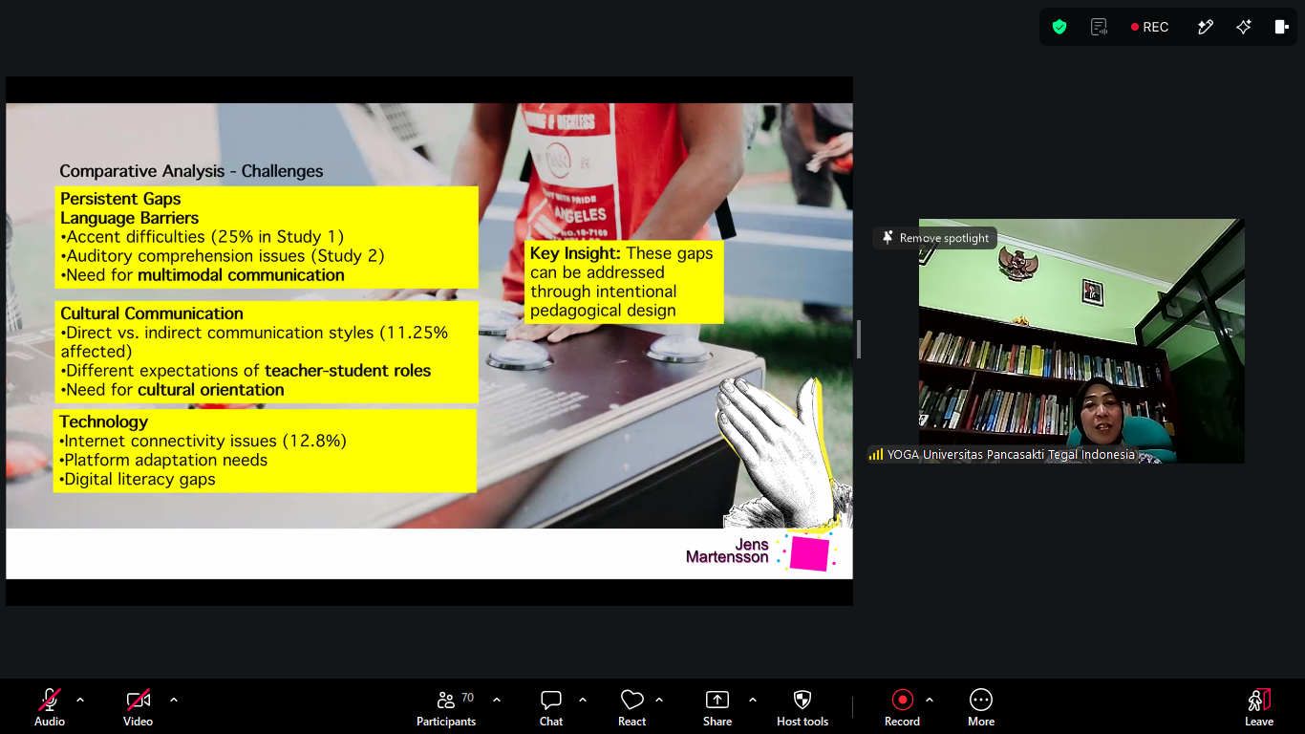
(Dr. Yoga Prihatin’s Lecture)

Ms. Nguyen Lan Huong, Head of Department of International Relations and Project Management, Ho Chi Minh City University of Technology, Vietnam shared the topic: From mobility to employability: Building Skills Beyond Borders. In her presentation Ms. Nguyen Lan Huong outlines a strategic framework for shifting the focus of international education from basic student mobility to sustainable career employability. Citing empirical data from UNESCO, the Erasmus Impact Study, and UUKi, she demonstrates that globally mobile students achieve notably higher professional-level employment rates and remain significantly less likely to experience long-term unemployment compared to their non-mobile peers. To realize these outcomes, Ho Chi Minh City University of Technology (HUTECH) offers comprehensive internationalization pathways. These initiatives include credit-transfer semester exchanges across eleven distinct academic disciplines, diverse internship opportunities, spanning research center assistantships and corporate industry placements utilizing HUTECH’s extensive network of 5,500 companies, and highly collaborative short-term immersion camps. By integrating cultural exchange with community-centered Design Thinking projects, these programs effectively prepare international youth with the cross-border competencies necessary for the modern workforce.
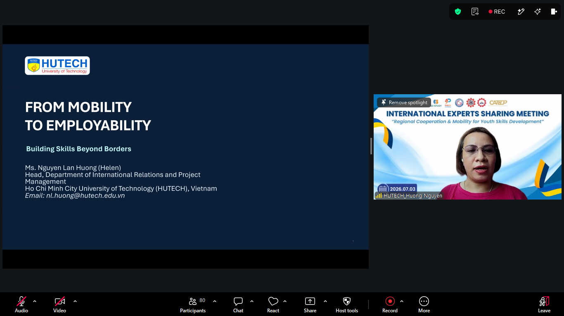
(Ms. Nguyen Lan Huong’s Lecture)
Mr. Nolie Jay N. Ope, Hospitality Industry Practitioner and Lecturer, Arellano University, Philippines shared the topic: Empowering and Facilitating Cross-cultural Engagement. Mr. Nolie explores how regional alignment and international mobility can empower young professionals through eco-tourism and cultural integration. He explains that meaningful engagement in the Philippines requires a deep understanding of core cultural values, such as Bayanihan (community spirit), Kapwa (shared identity), Pakikisama (harmony), and Hiya (propriety). To build strong professional partnerships, Mr. Nolie highlights engagement’s best practices, including using respectful titles, learning basic Tagalog, and smiling warmly. He also shows the country's rich natural geography, such as the unique Chocolate Hills and the Puerto Princesa Subterranean River, as major eco-tourism assets. Ultimately, he concludes that structured youth mobility programs provide significant long-term advantages, yielding better employment paths, modern technical skills, universally accepted vocational certifications, and profound personal or cultural growth for young professionals.
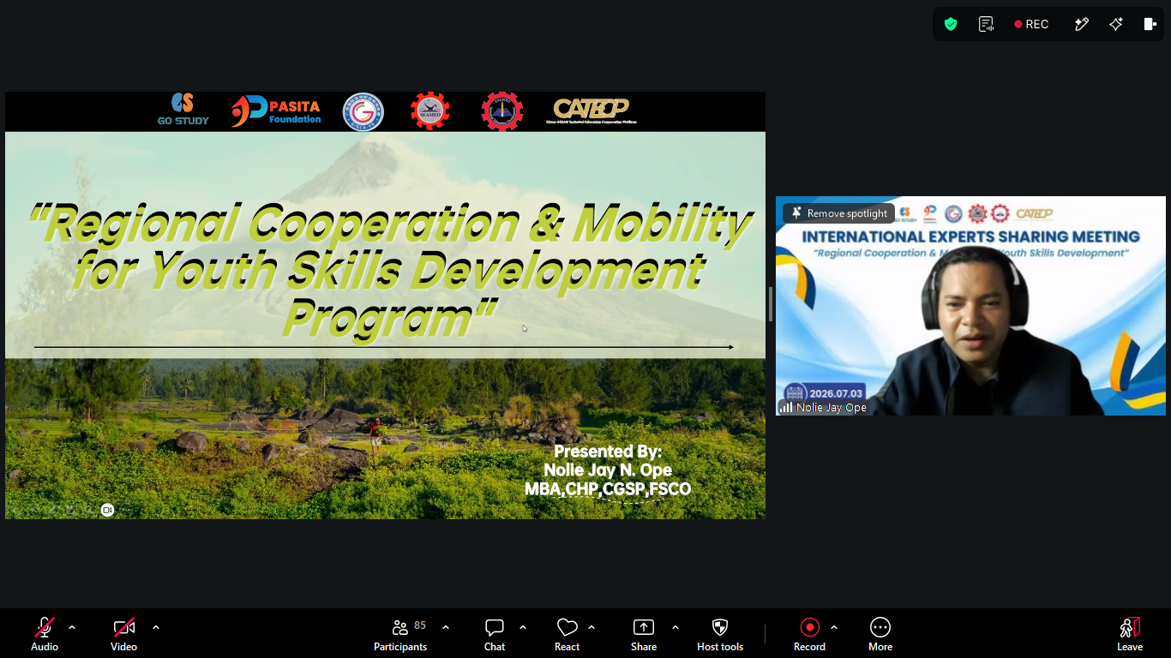
(Mr. Nolie Jay N. Ope’s Lecture)

Mr. Muhammad Ananda Fakhri, Lecturer, Faculty of Economics and Business, Universitas Sumatera Utara, Indonesia, shared the topic: Green Money Moves: Why ASEAN Youth Should Invest Differently. The presentation from Mr. Muhammad Ananda Fakhri focuses on a financial-engineering case for young investors to transition their capital from cryptocurrency to green and sustainable finance. While individuals under thirty represent a significant majority of individual and crypto investors in Southeast Asia, a "say-do gap" persists where their strong sustainability preferences are not reflected in their portfolios. Crypto successfully captured this demographic by offering access, agency, and a compelling narrative; however, green finance serves as the institutional upgrade. Valued at USD 5.7 to 6 trillion, every dollar in green bonds holds a legal claim on physical, real-world projects. Furthermore, because a 22-year-old investor absorbs decades of accumulating, unpriced climate risk, holding green assets acts as a vital portfolio shield and safe-haven shock absorber. Backed by synchronized regional regulatory frameworks across ASEAN and China, investors are urged to build disclosure literacy, audit climate risks, and execute green trades.
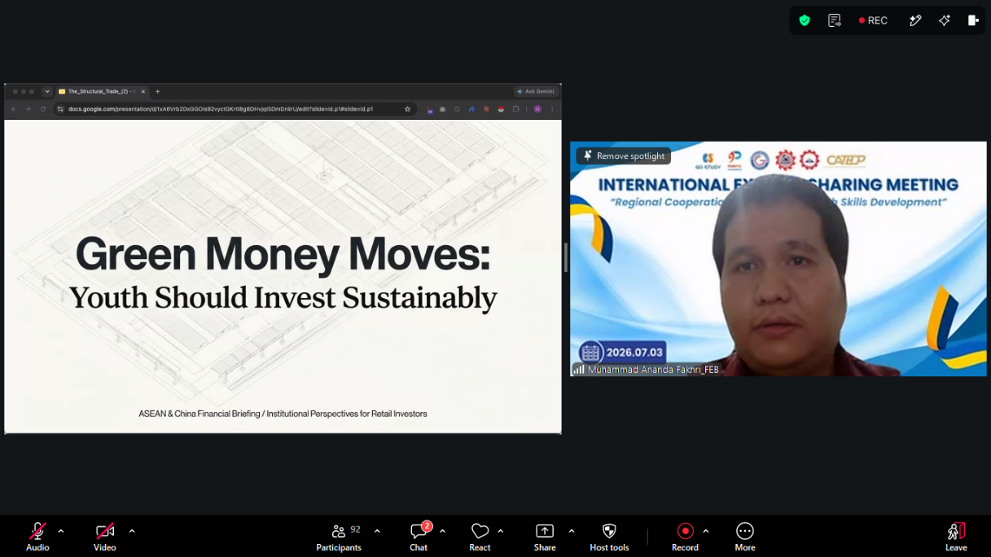
(Mr. Muhammad Ananda Fakhri’s Lecture)

