International UNESCO Chair Conference 2026

International Cooperation in High Education and TVET-Bridging the Gap between Theory and Practice of SDGs

30 September-02 October 2026

TU Dortmund University, Germany
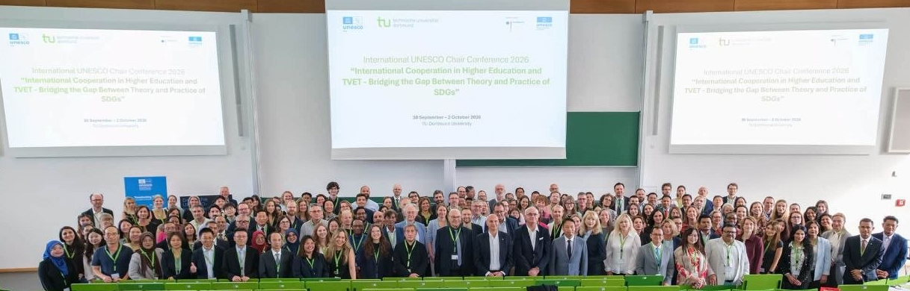

(Group Photo of All Participants)

1. Introduction
SEAMEO TED, in cooperation with TU Dortmund University, Germany co-organized the UNESCO Chair Conference on “International Cooperation o Higher Education and TVET-Bridging the Gap between Theory and Practice of SDGs on September 30-October 2, 2026 at TU Dortmund University, Germany, which was participated by over 200 international participants from over 40 countries as policy makers, curriculum developers, presidents/rectors of universities, TVET Experts, and researchers. The conference provided a multidisciplinary platform to examine how higher education and TVET can contribute to the Sustainable Development Goals (SDGs) and, importantly, how academic knowledge and policy commitments can be translated into practical actions. The conference aims to highlight innovative approaches to higher education and TVET which actively support the achievement of the sustainable development goals through research, development and implementation strategies, as well as teaching and learning practices. The conference features keynote speeches and workshops led by UNESCO Chairs in their respective fields of expertise. Participants had opportunities to take part in excursions to the Ruhr region, exploring sites that are relevant to the SDGs. The programme addressed a wide range of contemporary issues, including urban development, human-forest-water linkages, beyond the SDGs 2030, TVET’s contribution to social and technological sustainability, UNESCO’s practical guide on the integration of AI in TVET, digital literacy and circular economy, leadership for holistic implementation of education, virtual reality in competence development for SDGs, potential of modern digital geomedia, cultural entrepreneurship and policy, industrial heritage, and work-integrated learning. As a co-organizer of the conference, Dr. Songheang Ai, director of SEAMEO TED has led the ASEAN delegation as TVET experts, and policy makers to join it and share ASEAN perspectives with the audiences. Some of them are from Cambodia, Malaysia, Indonesia, Vietnam, Philippines, China, India, etc.

2. Opening Ceremony

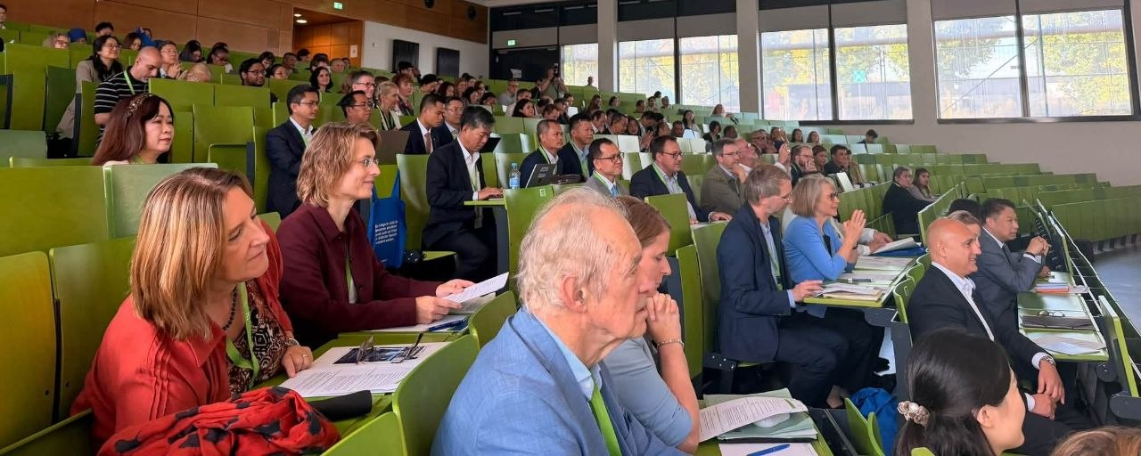
(Participants at the Opening Ceremony)
The conference was opened by (1) Prof. Dr. Manfred Bayer, President of TU Dortmund University; (2) Mr. Alexander Kalouti, Mayor of City of Dortmund; (3) Ms. Friederike Hansell, World Heritage Focal Point, UNESCO Section, Federal Foreign Office; (4) Prof. Dr. Christoph Wulf, Vice President of German UNESCO Commission; (5) Prof. Dr. Christine Volkmann and Prof. Julius Heinicke, Speaker of German UNESCO Chairs; (6) Dr. Sandra Garbade, President of Federal Institute for Vocational Education and Training (BIBB); and (7) Dr. Songheang Ai, Director of SEAMEO TED. Prof. Dr. Manfred Bayer emphasized the growing importance of artificial intelligence, higher education, and TVET in achieving the SDGs. His remarks reflected the need for education systems to respond to rapid technological and social changes. Mr. Alexander Kalouti highlighted the historical transformation of Dortmund from an industrial city toward a modern centre of education, culture, innovation, and internationalization, illustrating how education can contribute to the future development of cities and communities. Ms. Friederike Hansell emphasized the importance of SDGs, skills development, international research, and international cooperation, while Prof. Dr. Christoph Wulf raised the complexity of bridging the gap between theory and practice and expressed appreciation for bringing together participants from approximately 40 countries. Prof. Dr. Christine Volkmann and Prof. Julius Heinicke introduced research initiatives associated with the German UNESCO Chairs, while Dr. Sandra Garbade highlighted the issues related to internationalization of research and climate change.
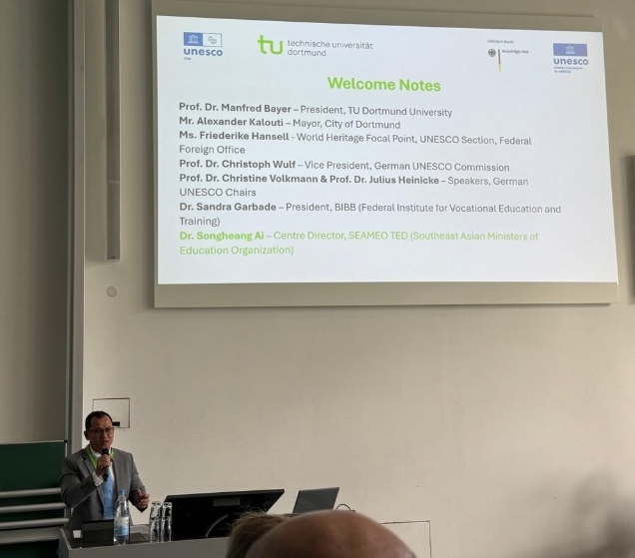
Finally, Dr. Songheang Ai emphasized that TVET is increasingly positioned at the intersection of demographic change, artificial intelligence, and the green transition. He also raised the importance of German Agency Involvement in TVET development in the ASEAN region that the German dual VET system can be shared and learned.

(Dr. Ai Delivering His Impressive Remarks)

3. Keynote Presentations
The keynote session provided the broad international perspective on the challenges and opportunities facing education, TVET, and sustainable development.

Digitalization and TVET
Dr. Wenxi Wu, UNESCO Chair on Digitalization in TVET, Shenzhen Polytechnic University, China, presented on the transformation of the world of work and learning. Her presentation emphasized a systems approach to digital transformation, highlighting integrated public digital infrastructure, industry–education integration, standards and governance, digital inclusion, teacher development, and AI-enabled teaching and learning. An important message was that digital transformation should not be viewed simply as the introduction of technology into classrooms. Rather, it requires institution-wide transformation, including changes in curricula, teaching and learning, governance, infrastructure, programmes, and partnerships.

Sustainable Water Management
Prof. Dr. Mariele Evers, UNESCO Chair in Human-Water-Systems, Rheinische Friedrich-Wilhelms-Universität Bonn, presented on “Transdisciplinary Research – Bridging the Gap between Theory and Practice for Sustainable Water Management”. Her contribution demonstrated the importance of connecting research and academic knowledge with practical environmental and societal challenges. The focus on human–water systems illustrated the need for interdisciplinary and transdisciplinary approaches to complex sustainability issues and reinforced the conference's central objective of connecting theory with practice.

Higher Education during the War Times
Prof. Olga Tsaryk, West Ukrainian National University; Prof. Dr. Mariana Sokol, Ternopil Volodymyr Hnatiuk National Pedagogical University; and colleagues from the University of Rzeszów, Poland, addressed “Maintaining Higher Education in Times of War.” The presentation brought an important perspective on educational resilience, institutional continuity, adaptation, and international cooperation during crisis and conflict. It demonstrated that sustainability also involves ensuring that education systems can continue to serve learners and communities under challenging circumstances. Together, the keynote presentations demonstrated that sustainable development requires simultaneous attention to technological transformation, environmental sustainability, social resilience, institutional adaptation, and international cooperation.

4. Parallel Workshops and Thematic Discussions
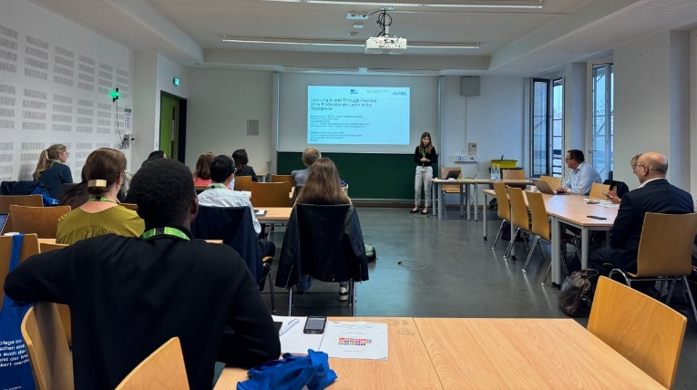
The conference programme included a broad range of parallel workshops, allowing participants to examine different dimensions of sustainable development and the role of higher education and TVET.
The first group of workshops covered:
- Urban Development – Strategies for a Sustainable Transformation of the City and Region of Tomorrow
- Human–Forest–Water Linkages: Towards Sustainable and Resilient Socio-Ecological Systems
- Beyond the SDGs 2030 – What New SDGs for 2050 Will Lead to a More Equal World?!
- TVET’s Contribution to Social and Technological Sustainability
- UNESCO’s Practical Guide on the Integration of AI in TVET
- Digital Literacy and the Circular Economy
- Doing Justice to the Past? Memory Politics and Education from a Transnational Perspective.
The second group of workshops addressed:
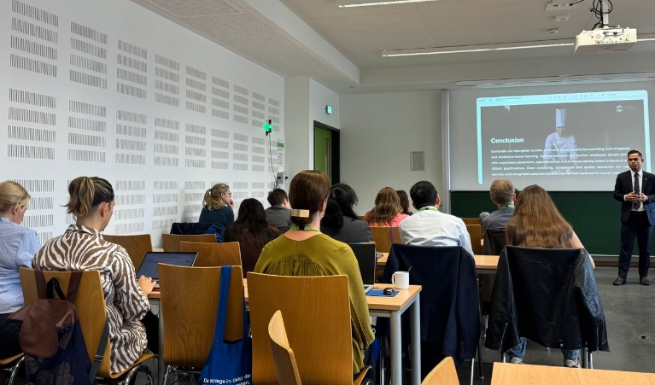
- Leadership for Holistic Implementation of Education for Sustainable Development in Schools and Universities
- Virtual Reality in Competence Development for SDGs
- TVET’s Contribution to Social and Technological Sustainability
- Potential of Modern Digital Media to Foster Education for Sustainable Development
- Cultural Entrepreneurship and Policy
- Limits of Change? Industrial Heritage between Preservation and Sustainable Development
- Work-Integrated Learning and Competence Development – The Future of Work and Learning?
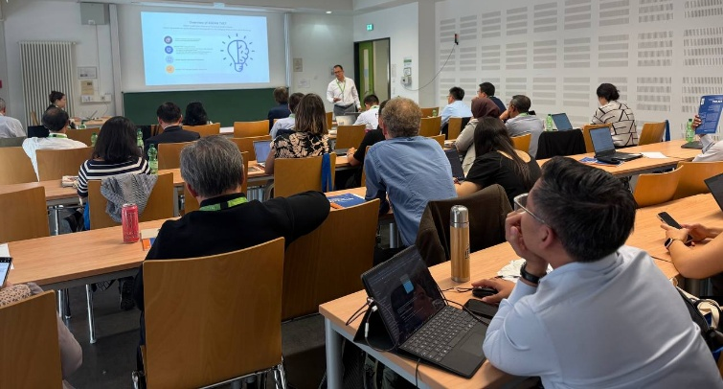
These workshops demonstrated the interdisciplinary nature of the conference and highlighted the increasing convergence between education, technology, sustainability, employability, leadership, entrepreneurship, and societal development.

(Dr. Ai Presenting his Topic)

Dr. Songheang Ai presented “Emerging Trends in TVET in the ASEAN Region,” highlighting key developments and priorities for transforming TVET across ASEAN. He emphasized the ASEAN Work Plan on Education 2026–2030, digital transformation and AI, green skills and the circular economy, and the growing importance of the care economy. Dr. Ai also highlighted regional mechanisms such as the AQRF, ASEAN TVET Council, and quality assurance frameworks, which support skills mobility, quality, and regional cooperation. He showcased practical initiatives involving SEAMEO VOCTECH, ASEAN–ROK TVET Mobility, and Greening TVET, demonstrating how curriculum development, industry engagement, internships, and green practices can strengthen learners’ skills and employability.
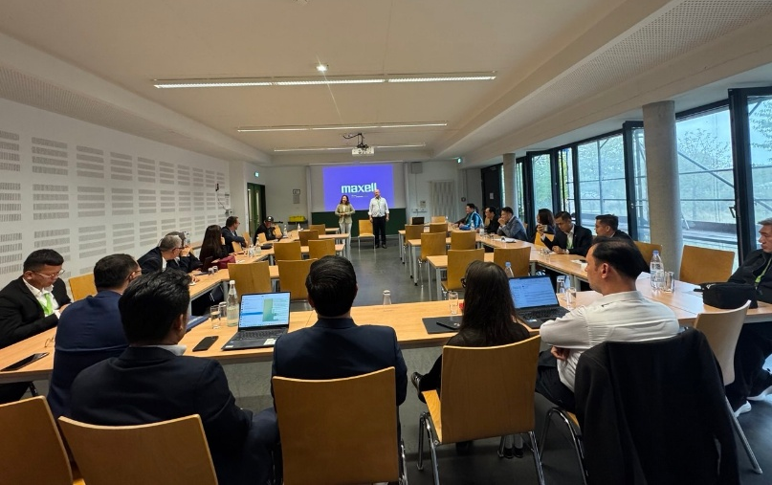
5. Strategic Discussion and Meeting Between TU Dortmund University and ASEAN Institutions
(Strategic Discussion between TU Dortmund University and ASEAN Institutions)

During the conference, Dr. Songheang Ai, coordinated the strategic discussion with Professor Dr. Maximiliane Wilkesmann, Vice President for International Affairs and Diversity of TU Dortmund University, to explore opportunities for strengthening institutional cooperation between TU Dortmund University, SEAMEO TED, and partners in the ASEAN region. The discussion focused on identifying practical areas of collaboration that could contribute to academic development, internationalization, mobility, entrepreneurship, and skills development. Both sides (TU Dortmund University and SEAMEO TED) agreed to cooperatively work on study programs for ASEAN students to study Master’s and doctoral degrees at TU Dortmund University for the upcoming academic year and students exchange programs.

6. Welcome Dinner, Exhibitions, and Institutional Visits
An important feature of the three-day conference was the combination of academic discussion with practical exhibitions, site visits, and experiential learning activities. Participants had the opportunity to engage with the DASA Workplace Exhibition Hall, providing practical insights into workplaces, occupational development, safety, technology, and the changing world of work. The welcome dinner was hosted by the president of TU Dortmund University on day 1 (30 September) of the conference.

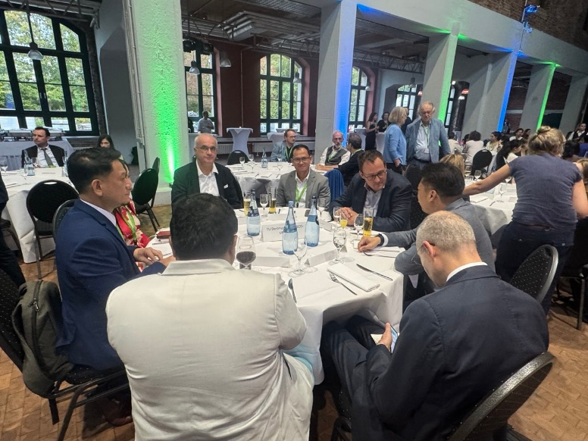

(VIP Table during the Welcome Dinner)
The programme also included visits and activities associated with:
- Colliery Zollern – Industrial Heritage Icon, demonstrating the historical importance and preservation of industrial heritage;
- Phoenix West Area, illustrating the transformation of a former industrial site and urban regeneration;
- German Football Museum, connecting culture, history, identity, and social development;
- Dortmund U and Union Quarter, demonstrating urban and cultural transformation; and
- Training Center of the Chamber of Crafts (Handwerkskammer Dortmund), providing insight into Germany's vocational education, skills training, and industry-oriented learning.
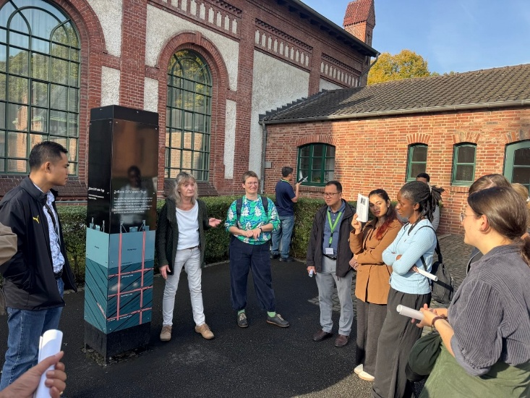
These activities complemented the academic workshops by demonstrating how the themes discussed in the conference are applied in real institutional, industrial, cultural, and community contexts.

(Visiting Colliery Zollern)

7. Lessons Learnt from the Three-Day Conference
The three-day programme highlighted six key lessons for higher education and TVET:
- Future-ready skills: Education must respond to AI, digitalization, climate change, demographic shifts, and emerging jobs.
- Digital transformation: AI adoption requires infrastructure, governance, teacher development, curriculum reform, and industry partnerships.
- Green and sustainable TVET: Green skills, circular economy, and climate resilience should be integrated into curricula and institutional practices.
- Stronger industry links: Work-integrated learning is essential for developing practical and employment-relevant skills.
- Institutional resilience: Higher education and TVET institutions must strengthen their ability to adapt and maintain continuity during crises.
- Regional and international cooperation: Complex challenges require collaboration among education institutions, governments, industry, communities, and international organizations.

8. Conclusion
Dr. Songheang Ai's participation in the UNESCO Chairs International Conference on Cooperation in Higher Education and TVET in Dortmund provided an important platform for SEAMEO TED to represent the ASEAN perspective in global discussions on sustainable development, higher education, and TVET. Across the three-day programme, the conference successfully connected research and practice, higher education and TVET, technology and sustainability, education and industry, and local experience with international cooperation. The keynote presentations provided perspectives on digitalization of TVET, sustainable water management, and the resilience of higher education during war, while the parallel workshops explored AI, digital literacy, circular economy, green skills, work-integrated learning, sustainable leadership, urban development, entrepreneurship, and industrial heritage. Dr. Ai's presentation on “Emerging Trends in TVET in the ASEAN Region” provided a valuable regional contribution, highlighting ASEAN's responses to digital transformation, AI, green transition, circular economy, demographic change, care economy, future skills, and lifelong learning.

For SEAMEO TED, the conference provided valuable knowledge, international visibility, professional networking, and potential avenues for future collaboration. It also reaffirmed the Centre's role in supporting ASEAN Member States to develop future-ready, inclusive, digital, green, and industry-responsive TVET systems that contribute meaningfully to sustainable development and the future of work

