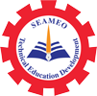
Training Course on
“Curriculum Development and Teaching Methodologies for Technical Education Teachers”
Samdech Akka Moha Sena Padei Techo Hun Sen – ROTA
Khsach Kandal General and Technical High School
16–17 July 2026
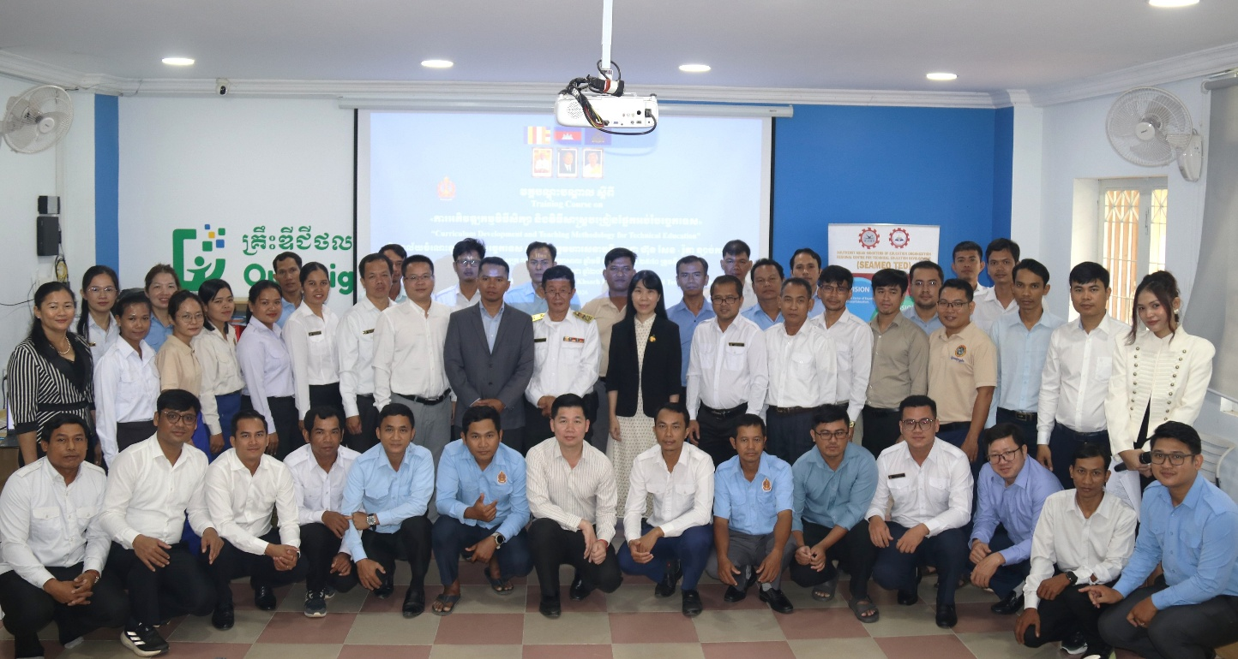
(Group Photo of Opening Ceremony)

The Southeast Asian Ministers of Education Organization Regional Centre for Technical Education Development (SEAMEO TED), in collaboration with Samdech Akka Moha Sena Padei Techo Hun Sen – ROTA Khsach Kandal General and Technical High School, Kandal Province, organized a training course on “Curriculum Development and Teaching Methodologies for Technical Education Teachers”. The training accommodated a total of 47 participants (including 10 females), 35 of whom are teachers from six General and Technical High Schools across the Kingdom of Cambodia, including:
- Samdech Akka Moha Sena Padei Techo Hun Sen – ROTA Khsach Kandal General and Technical High School, Kandal Province
- Kampong Chheuteal Institute of Technology, Kampong Thom Province
- Preah Norodom Sihamoni General and Technical High School, Kampot Province
- Preah Reach Samphear General and Technical High School, Kampot Province
- Preah Bat Samdech Preah Boromneath Norodom Sihamoni General and Technical High School, Kampong Chhnang Province
- Techo Sen Koh Kong General and Technical High School, Koh Kong Province.

The course aimed to enhance teachers' capacities in curriculum and textbook development techniques, as well as modern teaching methodologies for technical education teachers in Cambodia. During the opening ceremony, Mr. Meas Mike, Deputy Director of SEAMEO TED, expressed a warm welcome to all participants. In his speech, he highlighted that Technical and Vocational Education and Training (TVET) is a crucial catalyst for Cambodia’s economic growth and competitiveness in the era of Industry 4.0 and the digital economy. This initiative aligns directly with the Royal Government of Cambodia’s Pentagonal Strategy - Phase 1, which designates human resource and technical education development as a top priority.

He emphasized that as educators, and teachers, we must understand the national strategic policies and priorities of the Royal Government of Cambodia, the Ministry of Education, Youth and Sport, and other relevant ministries. Furthermore, teachers need to clearly understand the vision, mission, and goals of their own schools or institutions to align their teaching and equip students with the knowledge, skills, and attitudes that meet those strategic plans and priorities.

Mr. Meas Mike also outlined the core objectives of the training, which was designed around three main goals: enhancing teacher competencies in contemporary curriculum development, elevating modern student-centered teaching methodologies (such as Project-Based Learning), and fostering knowledge sharing among various general and technical high schools. To ensure that this training leads to a "transformative shift" in classrooms and workshops, he provided five key recommendations for educators and schools:
- Mindset Shift: Teachers must abandon rigid, traditional note-taking habits and adopt modern teaching methodologies, as student growth depends entirely on instructional changes.
- Practical Focus: Lesson plans must prioritize ample, hands-on workshop experience with technical equipment rather than excessive lecture time.
- Competency-Based Assessment: Student evaluations must move away from written paper exams to measure actual practical skills and standard workplace readiness.
- Networking: Participants should establish a Professional Learning Community (PLC) across institutions to collectively solve challenges and share best practices.
- Quality Assurance: Schools must implement ongoing monitoring and adaptation mechanisms—incorporating feedback from both students and the private sector—to keep the curriculum aligned with rapid technological changes.
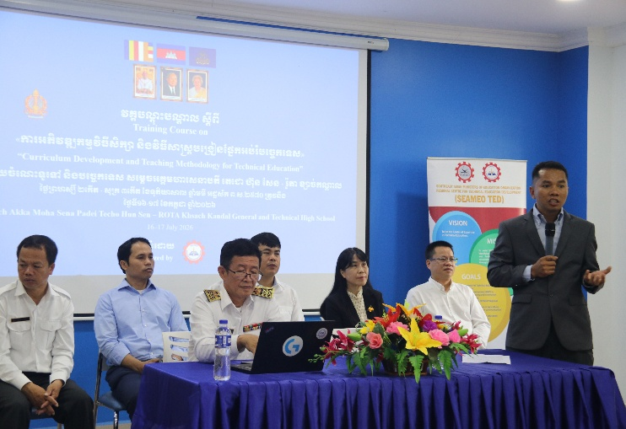 | 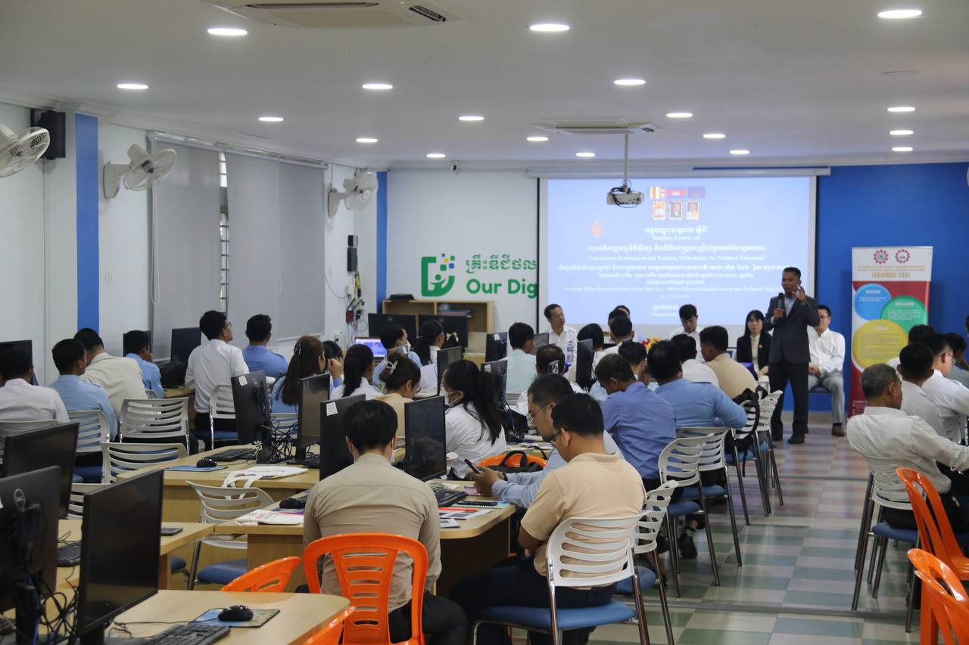
(Mr. Meas Mike delivering the opening remarks.)

This training was taught by two Chinese experts— Ms. Wei Qin, Professor of Guangxi Vocational College of Water Resources and Electric Power, and Mr. Li Jiahong, Senio Engineer of Guangxi Polytechnic of Construction. The two trainers covered five different topics with a balance of theory and practices: (1) Curriculum Development & Implementation; (2) Process of Curriculum and textbook development in China; (3) Textbook development; (4) Teaching methodologies in Technical and Vocational Education, and (5) Practical lesson design analysis based on Vocational Education Theories.

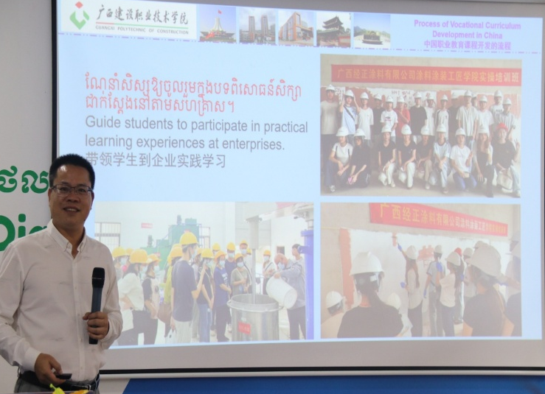 | 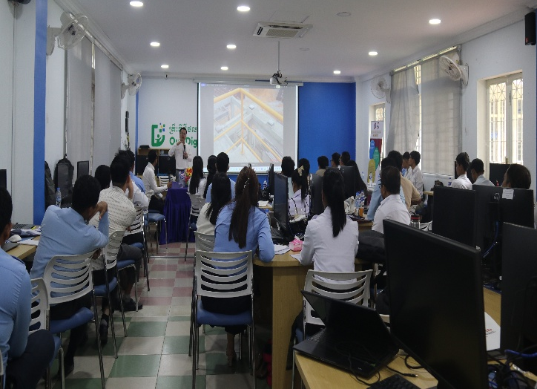
(Mr. Li Jiahon, the trainer, explaining curriculum development process in China)

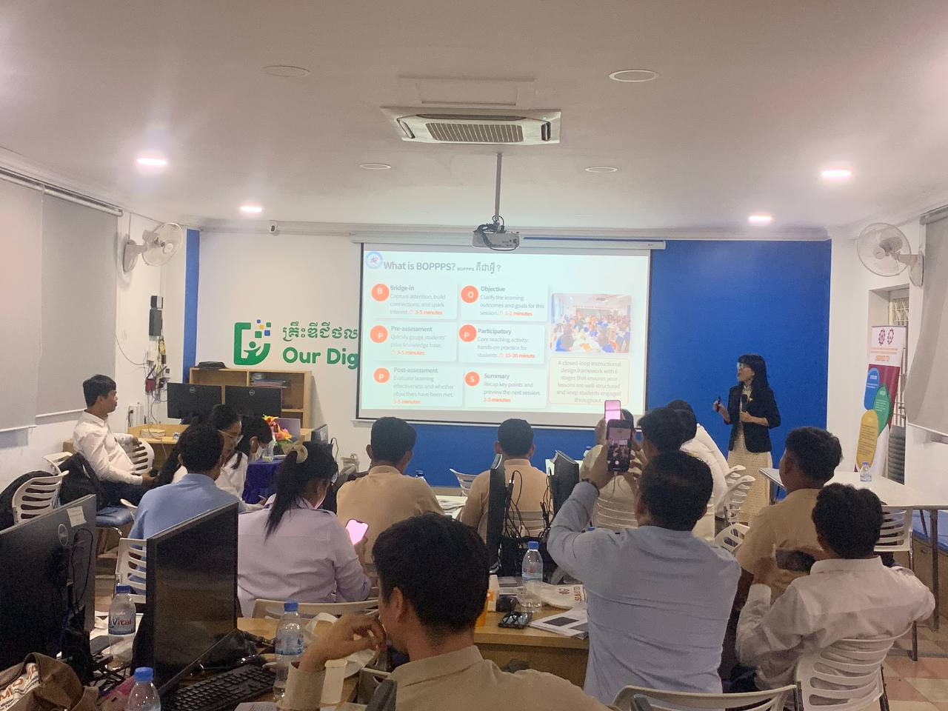 | 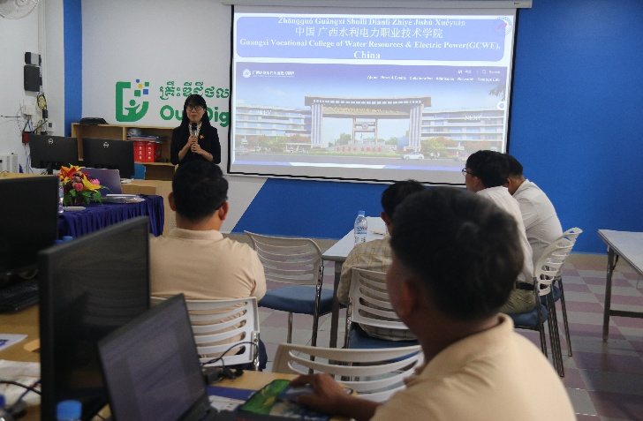
(Ms. Wei Qin, the trainer, explaining BOPPS method)

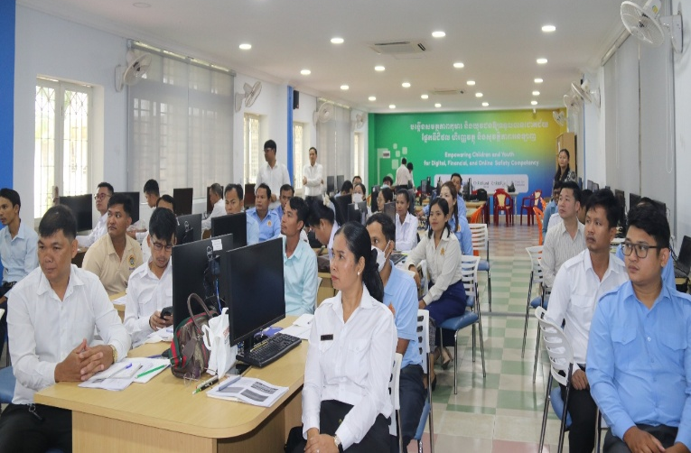 | 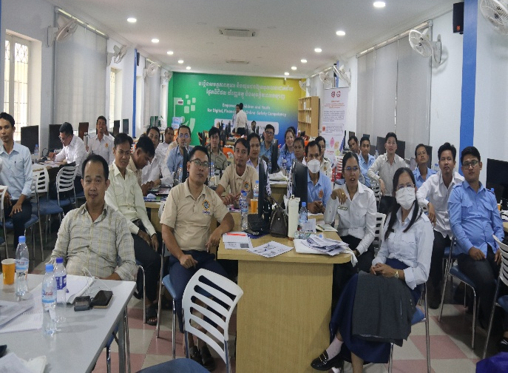
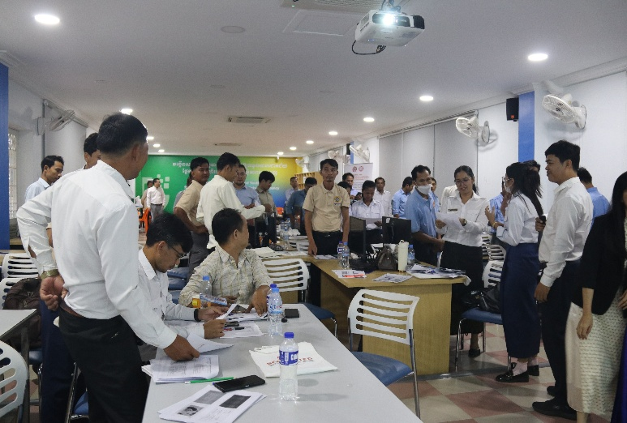 | 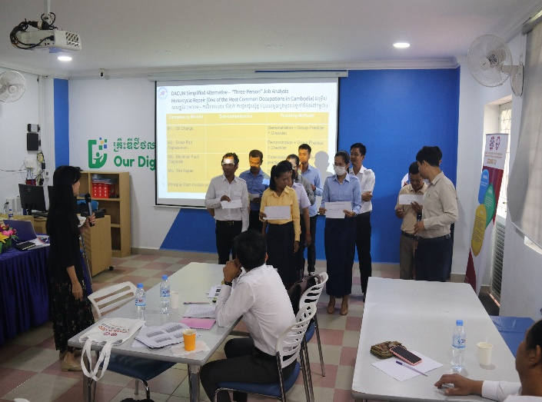
(Participants during the training session)
As part of lecturing methods, trainers enabled participants to practice what they have learnt by engaging them in group work, discussion and hands on activity. The course evaluation was also undertaken to measure the level of their learning and satisfaction with the course.

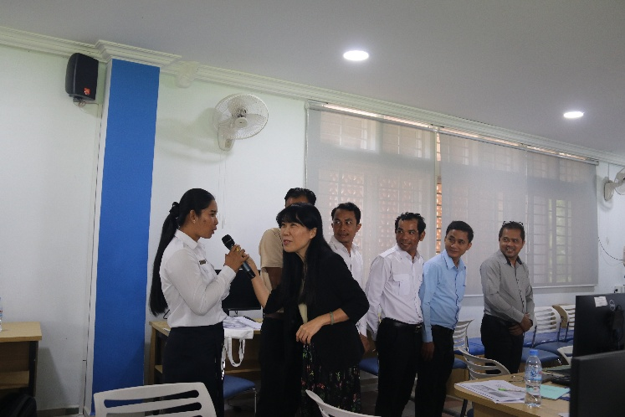 | 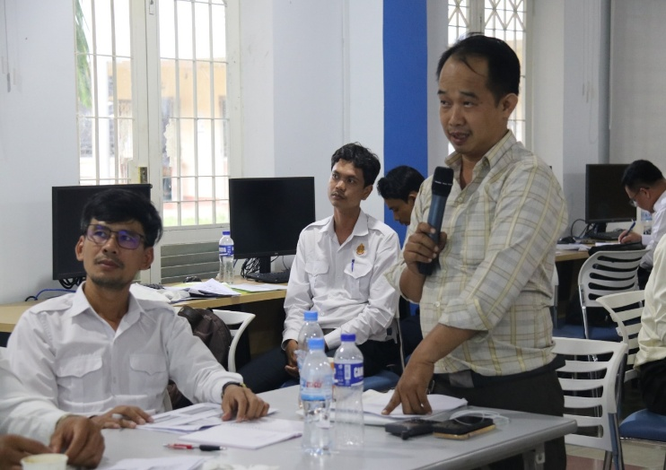
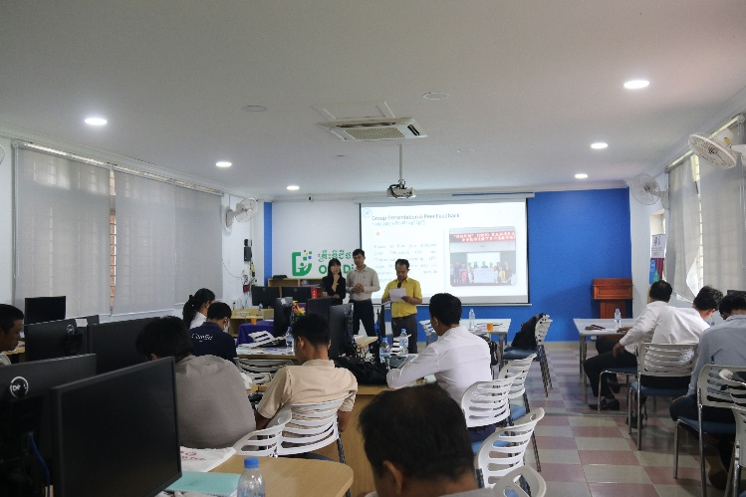 | 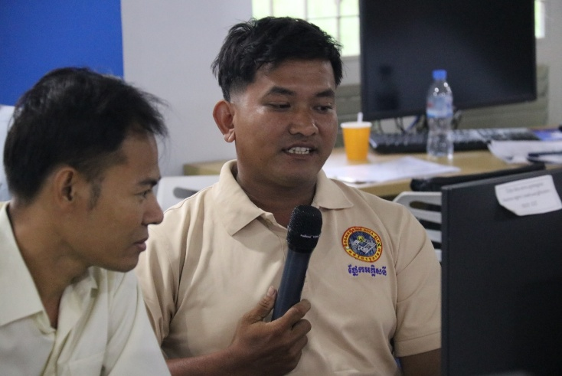

(Participant raised a question and sharing experiences)

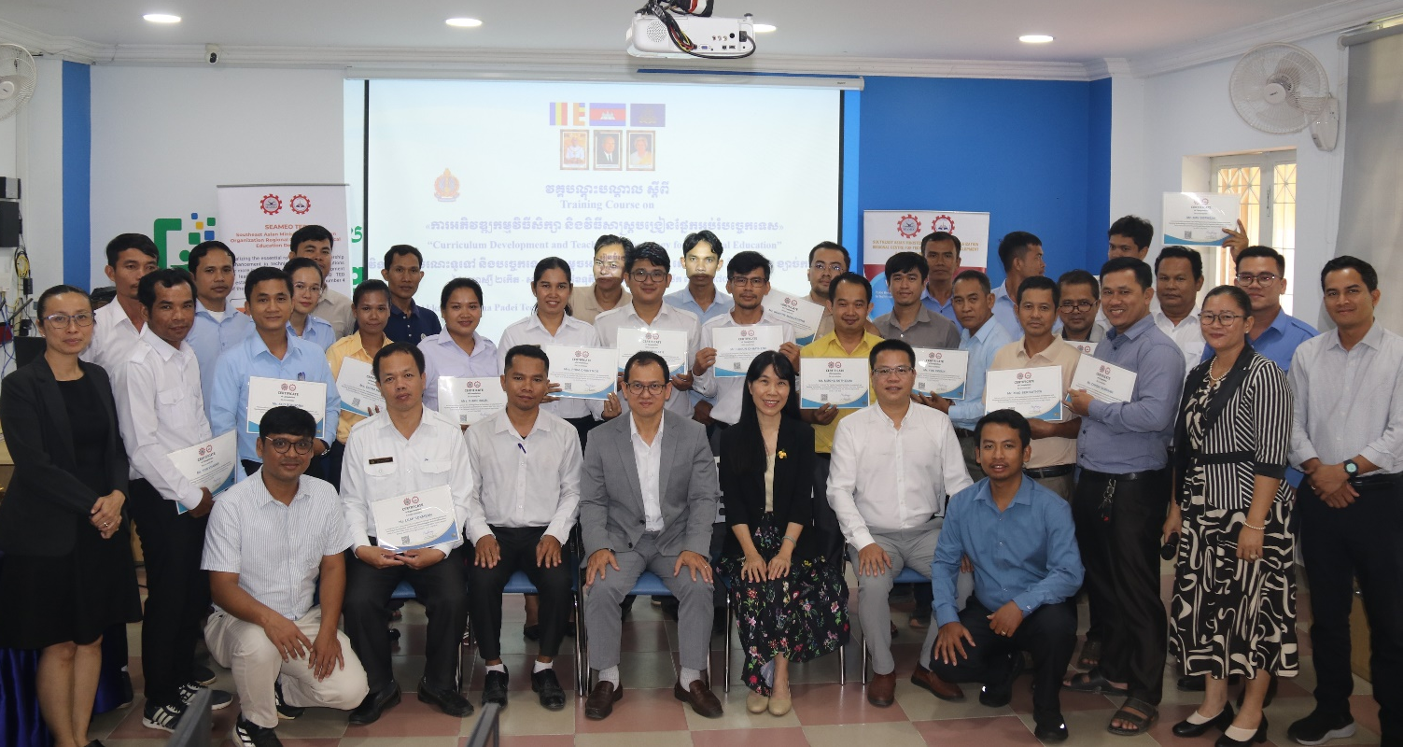
(Group photo at the closing ceremony)

Dr. Songhenag Ai, director of SEAMEO TED delivering the closing remarks stressing the continuous professional development programs (CPDs), as part of one strategic priority to develop the capacities of teachers as a lifelong learner. He mentioned that “it is a forum for learning from Chinese experts what China has done in terms of curriculum and textbook development, and teaching methodologies that our teachers can consider and integrate them into their currently teaching practices”. He also posed the takeaway messages that “after the training, please don’t forget to share that you have learned with your peer”. The course was concluded with the achievement certificate offered to each participant.

