International YouthTalk on
Why I Want to Learn Skills Across Borders
17 July 2026 (Online)

July 17, 2026: the 7th session of the “International Youth Talk,” jointly organized by the Southeast Asian Ministers of Education Organization Regional Centre for Technical Education Development (SEAMEO TED), the China-ASEAN Technical Education Cooperation Platform (CATECP), with support from The Southeast Asia Youth Sustainable Development Foundation (PASITA), was successfully concluded online. The meeting was attended by 26 male and 77 female participants, making a total of 180 participants. The events featured online presentations by youth representatives from universities across multiple countries including Indonesia, Malaysia, Vietnam, and the Philippines. Centered around the theme of “Why I Want to Learn Skills Across Borders”, the youth showcased fresh perspectives with a global vision, sparking creative and cross-cultural exchanges.

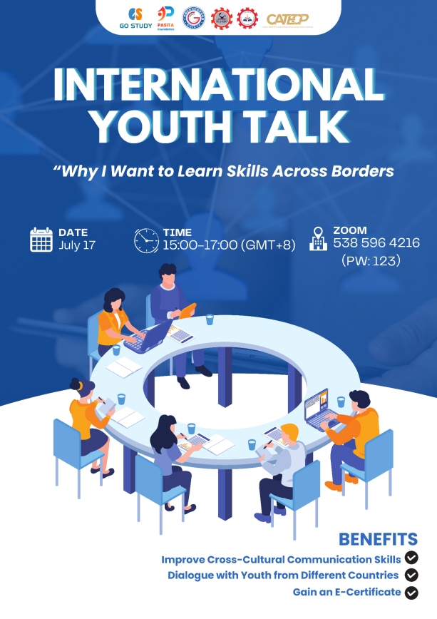

The opening remarks were delivered by Ms. Cheng Cantola, Head of Administration, Finance, and Planning at SEAMEO TED, who emphasized that learning from people around the world enables us to gain new ideas, broaden our perspectives, and become more adaptable in addressing global challenges. She explained that learning skills across borders is not only about acquiring knowledge but also about building meaningful connections, embracing diversity, and contributing to a global community. According to her, every skill we develop is an opportunity to grow, solve problems creatively, and make a positive impact beyond national boundaries, as the best solutions to local challenges often come from international perspectives. She further highlighted that cross-border learning goes beyond professional development by fostering curiosity without boundaries and encouraging us to understand how people from different cultures perceive and solve problems. She concluded her remarks by encouraging all participants to actively engage in the discussions and wishing them a productive and insightful event.

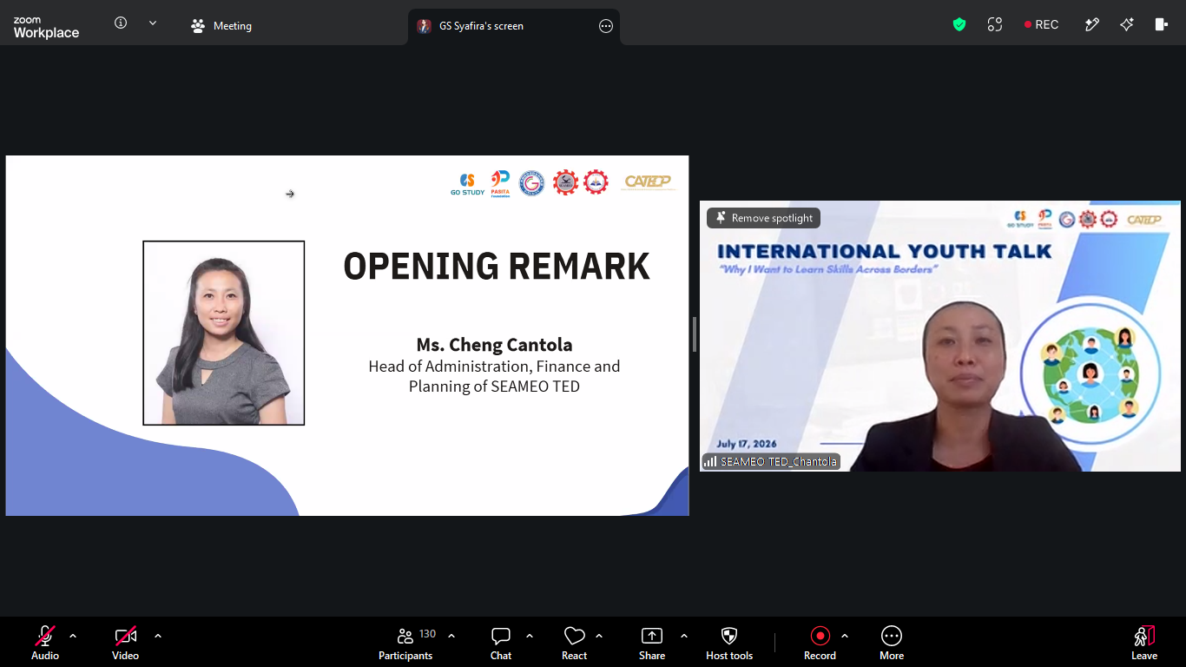
(Ms. Cheng Chantola Delivering Opening Remarks)

Representatives from John B. Lacson Colleges Foundation – Bacolod, the Philippines presented a study on the essential learning skills needed by maritime students to succeed in the global maritime industry. The presentation emphasized that, beyond technical competencies, future seafarers must develop communication, teamwork, problem-solving, adaptability, digital literacy, leadership, and cultural intelligence to effectively work in multinational environments. It also highlighted the importance of professionalism, ethical decision-making, and lifelong learning in preparing graduates for international maritime careers. The presenters concluded that equipping maritime students with these transferable skills enables them to adapt to the evolving demands of the global shipping industry and become competent, globally competitive maritime professionals.
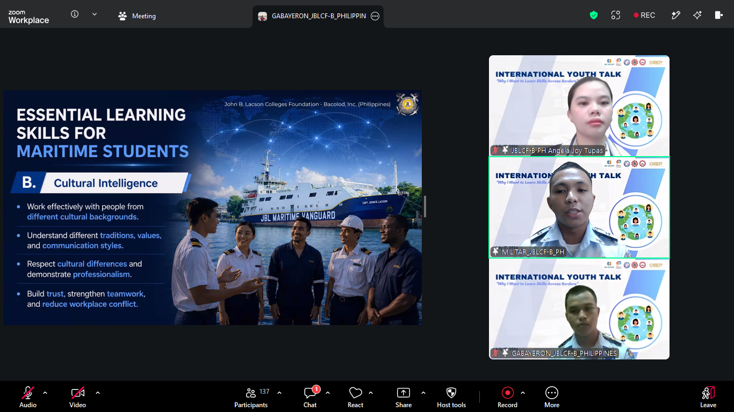
(Speakers from John B. Lacson Colleges Foundation – Bacolod, the Philippines)

The speaker from Van Lang University, Vietnam presented on how Vietnamese youth can thrive in an increasingly connected world by developing global competencies beyond technical knowledge. The presentation highlighted Vietnam's rapidly growing digital economy and expanding international opportunities, emphasizing that success in a globalized environment requires strong communication, cultural intelligence, and adaptability. The speaker also encouraged students to participate in international exchange programs, attend global events, and pursue lifelong learning through online platforms to strengthen these essential skills. He concluded that by continuously learning, embracing cultural diversity, and adapting to change, Vietnamese youth and youth all around the world can maximize global opportunities and become competitive contributors on the international stage.
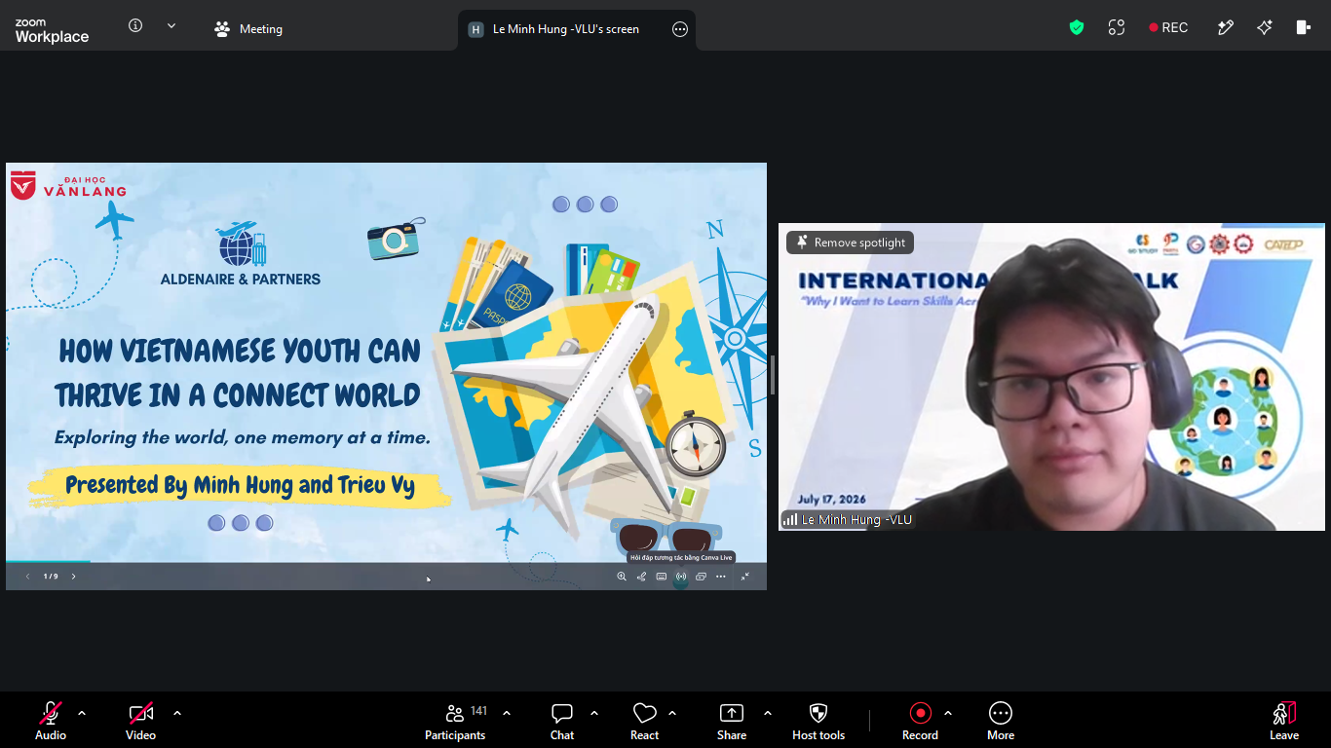
(Speaker from Van Lang University, Vietnam)
Representatives from Universitas Ma Chung, Indonesia presented on how learning across borders fosters personal growth through both international experiences and multicultural identities. Drawing from the journeys of two Indonesian youth with different cultural backgrounds, the presentation demonstrated that cross-border learning extends beyond physical travel to include navigating diverse cultures, languages, and perspectives. The speakers highlighted the importance of leadership, cross-cultural communication, tolerance, and global collaboration, showing how these skills can be applied to create meaningful social impact. They concluded that while individuals may take different paths toward global learning, embracing diversity and lifelong learning enables young people to bridge cultural differences, innovate, and contribute positively to society.
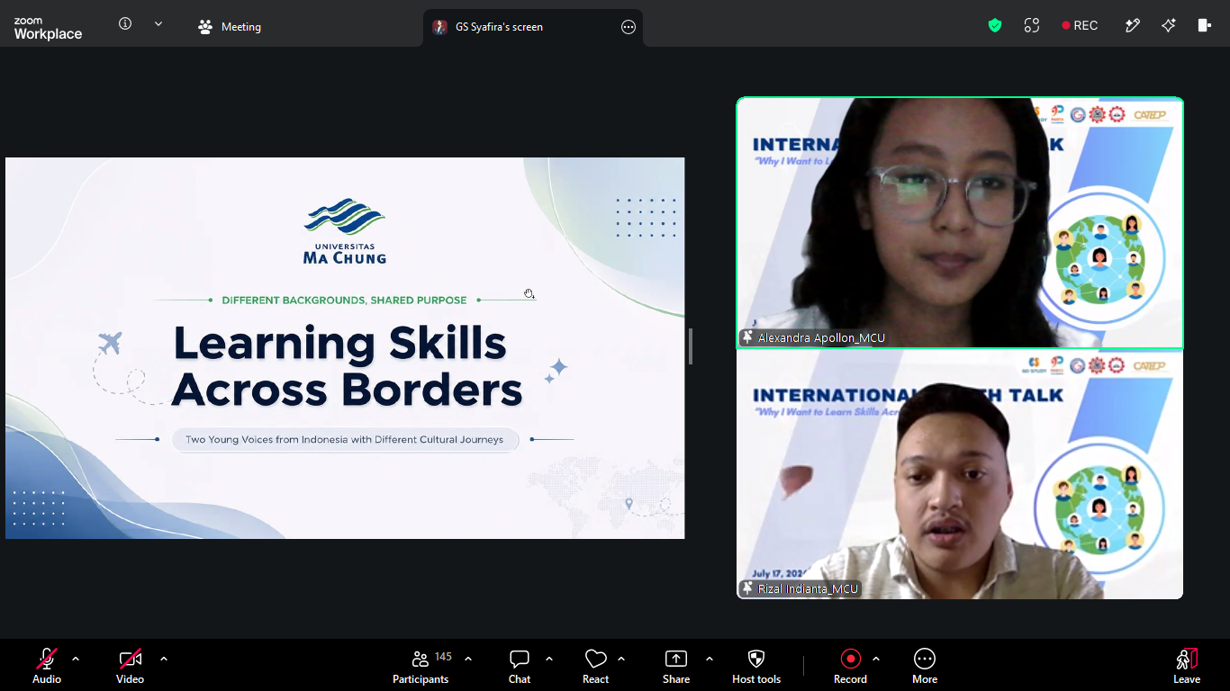
(Speakers from Universitas Ma Chung, Indonesia)
The speaker from Politeknik Sultan Mizan Zainal Abidin, Malaysia presented on the importance of digital skills as essential competencies for Technical and Vocational Education and Training (TVET) students in the AI era. The presentation highlighted how artificial intelligence, digital technologies, and global collaboration are reshaping the workforce, requiring graduates to combine technical expertise with digital literacy, AI awareness, communication, and teamwork. The speaker also showcased his institution's initiatives, including project-based learning, digital platforms, and exposure to international programs, while acknowledging challenges such as unequal digital literacy and language barriers. He concluded that strengthening digital competencies, embracing lifelong learning, and participating in cross-border learning opportunities will prepare TVET graduates to thrive and compete confidently in the global workforce.
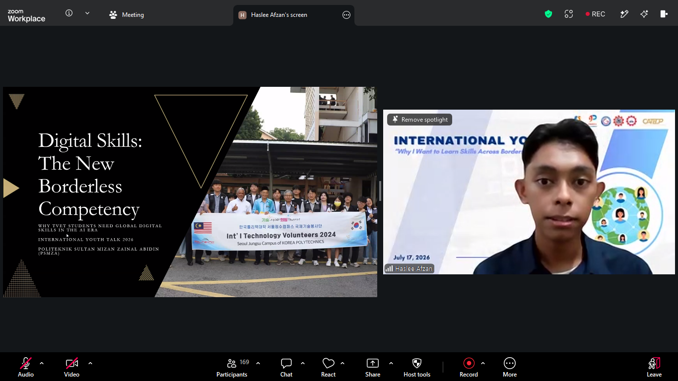
(Speaker from Politeknik Sultan Mizan Zainal Abidin, Malaysia)
The speakers from Politeknik Negeri Malang, Indonesia presented on the importance of learning skills across borders to prepare young people for an increasingly interconnected world. The presentation emphasized that embracing cultural diversity, developing cross-cultural understanding, and strengthening intercultural communication enable individuals to collaborate effectively with people from different backgrounds. The speakers also highlighted adaptability, innovation, and international networking as essential competencies that foster problem-solving, career readiness, and global collaboration. They concluded that by cultivating these cross-border learning skills, students can become more open-minded, adaptable, and prepared to succeed in multicultural and international environments.
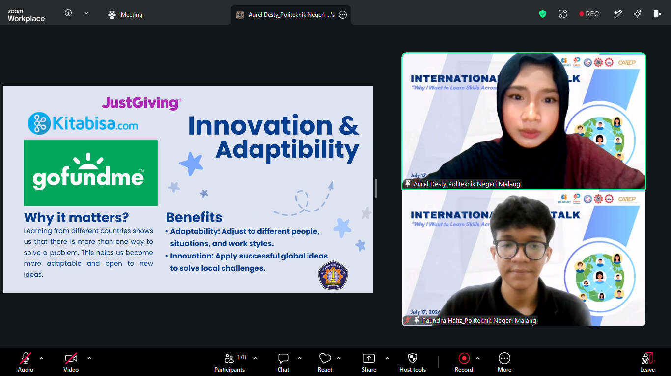
(Speakers from Politeknik Negeri Malang, Indonesia)

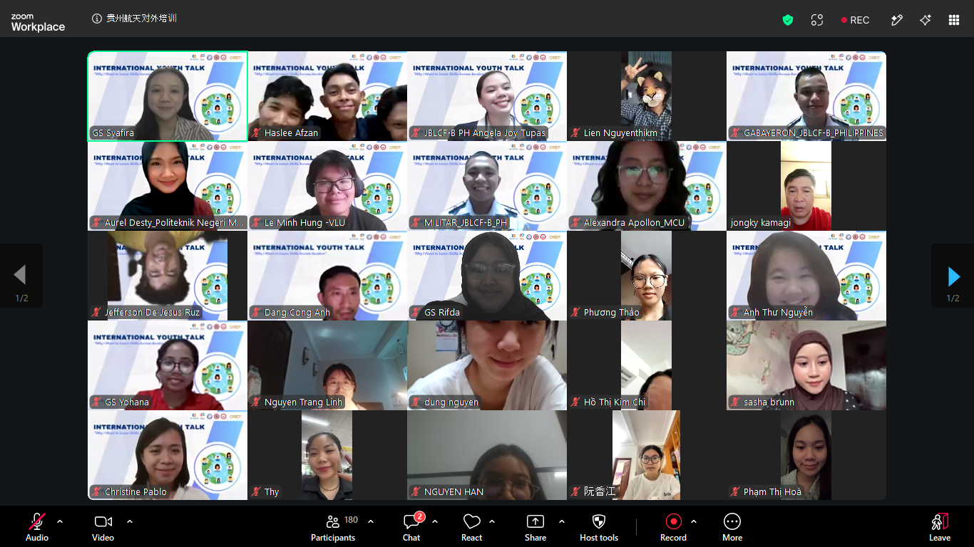

(Group Photo of Participants)

