Chinese Frontier Cultural Tourism Lecture Series
15-16 July 2026 (Online)

From July 15 to 16, the Chinese Frontier Cultural Tourism Lecture Series was successfully conducted under the joint efforts of the Southeast Asian Ministers of Education Organization Regional Centre for Technical Education Development (SEAMEO TED), the China-ASEAN Technical Education Cooperation Platform (CATECP), Go Study Global Education, and Chinese partner institutions. The series aimed to provide participants with deeper insights into China’s cultural and tourism resources, while promoting cultural exchange and cooperation between China and ASEAN countries.
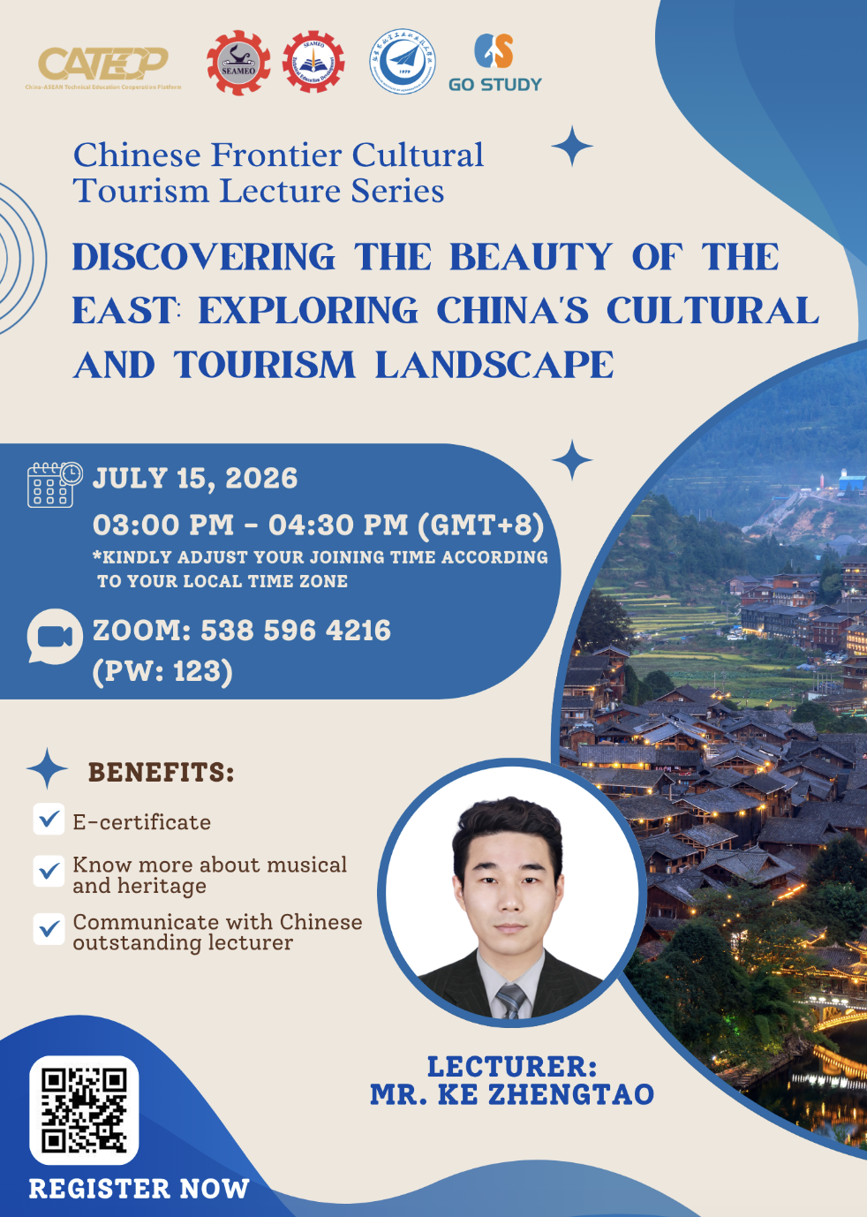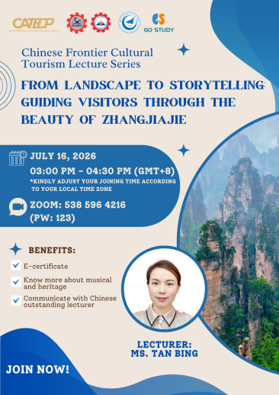

On July 15, the first training session, “Discovering the Beauty of the East: Exploring China's Cultural and Tourism Landscape,” was conducted. The session introduced China’s rich cultural and tourism resources, including history, architecture, traditional gardens, cuisine, and handicrafts. Through various examples, participants gained a deeper understanding of the charm and value of Chinese culture. A total of 300 participants attended the session, including 200 females and 17 males.



On July 16, the second training session, “From Landscape to Storytelling: Guiding Visitors through the Beauty of Zhangjiajie,” was conducted. The session focused on Zhangjiajie’s unique natural landscapes and tourism resources, introducing famous attractions such as Zhangjiajie National Forest Park and Tianmen Mountain National Park. Participants learned more about the beauty and cultural significance of China’s landscape tourism. A total of 275 participants attended the session, including 265 females and 8 males.

