International Future Skills Lab: How to Polish a CV and Nail a Job Interview
31 July 2026 (Online)

On the afternoon of July 31, 2026, the 1st session of the “International Future Skills Lab,” jointly organized by the China-ASEAN Technical Education Cooperation Platform (CATECP), the Southeast Asian Ministers of Education Organization Regional Centre for Technical Education Development (SEAMEO TED), SEAMEO Regional Open Learning Centre (SEAMOLEC), and Go Study Global Education, was successfully concluded online. The meeting was attended by 45 male and 126 female participants, making a total of 171 participants.

Centering around the theme “How to Polish a CV and Nail a Job Interview”, the meeting brought together HR experts, industry professionals, and university representatives from Indonesia and Philippines. Discussions focused on optimizing personal CVs, projecting confidence during interview rounds, understanding employer expectations, and building a persuasive professional brand.
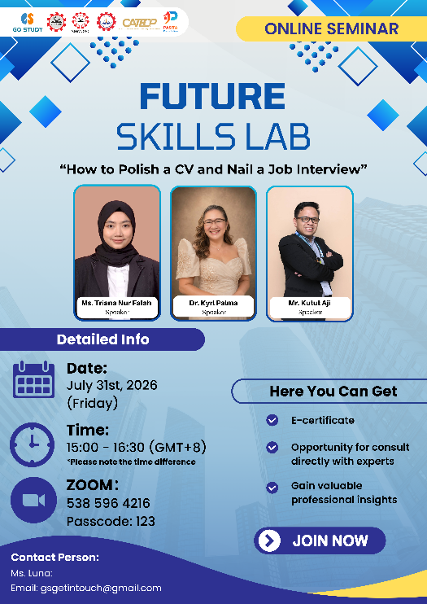
The opening remarks were delivered by Ms. Cahya Kusuma Ratih, Director of SEAMEO SEAMOLEC. She emphasized how career readiness and lifelong learning are essential in today’s rapidly changing job market. In a world reshaped by digital transformation, artificial intelligence, and globalization, employers increasingly prioritize soft skills, such as effective communication, adaptability, and critical thinking, alongside technical expertise. She noted that tools like a well-crafted CV and a job interview are key opportunities for candidates to tell their personal story and showcase their true potential. Lastly, she encouraged all participants to actively engage in the webinar, ask questions, and learn from the expert speakers to gain practical strategies for their future careers.
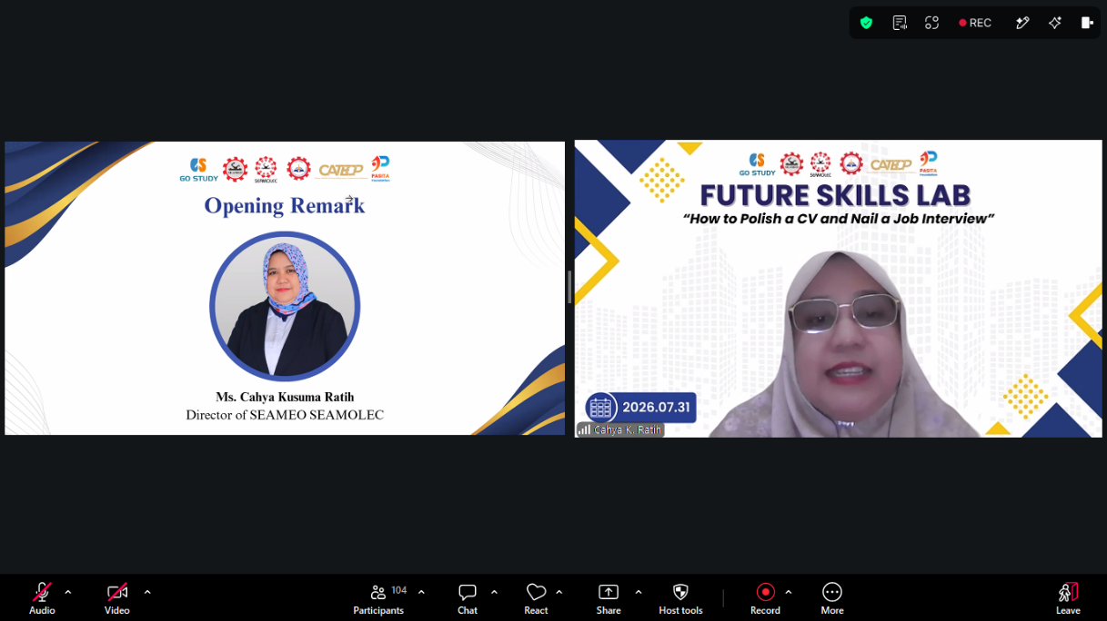
(Ms. Cahya Kusuma Ratih Opening the Forum)

Mr. Kutut Aji Prayitno, head of Politeknik ATK Yogyakarta, Indonesia, shared the topic on “Beyond a Good CV: What Employers Really Look for in Fresh Graduates”. He addresses the critical challenge fresh graduates face in navigating global job markets and widespread youth unemployment. Contextualizing current labor trends and recruiter talent shortages, he emphasizes that standing out requires looking beyond a standard resume. While an optimized, achievement-focused CV serves as the initial gateway to secure screening opportunities, true candidate differentiation occurs during the interview stage. He outlines a structured, three-phase interview strategy which are thorough preparation and research beforehand, clear communication using the STAR method during the session, and professional reflection afterward. Ultimately, Mr. Kutut concludes that while strong technical preparation opens the door to hiring stages, soft skills such as proactive communication, professional etiquette, initiative, and a continuous growth mindset are the ultimate factors that convince employers to select one candidate over another.
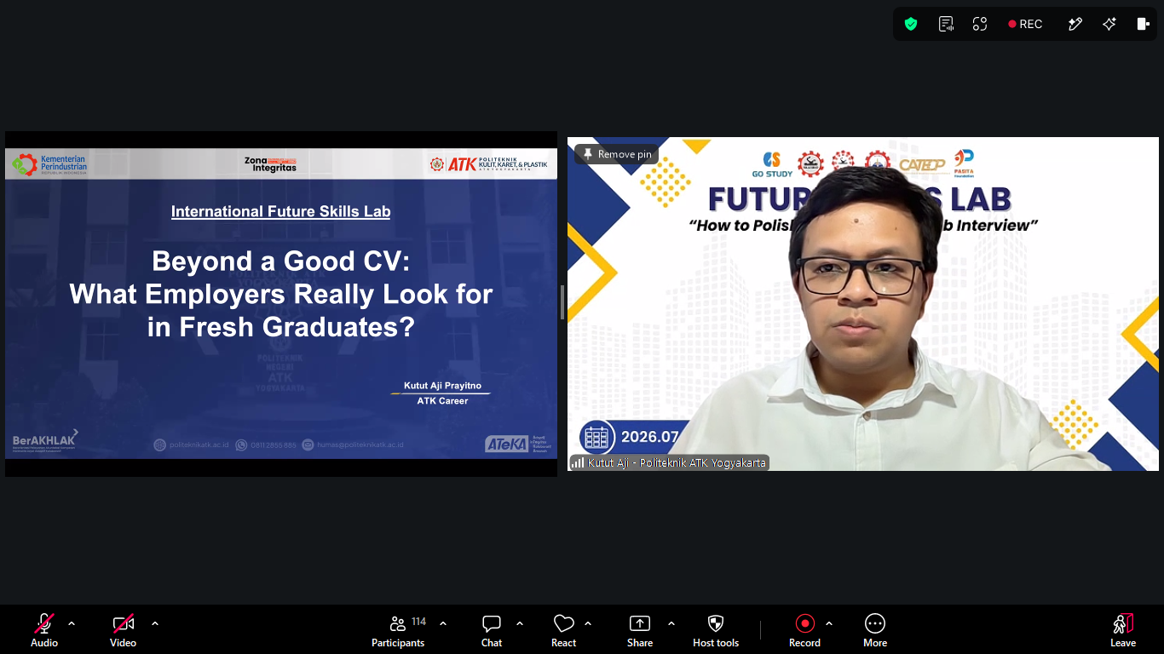
(Mr. Kutut’s Presentation)

Dr. Kyrl S. Palma, associate professor of Guimaras State University, Philippines, shared the topic on “From Paper to Person: Polishing Your CV and Nailing the Interview”. She addresses the essential process of transitioning from a qualified applicant on paper to a successful candidate in person by outlining two critical recruitment checkpoints. He establishes that while a tailored, ATS-friendly CV serves as the initial handshake to prove technical capability, the interview ultimately determines institutional fit. To optimize the written document, Palma details key structural elements, distinguishing between comprehensive academic CVs and targeted résumés while emphasizing readability, reverse-chronological formatting, and quantifiable achievements. Moving to the interpersonal stage, he advocates for a structured, three-part interview strategy. This includes rigorous organizational research and story preparation beforehand, authentic active listening and structured communication using the STAR method during the discussion, and continuous professional follow-through afterward. In conclusion, she emphasized that while a polished resume opens career opportunities, candidate confidence, strategic preparation, and clear personal presentation are what secure the role.
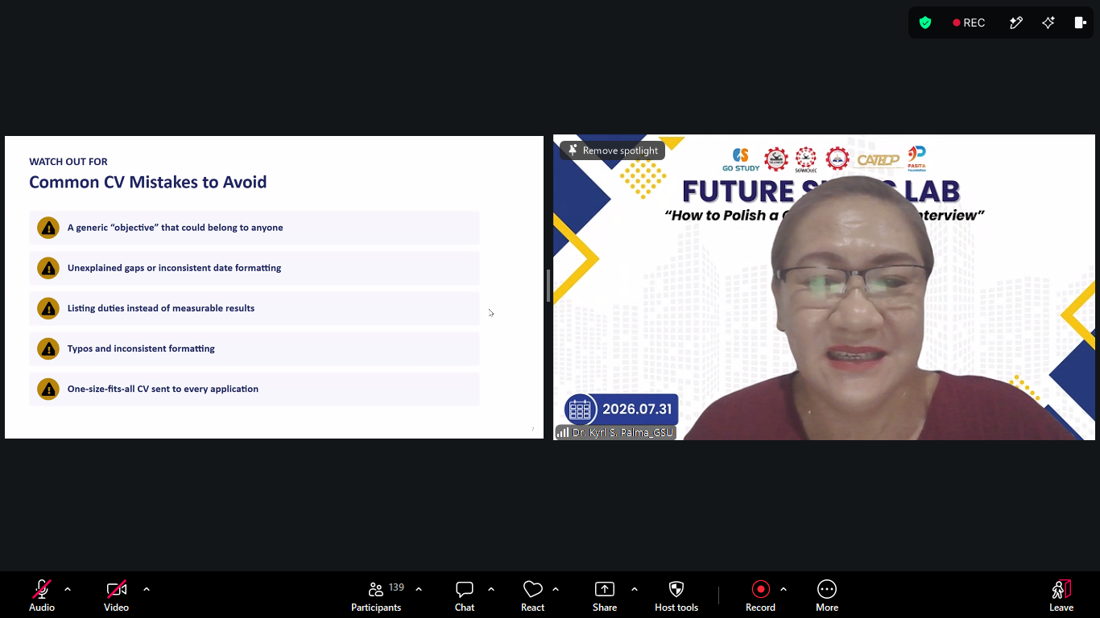
(Dr. Kyrl S. Palma’s Presentation)
Ms. Triana Nur Falah, head of finance and administration at Go Study Edukasi Indonesia shared the topic “How to Polish Your CV and Nail a Job Interview”. She breaks down the practical recruitment landscape for fresh graduates seeking roles in Indonesia, particularly within China-based enterprises. Drawing from her hands-on experience in talent acquisition, she outlines the complete hiring journey from initial screening forms evaluating language fluency and basic qualifications to final suitability assessments by hiring managers. She stresses that clearing the initial application review requires an accurate, tailored, and up-to-date CV free of inflated claims or redundant details. Beyond written credentials, successfully navigating the interview phase hinges on thorough company research, clear articulation of past projects, and avoiding critical pitfalls like vague responses or failing to engage the interviewer. Ultimately, she highlights that foreign and local employers alike value candidates who demonstrate adaptable mindsets, genuine willingness to learn, and a clear alignment between their skills and the position.
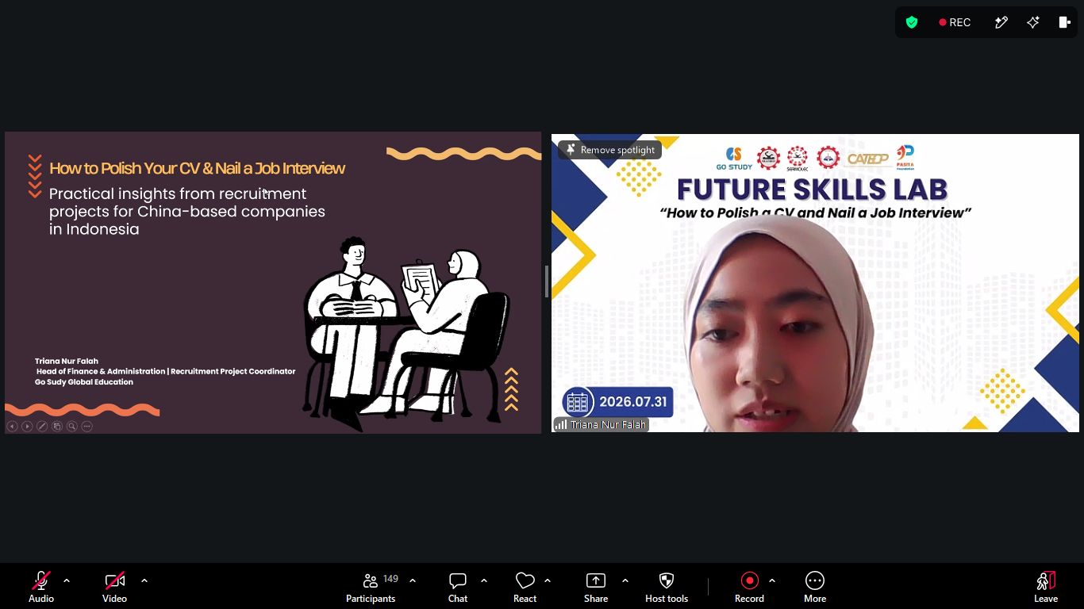
(Ms. Triana Nur Falah’s Presentation)

