International Experts Sharing Forum on
“Bridging Differences Through Language”
August 07, 2026 (Online)

On August 7, 2026, the 8th session of the “International Experts Sharing Forum,” jointly organized by the China-ASEAN Technical Education Cooperation Platform (CATECP), the Southeast Asian Ministers of Education Organization Regional Centre for Technical Education Development (SEAMEO TED), and Go Study Global Education, was successfully concluded online. The meeting was attended by 68 male and 176 female participants, making a total of 244 participants. Themed “Bridging Differences Through Language”, the meeting brought together experts and scholars from Indonesia, Philippines, and Thailand. Discussions focused on cross-cultural communication, language preservation, regional cultural values, and global citizenship. These topics were explored through keynote speeches, case studies, and interactive exchanges.
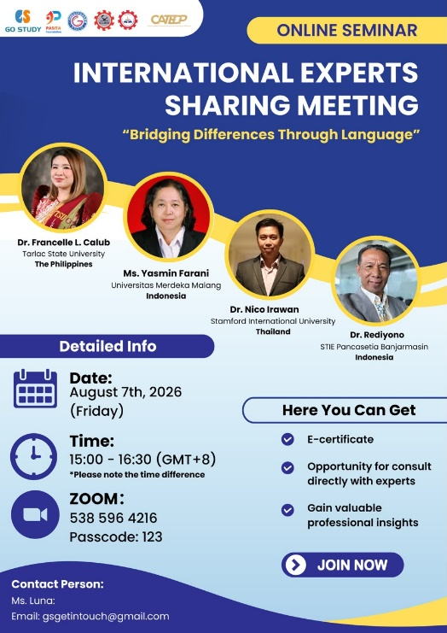
The opening remarks were delivered by Mr. Ravy Voeun, Vice Head of the Research and Development Division of SEAMEO TED. He emphasized that language is more than communication. Instead, it connects cultures, builds mutual understanding, and helps address global challenges. He highlighted that learning from experts through interactive discussion will inspire innovative thinking and strengthen international collaboration across disciplines. Lastly, he expressed sincere gratitude to the distinguished speakers and encouraged all participants to actively engage in the discussions to foster meaningful professional connections and gain valuable knowledge on the topic.
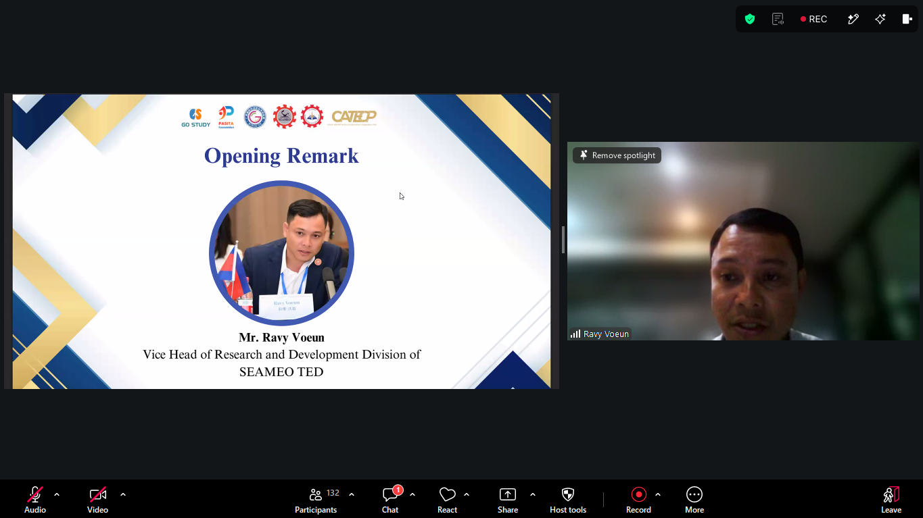
(Mr. Ravy Voeun Delivering Opening Remarks)
Dr. Francelle L. Calub from Tarlac State University, Philippines shared the topic “Bridging Differences through Language: From Language Vitality to Community-Based Revitalization”. She explores how language functions as a bridge for identity, memory, and community rather than a barrier. Addressing the vulnerabilities caused by linguistic ideologies and power relations, she highlights the Ayta Mag-Antsi community to demonstrate how research can transition from assessing language endangerment to driving community-based revitalization. Dr. Calub outlines a framework for action involving assessment, listening, co-creation, usage, and sustainability, emphasizing that language preservation requires everyday participation from individuals. Furthermore, she advocates for linguistic confidence and inclusivity, calling on schools and employers to prioritize clarity and communication over native-like conformity. Ultimately, she encourages individuals to preserve, communicate, and respect diverse ways of speaking to foster understanding and preserve cultural heritage.
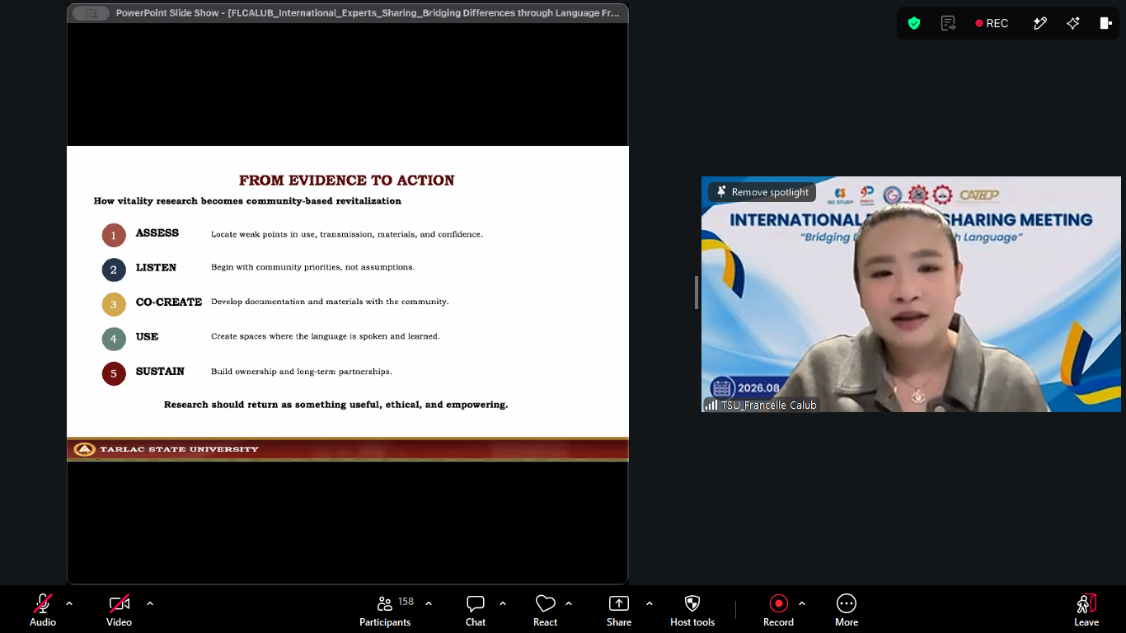
(Dr. Francelle L. Calub’s Presentation)
Ms. Yasmin Farani, English Lecturer of Universitas Merdeka Malang, Indonesia shared the topic “Bridging Differences Through Language: A Point of View of an Indonesian EFL Teacher”. She explores language as a unifier across domestic and international contexts from the perspective of an Indonesian EFL teacher. Highlighting Indonesia’s vast geographic and cultural diversity, encompassing over 700 living indigenous languages, she emphasizes how Bahasa Indonesia serves as a crucial national bridge, a unifying role established during the 1928 Youth Pledge. She discusses the evolving nature of language through local informal slangs, such as Malang’s Boso Walikan, and notes her research on unique regional dialects like Javanese-Chinese. Beyond national borders, Ms.Yasmin presents the Bahasa Indonesia bagi Penutur Asing (BIPA) program as a tool for international connection. Furthermore, she examines Southeast Asian linguistic ties (SEAblings) and highlights English as a global bridge. Ultimately, she aligns with Indonesia's Trigatra Bangun Bahasa philosophy: prioritize Bahasa Indonesia, preserve local languages, and master international languages.
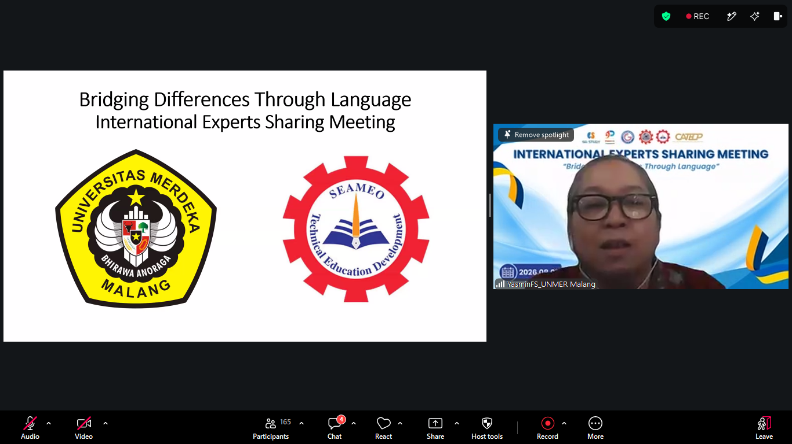
(Ms. Yasmin Farani’s Presentation)
Dr. Nico Irawan, program leader of Graduate School Stamford International University, Thailand shared the topic on “Language as a Bridge to Global Citizenship: Building Connections Across Cultures”. He examines how language serves as a crucial bridge for fostering intercultural connections and active global citizenship. Grounded in the premise that individuals belong to a shared global community, the talk highlights language as a foundational tool for expressing cultural identity, building empathy, and facilitating international relations. Dr. Nico highlights the benefits of multilingualism such as enhanced cognitive growth, career advancement, and cross-cultural collaboration while addressing challenges like resource constraints and cultural barriers. Through case studies and cultural exchange frameworks, he illustrates how effective language learning and local language policies empower marginalized communities and safeguard endangered heritage. Supported by modern technology and structured educational strategies, language education ultimately cultivates the intercultural competence needed for social cohesion, advocacy, and a more interconnected, equitable world.
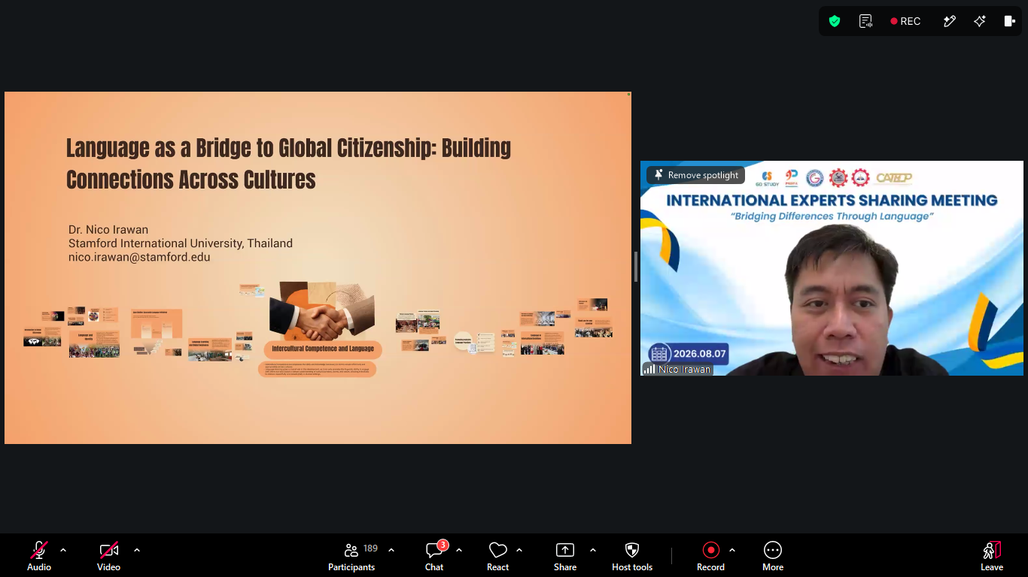
(Dr. Nico Irawan’s Presentation)
Dr. Rediyono, lecturer of Graduate Program of Economics, STIE Pancasetia Banjarmasin, Indonesia shared the topic on “Beyond Words: From Lost in Translation to Cross-Cultural Understanding”. He outlines a framework for moving beyond literal translation toward true cross-cultural understanding. Highlighting that over 70% of communication problems in multicultural teams stem from cultural differences rather than language proficiency, he demonstrates that language alone does not equal effective communication. Citing core frameworks like Meyer’s The Culture Map, the Sapir-Whorf Hypothesis, and Hall’s context theories, he explains how underlying cultural values, such as high-context collectivism versus low-context individualism, shape interpretation and behavior in everyday workplace scenarios. To bridge these gaps, Dr. Rediyono introduces Cultural Intelligence (CQ), which encompasses motivation, knowledge, strategy, and behavioral adaptation. Ultimately, by active listening, seeking clarification, avoiding cultural assumptions, and respecting varied communication styles, individuals can build empathy and trust, ensuring that language opens conversations while cultural understanding provides true meaning.
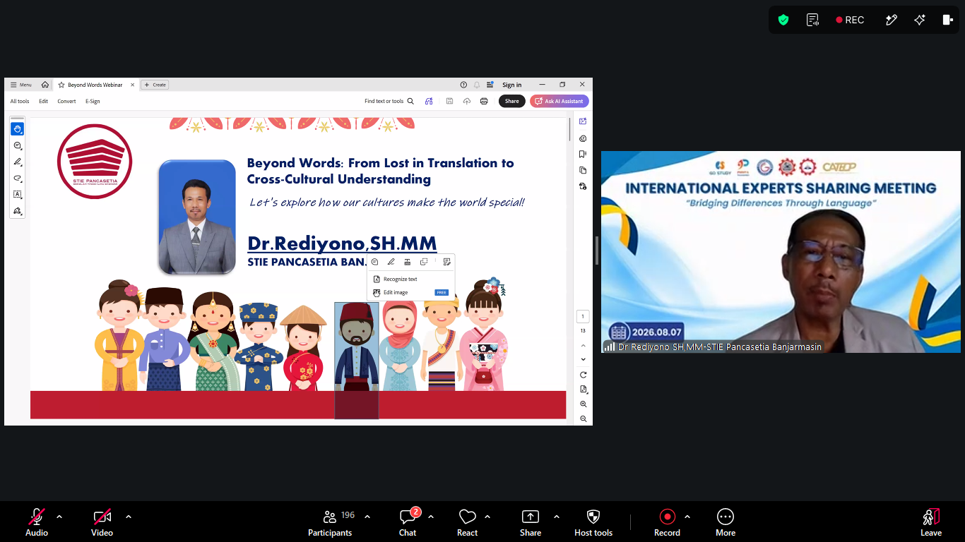
(Dr. Rediyono’s Presentation)

