Training Course on
“Digital Learning Approach in Transforming Education”
August 15, 2026, Phnom Penh, Cambodia

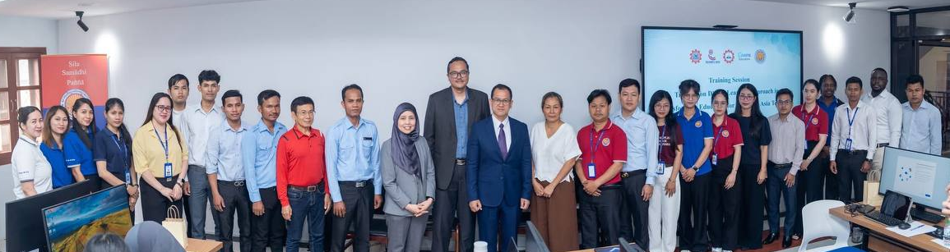
(Group Photo of Participants and Trainer)

On 15 August 2026, SEAMEO TED, in collaboration with SEAMEO SEN, Paññāsāstra University of Cambodia (PUC), Using Technology Better (UTB), and Canva Education, successfully organized the Training on Digital Learning Approach in Transforming Education for Southeast Asia Teachers at the PUC Campus, Phnom Penh, Cambodia. The course brought together over 60 participants as teachers, education professionals, and administrators to explore how digital learning and creative technology can support engaging, interactive, collaborative, inclusive, and student-centred teaching and learning in the classroom practice to accelerate learning progression.
Throughout the one-day programme, participants engaged in interactive sessions, demonstrations,
and practical learning activities focused on designing engaging educational materials, developing
professional classroom resources, integrating interactive and dynamic media into lessons, and
using digital tools to strengthen collaborative learning.

The Opening Session was graced by Dr. Songheang Ai, Director of SEAMEO TED, and Dr. Kol D. Sophia, Vice President for Policy & Planning, PUC. The programme was enriched by the expertise of Ts. Olya Dollah, CANVA Certified Trainer and Technology Specialist, Using Technology Better, Malaysia, and Mohd Zulkarnain Abdul Wahab, Head of Training and Capacity Development Division, SEAMEO SEN, Malaysia.

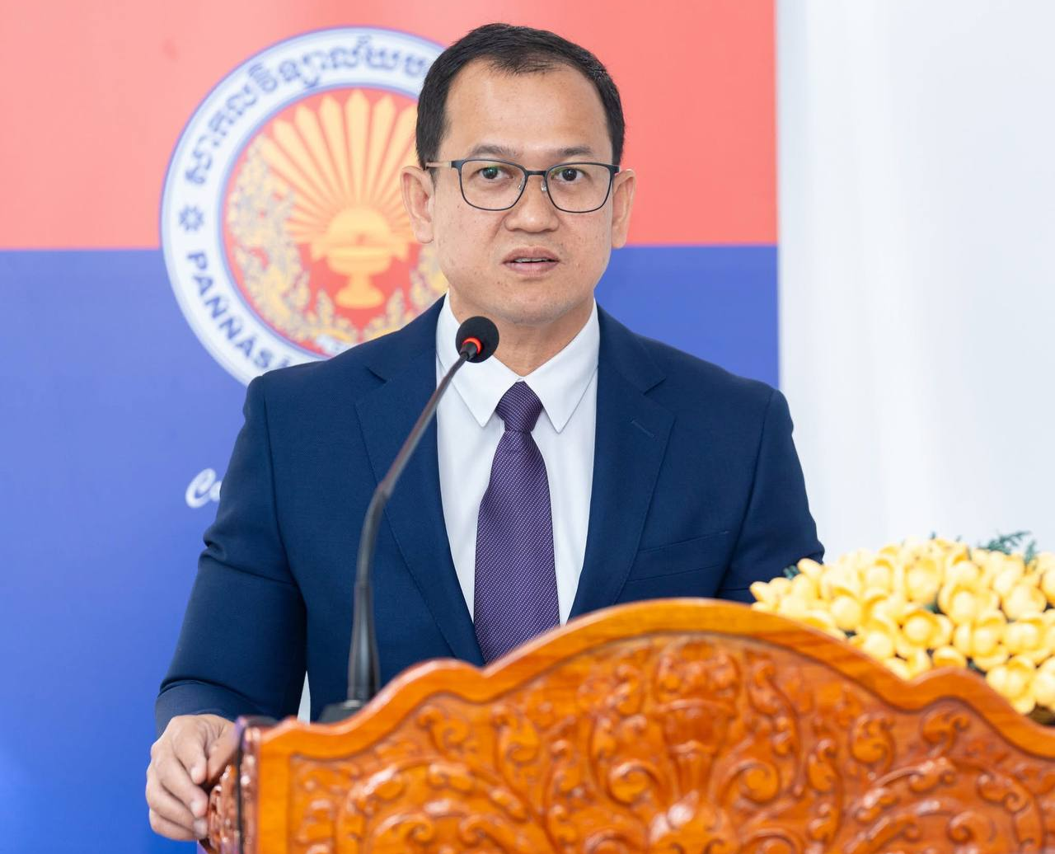
(Dr. Songheang Ai Delivering Opening Remarks)

Dr. Songheang Ai, stressed that “Such training is part of the continuous professional development programs (CPD) that the Ministry of Education, Youth and Sport (MoEYS) encouraged all educators to be professionally developed their digital skills consistently to meet the fast-ever growing technologies for the benefits of learners”. He addressed the importance of such as training to partner among academic institutions, regional centres, corporate partner, and schools to move forward together in the right direction.

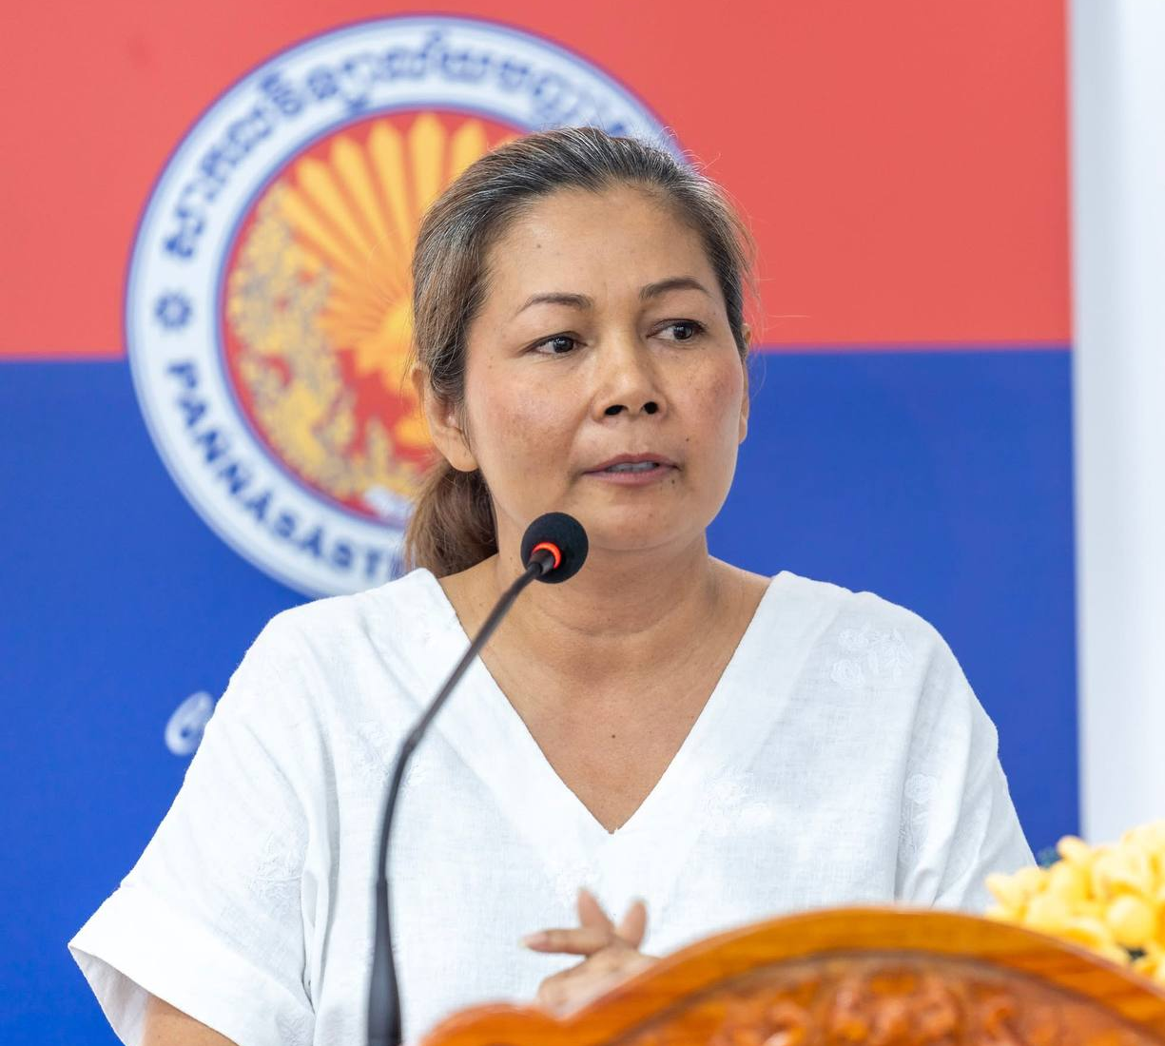
(Dr. Kol D. Sophia Delivering Welcome Remarks)

Dr. Kol D. Sophia encouraged all participants to actively join the instructional activities with questions and answers (Q&A) for clarification and shared what they have learned with their peers after training.

Ts. Olya Dollah noted that “She is happy to share what Canva Education have done in Malaysia and cutting-edge technologies of Canva that other countries have implemented for instructional purposes”. After the course, she will offer a free-of-charge subscription for Canva systems that can be used for the benefits of learners.

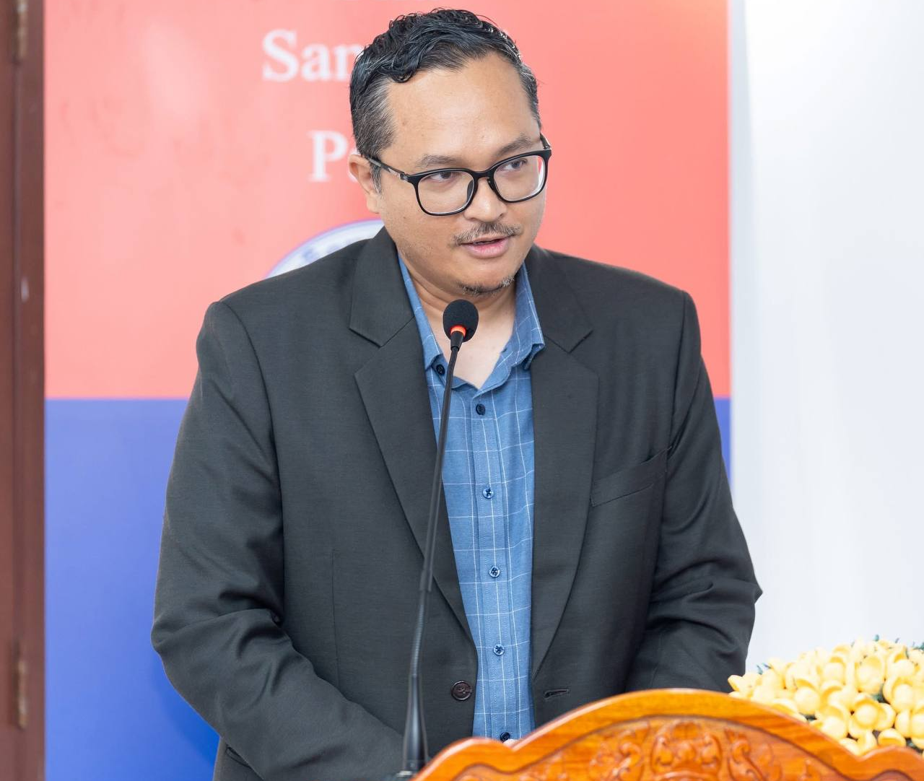
(Mr. Mobd Zulkarnain Abdul Wahab Delivering Impressive Remarks)

Mohd Zulkarnain Abdul Wahab, on behalf of SEAMEO SEN, raised that “he tried to work together with other SEAMEO regional centers as part of inter-center collaboration to support learning and teaching”.

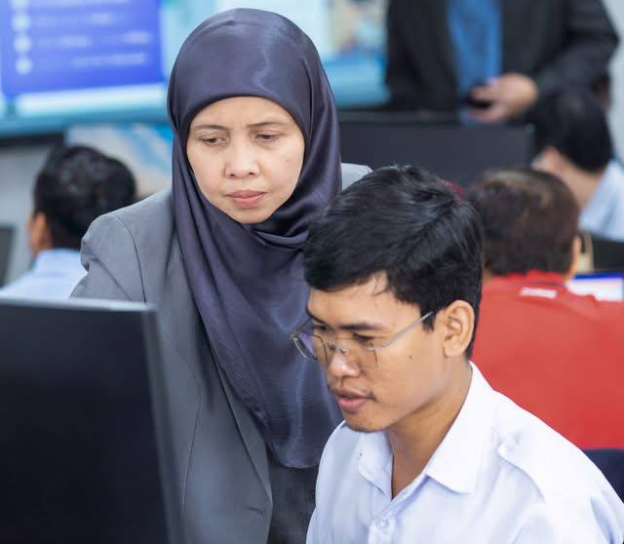
(Ts. Olya Dollah Instructing a Participant)
As part of the programme, educators also had the opportunity to learn about the SEAMEO SEN–Canva Creativity in Education Award 2026, which celebrates creative and inclusive teacher-led practices and encourages educators across Southeast Asia to share innovative approaches that empower every learner.

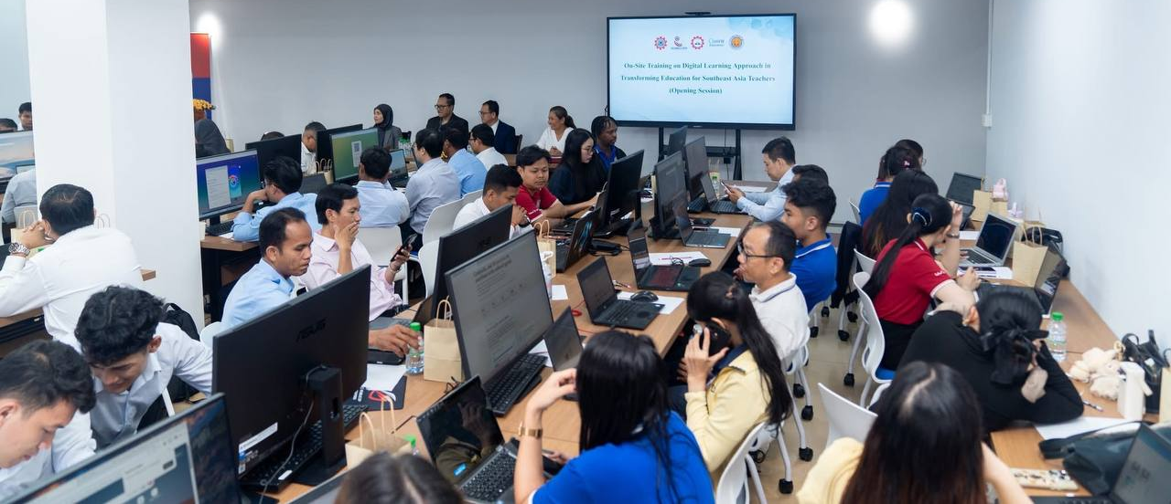
(Overview of Training Participants)

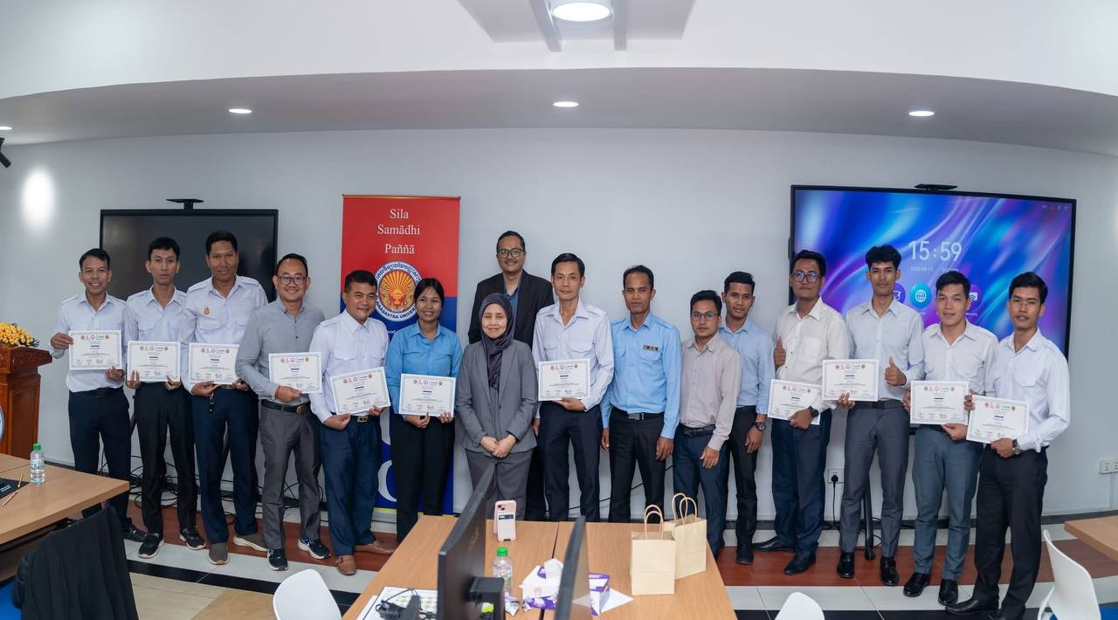
(Achievement Certificate Conferment to Participants)

