International YouthTalk on
How Learning Languages Changed MyWorldview
21 August 2026 (Online)

On the afternoon of August 21st 2026, the 8th session of the "International Youth Talk," jointly organized by the Southeast Asian Ministers of Education Organization Regional Centre for Technical Education Development (SEAMEO TED) and the China-ASEAN Technical Education Cooperation Platform (CATECP), with support from The Southeast Asia Youth Sustainable Development Foundation (PASITA), was successfully concluded online. The meeting was attended by 115 male and 341 female participants, making a total of 456 participants.

The events featured online presentations by youth representatives from universities across multiple countries including Indonesia, Thailand, and the Philippines. Centered around the theme of "How Learning Languages Changed My Worldview", the youth showcased fresh perspectives shaped by their personal journeys with language learning, sparking creative and cross-cultural exchanges.

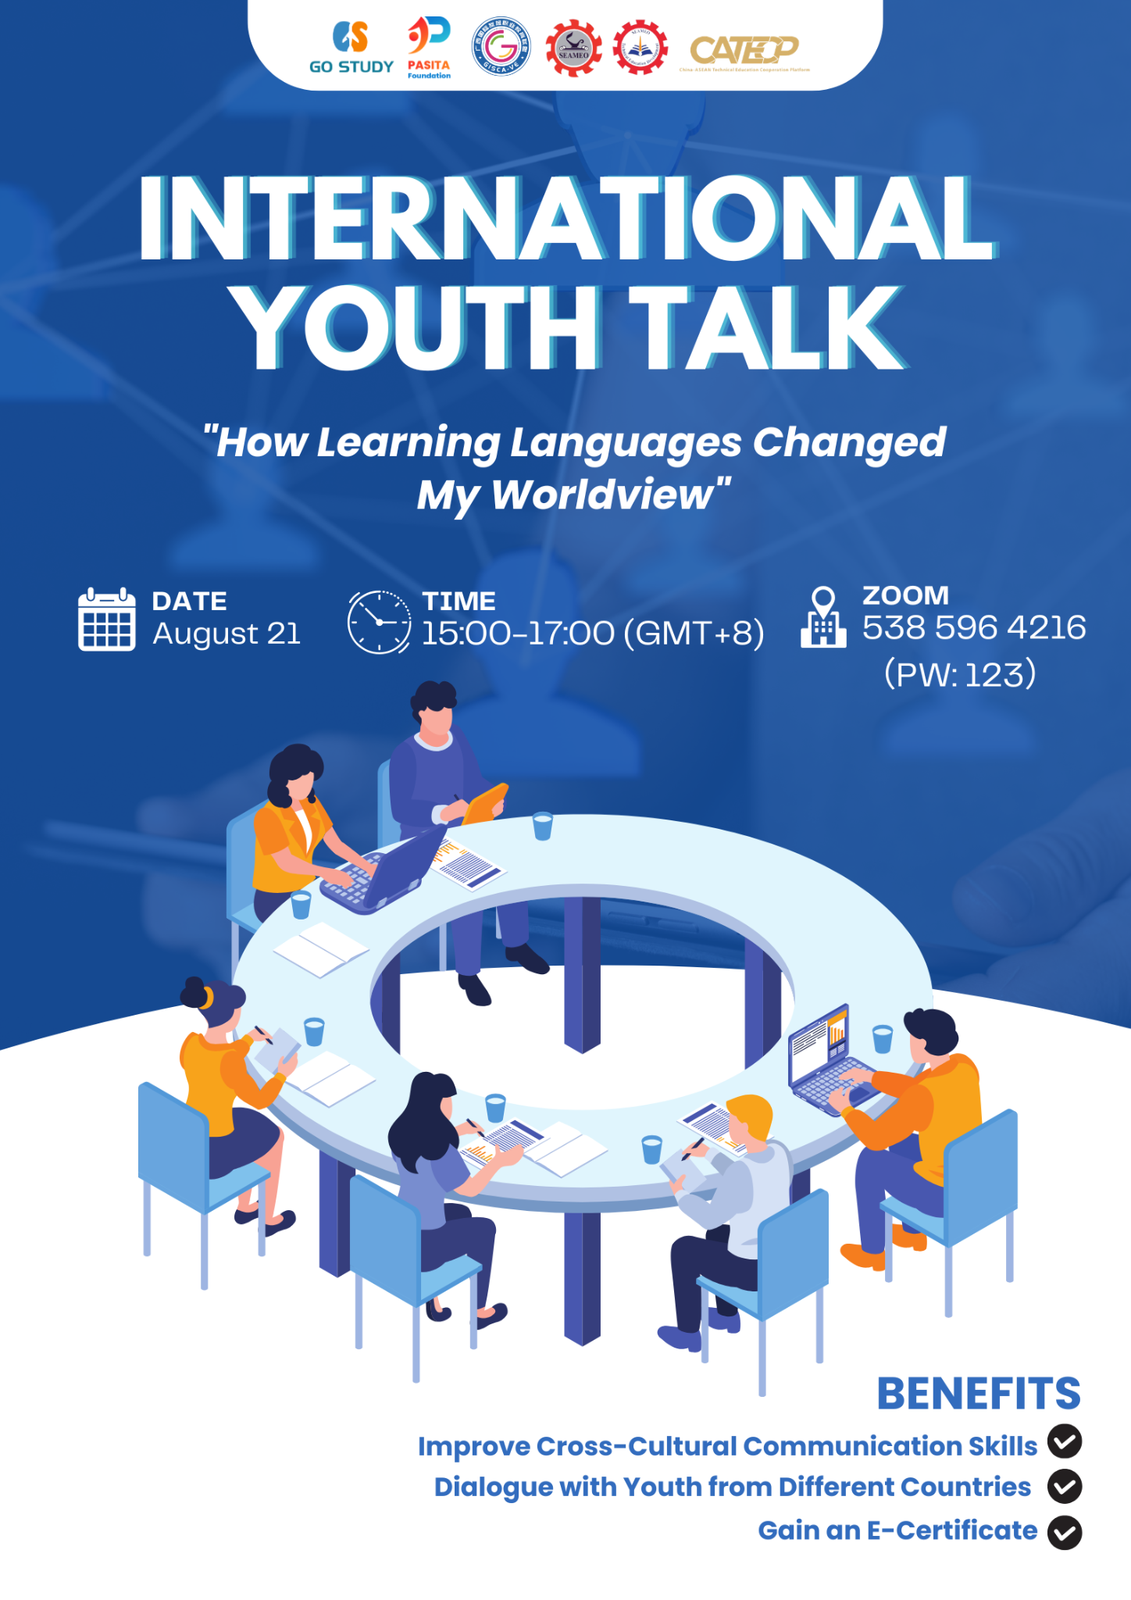

The opening remarks were delivered by Mr. Meas Mike, Deputy Director of SEAMEO TED. He emphasized that immersing oneself in a new language can help people realize that language is not merely a collection of words, but a window into the soul, culture, and identity of a nation. Learning a new language also allows people to discover new things about the world, understand other peoples identities and personalities, and open their minds to different perspectives. He highlighted that language can connect boundaries between cultures, reminding us that although humanity speaks different languages, we share many of the same aspirations. Therefore, he encouraged participants to broaden their understanding of different languages and recognize how each language can add to or transform their experiences and knowledge through different perspectives.

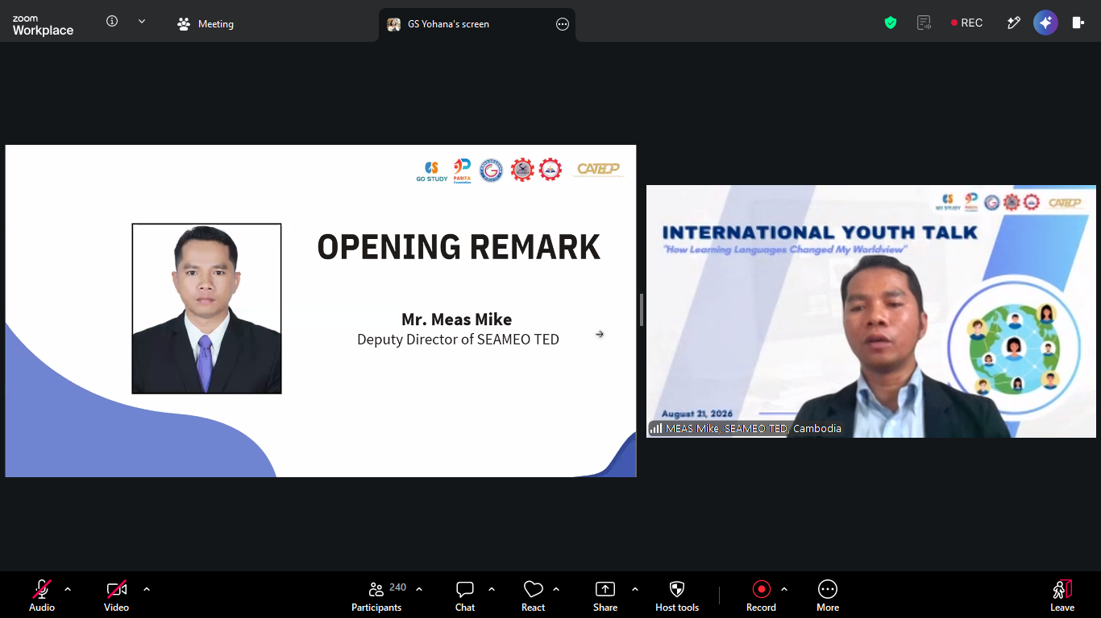
(Mr. Meas Mike Delivering Opening Remarks)

Representatives from Mariano Marcos State University in the Philippines explored how language learning can transform the way people understand the world through their presentation. They emphasized that language itself is not necessarily a barrier to communication, but rather the unwillingness to understand others. The presentation highlighted how every language reflects its own culture, history, values, and worldview, making language learning more than simply learning words and grammar. It also develops qualities such as patience, humility, curiosity, and empathy, while encouraging learners to appreciate different perspectives and cultures. The presenters further explained that understanding other languages and cultures also makes them appreciate their own identity. They concluded that language is not merely a tool for communication, but a bridge that connects people and helps them see the world from different perspectives.
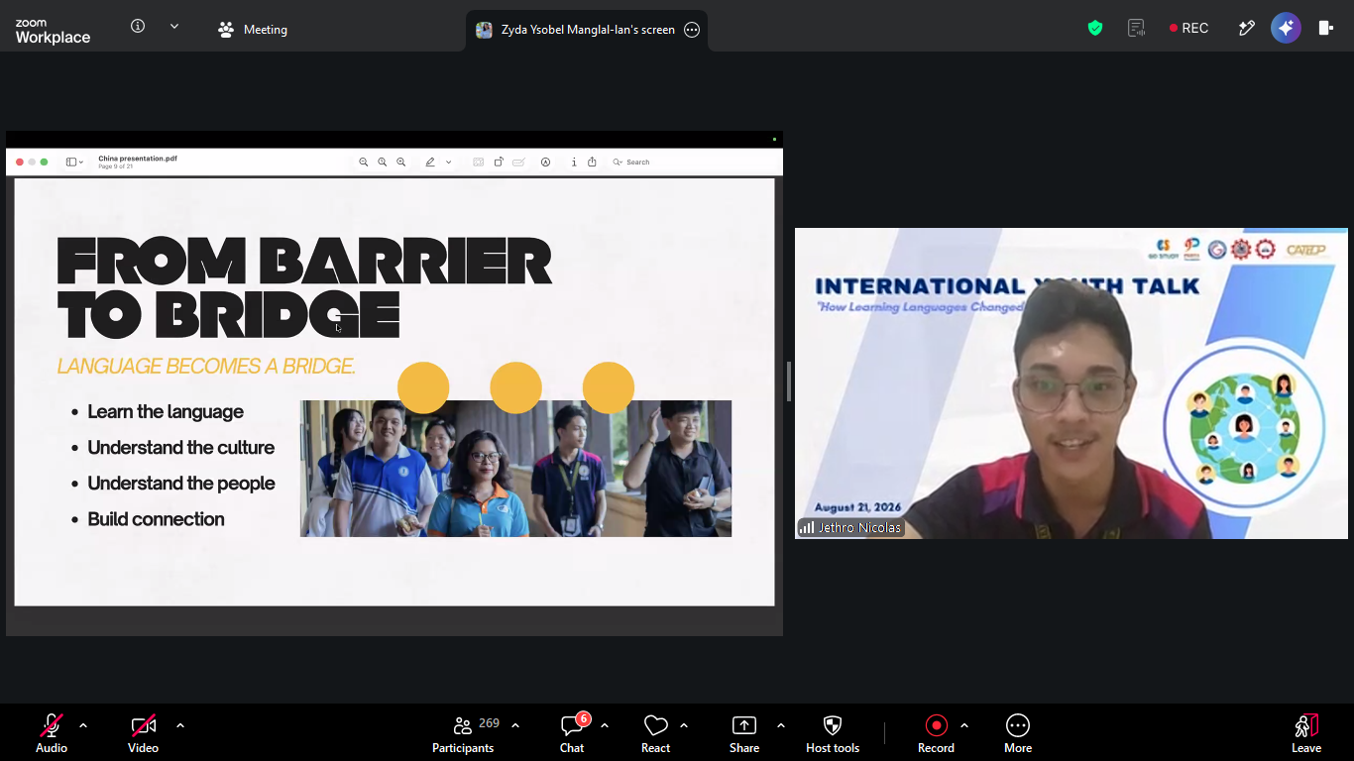
(A representative from Mariano Marcos State University, the Philippines)

A representative from Stamford International University in Thailand explored how learning English can expand his experience and knowledge. Drawing from his personal journey of learning English, he explained how the language gradually became more than just an academic subject and became an important part of his life and intercultural communication. His experiences in Ireland and Thailand introduced him to people from different backgrounds, allowing him to understand that every country is made up of individuals with their own experiences, struggles, and stories. He also shared how English connected different parts of his life, from academic research and friendships to books, films, and everyday experiences. The presentation emphasized that English is not simply a bridge between cultures, but a way to explore different perspectives and better understand both others and oneself. Ultimately, he encouraged learners to find their own passion for English, use it to discover the multicultural world, and continue walking their own path.

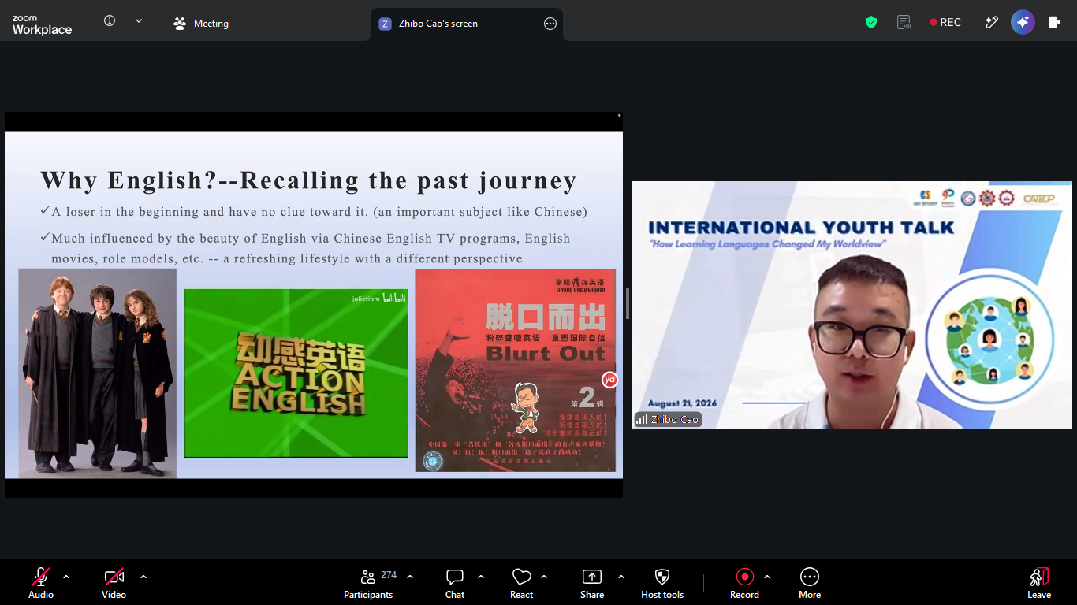
(A representative from Stamford International University, Thailand)

A representative from John B. Lacson Colleges Foundation (Bacolod), Philippines, explored how learning languages can transform her worldview. She highlighted how language goes beyond communication, serving as a way to build connections, understand cultures, and develop different perspectives. Drawing from experiences in hospitality and visits to various countries, she explained how travel, observation, and interaction strengthened her learning and cultural understanding. She also emphasized the importance of cultural intelligence, empathetic communication, global adaptability, and lifelong curiosity when interacting with people from different cultural backgrounds. In the context of hospitality, these qualities help professionals communicate effectively, respect cultural traditions, and create welcoming experiences for guests. The speaker then encouraged learners to remain curious, build meaningful connections, continue learning, and lead with humanity in an increasingly multicultural world.
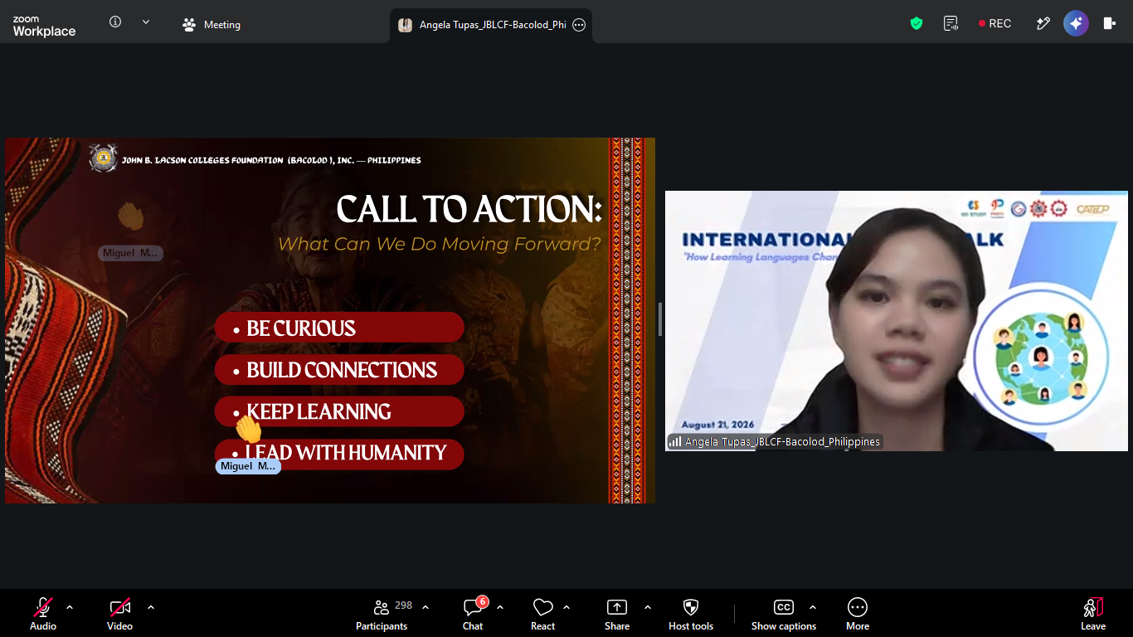
(A representative from John B. Lacson Colleges Foundation, Philippines)
The Representatives from Universitas Sebelas April in Indonesia explored how learning language can change the way people understand communication, culture, and society. They explained that language goes beyond words, as signs such as clothing, gestures, colors, numbers, and even silence can carry different meanings depending on cultural context. The team also highlighted how language is closely connected to culture, shaping how people show respect, address others, express emotions, and build social relationships. Through literature, they showed how language evolves with society and reflects the concerns, values, and experiences of different generations. They concluded that learning a language is also learning its world, as language carries stories, reflects society, and helps people see the world from different perspectives.

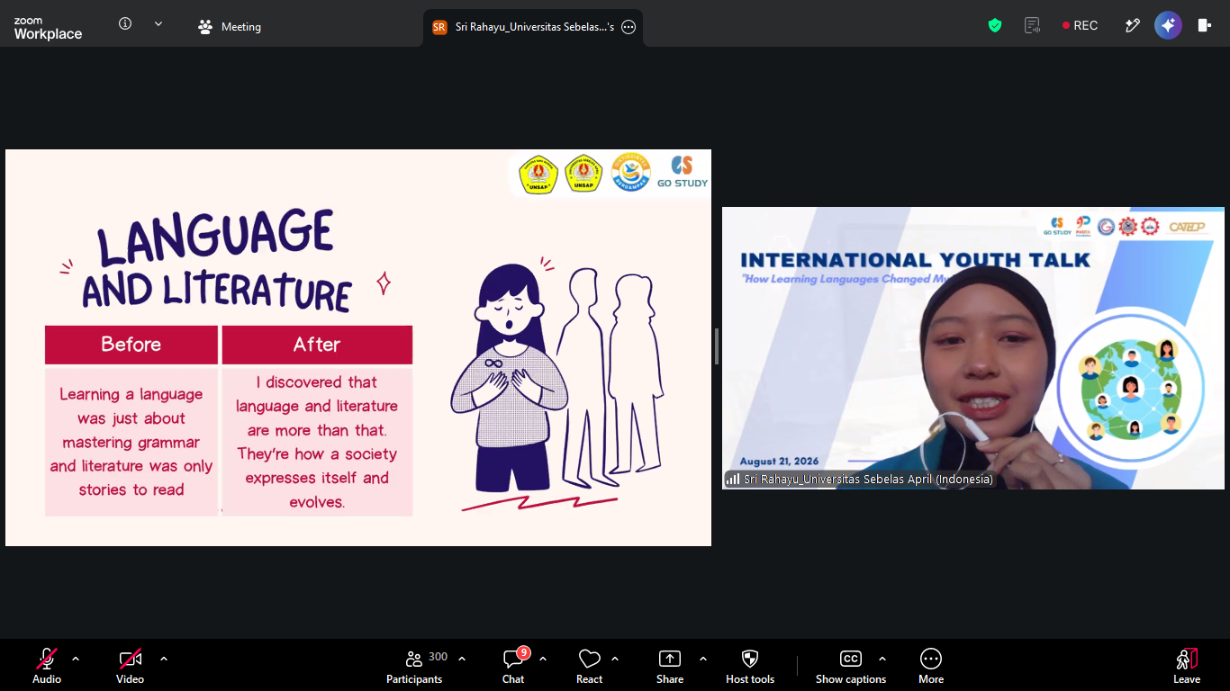
(A representatives from Universitas Sebelas, Indonesia)

