Higher Education Sustainability and Digital Innovation Forum
“Pursuit of Higher Education Sustainability toward Skills Development in the Digital Era: Theoretical Foundation and Practical Approaches”
27 August 2026 (Online)
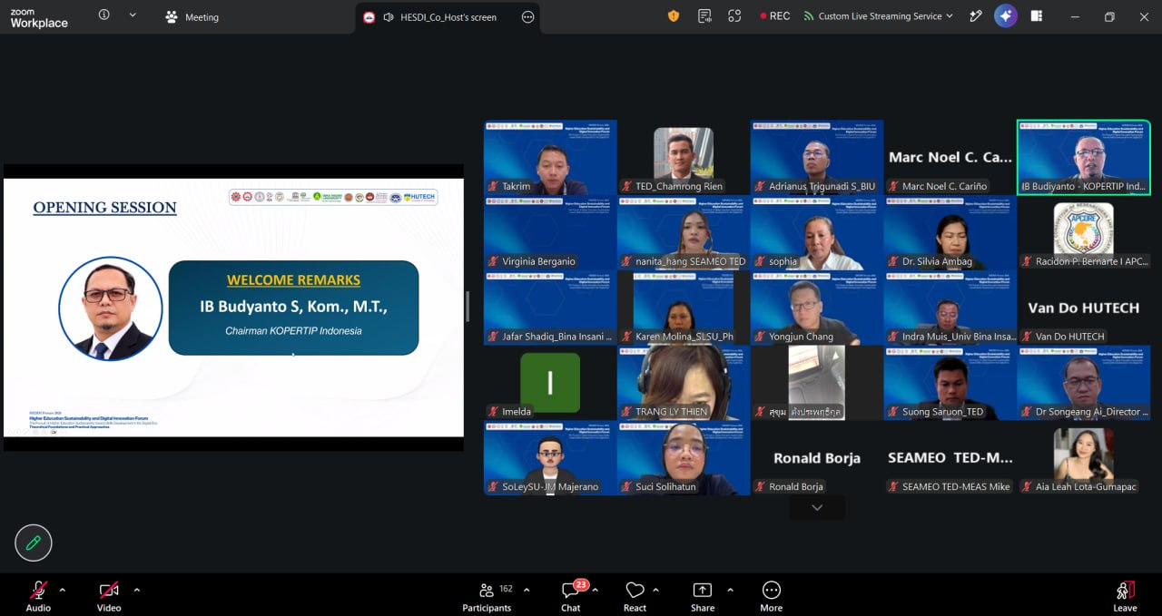
(IB Budyanto S, Kom., M.T. Delivering Welcome Remarks)
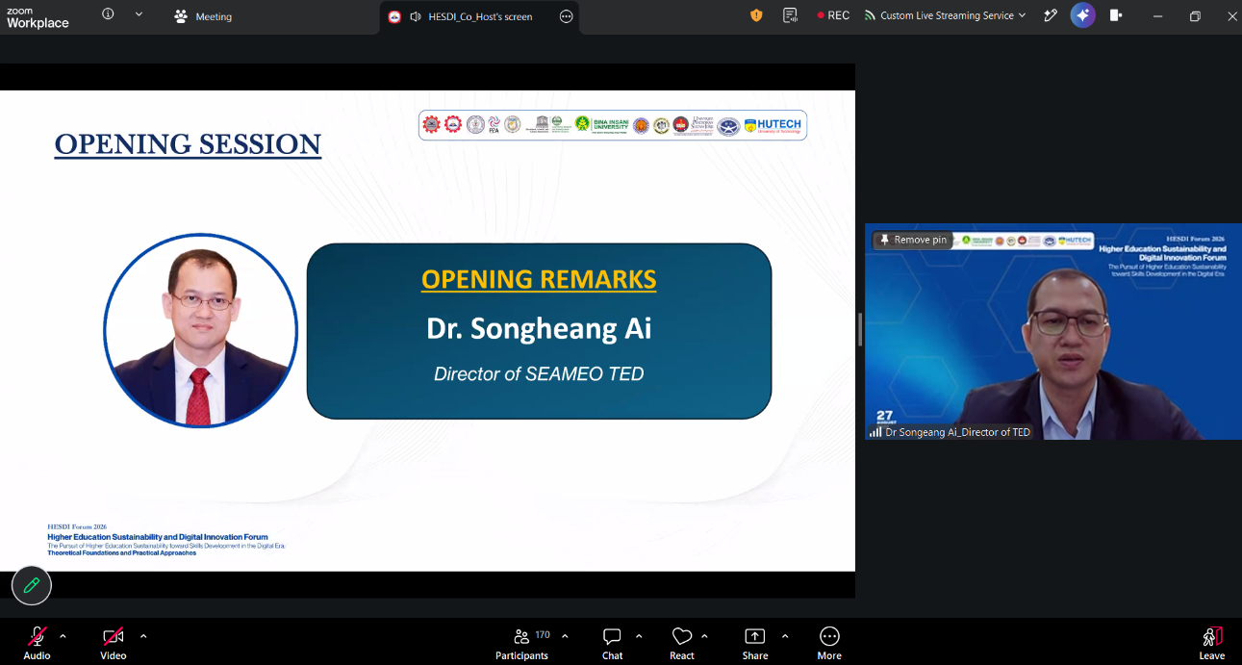
(Dr. Songheang Ai Delivering Opening Remarks)
On 27 August 2026, SEAMEO TED, in cooperation with KOPERTIP Indonesia, UNESCO INRULED, APCORE, P2A, and Ho Chi Minh City University of Technology (HUTECH), co-host the Higher Education Sustainability and Digital Innovation Forum on “Pursuit of Higher Education Sustainability toward Skills Development in the Digital Era: Theoretical Foundation and Practical Approaches”, attended by over 200 participants from Southeast Asia, China, South Korea, India, Malawi, beyond. The international forum brought together university leaders, researchers, educators, practitioners and experts to exchange experiences and explore practical approaches for building universities that are sustainable, inclusive, innovative, digitally capable and responsive to the changing needs of society. The forum aims (1) to explore current issues and future trends in higher education sustainability; (2) to share theoretical perspectives and practical experiences from different countries; (3) to discuss strategies for developing future-oriented skills in the digital era; and (4) to strengthen international collaboration among higher education institutions.
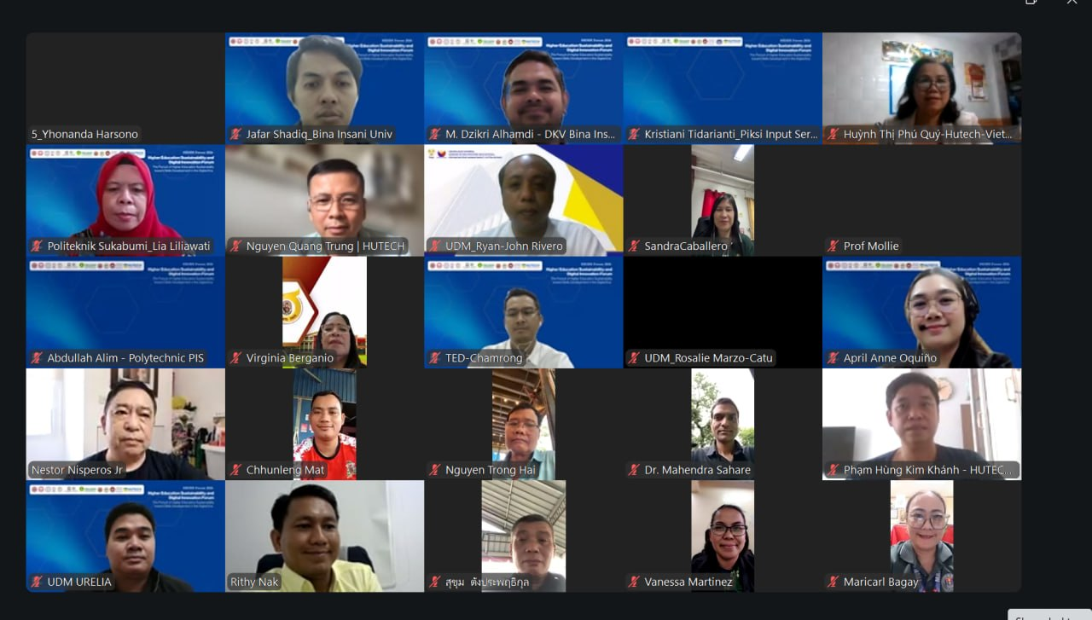
(Group Photo of all Participants)
The forum was welcomed by IB Budyanto S, Kom., M.T., Chairman of KOPERTIP Indonesia stressing the importance of digital transformation approaches can be adapting to the country context. Dr. Songheang Ai, director of SEAMEO TED opened the forum by highlighting that “Sustainability in higher education is not only about the environment. It also includes institutional resilience, quality education, digital transformation, inclusive learning, strong governance, partnerships, and future-ready skills”. Two keynote speakers namely Dr. Qi Xinjian, assistant director of UNESCO INRULED, and Dr. Racidon Bernarte, Managing Director of APCORE, who spoke about “Future Skills for Digital Citizens: Preparing Graduates for Industry 4.0 Skills Readiness through Digital and Institutional transformation”.
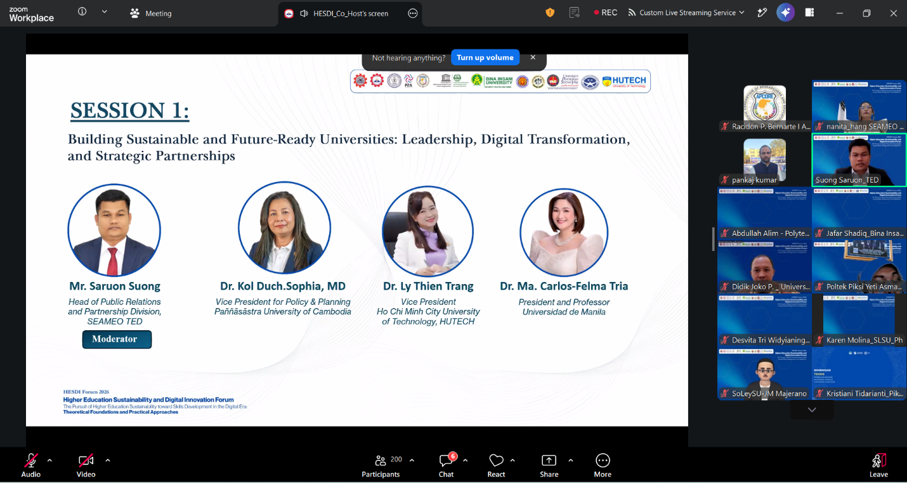
(Three Speakers for Session 1)
Session 1 focused on “Building Sustainable and Future-Ready Universities: Leadership, Digital Transformation, and Strategic Partnership”, shared by Dr. Kol Duch Sophia, Vice President of Paññāsāstra University of Cambodia, Cambodia, Dr. Ly Thien Trang, Vice President of Ho Chi Minh City University of Technology, Vietnam, and Dr. Ma. Felma Carlos-Tria, President of Universidad de Manila, the Philippines.
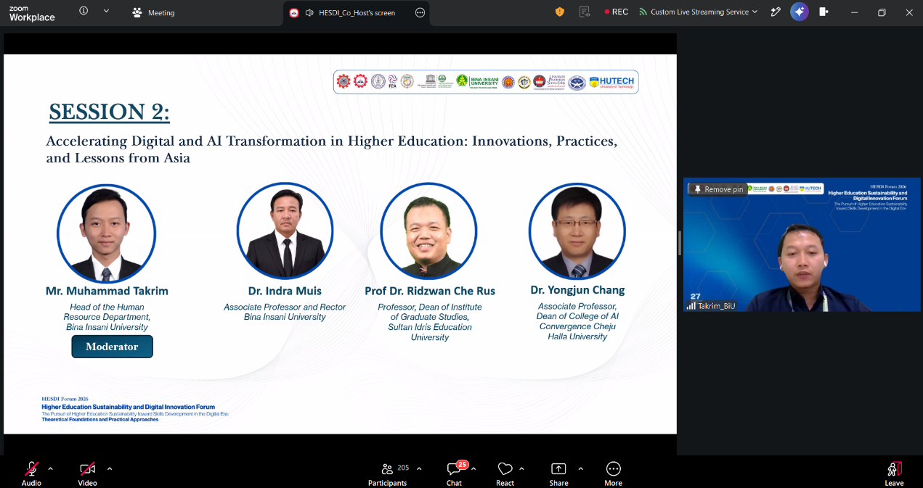
(Three Speakers for Session 2)
Session 2 focused on “Accelerating Digital and AI Transformation in Higher Education: Innovation, Practices, and Lessons from Asia”, shared by Dr. Indra Muis, Rector of Bina Insani University, Indonesia, Dr. Ridzwan Che Rus, Dean of Post Graduate Studies from Sultan Idris Education University, Malaysia, and Dr. Yongjun Chang, Professor from Cheju Halla University, South Korea.

(Dr. Ethel Agnes Valenzuela Delivering her Closing Remarks)
The forum was concluded with the closing remarks by Dr. Ethel Agnes Valenzuela, Chair of P2A ASEAN AI Council. She hopes that the participants learn a lot from our eminent speakers and encourages them to share what they have learnt with their peers.
Five Key Themes Emerged from the forum including:
- Sustainability should be redefined. A sustainable university should be environmentally responsible while also being human-centred, digitally responsible, quality-driven, globally connected and resilient.
- Universities should prepare students for changing jobs, not simply existing jobs. Future-ready graduates need a combination of AI and digital literacy, analytical and creative thinking, adaptability, leadership, collaboration, lifelong learning and entrepreneurial capabilities.
- Digital transformation is about people and institutional culture, not technology alone. Lessons from Indonesia highlighted the importance of leadership, student-centred digital learning, AI-supported education, partnerships and sustainability.
- AI should be adopted responsibly. The discussions highlighted the need for stronger AI governance, faculty capacity development, responsible assessment, data protection and human judgment.
- Partnerships are essential. Universities cannot transform digital education alone. Stronger collaboration among universities, industry, government, technology providers, communities and international partners is needed to accelerate innovation and improve graduate employability.
- Learning might move from knowledge to action. Future-ready education should increasingly emphasize project-based, problem-based, experiential, collaborative and community-engaged learning.

(Group Photo of All Participants)

